

**Out Today: GRAMMY Award-Winning**

**Chick Corea Trilogy**- ***Trilogy* & *Trilogy 2***

**on Limited Edition Vinyl for the First Time**

**via Concord Jazz**

**Deluxe Edition 8-LP box set to include 32-page book with never-before-seen photos, essays by Corea, Brian Blade, Christian McBride**

**and Bernie Kirsh**

**Released digitally everywhere and as a 5-CD deluxe**

**box set internationally**

[**Order here**](https://found.ee/ChickCoreaTrilogy)

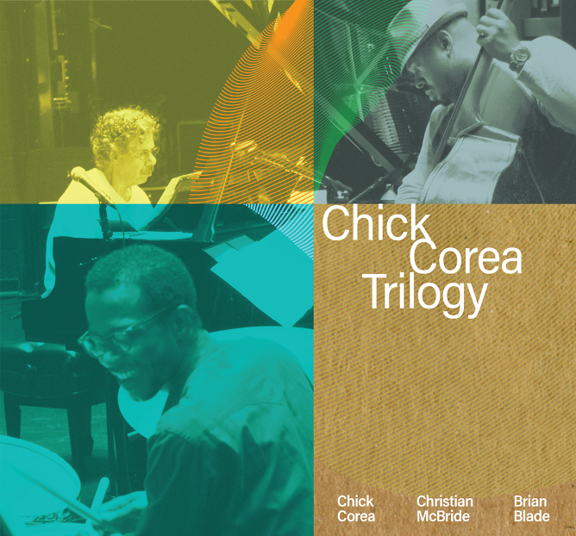

For the first time ever on vinyl, a limited edition 8-LP deluxe box set featuring **Chick Corea’s** 2013 album ***Trilogy*** *&* 2019 album ***Trilogy 2,*** has been remastered and released today collectively as ***Trilogy*** by **Concord Jazz**.

The GRAMMY® Award-Winning Trio featured on the collection (with a combined 40 wins between them) includes iconic jazz pianist **Chick Corea** along with **Brian Blade** on drums and **Christian McBride** on bass. Originally recorded by **Bernie Kirsh,** the set has been re-mastered by the legendary **Bernie Grundman**.

**Watch the *Trilogy* Box Set Unboxing Video:**

[**https://found.ee/ChickCoreaTrilogyUnboxingYT**](https://found.ee/ChickCoreaTrilogyUnboxingYT)

2013’s ***Trilogy*** was famously recorded live at tour stops in Washington, D.C., Oakland, CA, Spain, Switzerland, Austria, Slovenia, Turkey, and Japan. The follow-up album, 2019's ***Trilogy 2***, features further in-concert performances captured during various tours between 2010 and 2016 in places like Ottawa, Bologna, Zurich, and St. Louis. The material includes American Songbook standards to jazz classics, reaching back into Corea’s own catalog as well as that of some of his most renowned collaborators, including Miles Davis and Joe Henderson. Both albums received wide critical acclaim at the time of their release with *The Guardian* proclaiming about the former: “For Corea admirers, and jazz-piano fans of all kinds, it’s a must.”

From the liner notes –

“Together they establish rare chemistry on highly interactive, conversational interpretations”

– **Bill Milkowski** (journalist)

“Chick’s invitation to play with… his Trio was a blessing that I never saw coming. For all of the melodies and laughter and love and friendship he shared with me, I am eternally inspired and thankful.” **– Brian Blade** (drums)

“Chick certainly had his own sound and identity that had been fully formed for a long time, so even when we were playing Thelonious Monk’s “Crepescule with Nellie” or “Work,” it just felt like Monk through the eyes of Chick Corea. He wasn’t ever trying to deconstruct Monk. He respected Monk’s legacy too much to do that…  I loved the fact that he always addressed the tradition, not by denouncing it or constantly trying to change it but by revering it. He just played it the way he felt and I really respected him for that.” **– Christian McBride** (bass)

“He was incredibly generous as a musician as well as a man. And he did all he could to help bring out the best in others. He was happiest when those with whom he played achieved their creative visions. And I think that’s what you can hear on these discs.” **– Bernie Kirsh** (recording engineer)

“All I can say is that it was a challenge and an adventure the whole way through. Each

night a different city, a different venue, a different audience, a different piano and a

brand new opportunity to bring all the elements of this game together in a big win.

 I hope you can share some of the excitement the three of us had through these

recordings. And I hope it brings you some pleasure, as it surely did me.” **– Chick Corea** (2013)

Encased in an outer box, the inner portfolio showcases the 180 gram vinyl, a 32-page book with exclusive tour photos, liner notes by award-winning journalist **Bill Milkowski**, essays by Corea, Blade, McBride and more. ***Trilogy*** will also be available as a CD box set (*International only*). Vinyl and CD box sets designed by 2-time GRAMMY® Award-winning creative director **Lawrence Azerrad** at **LADdesign**.

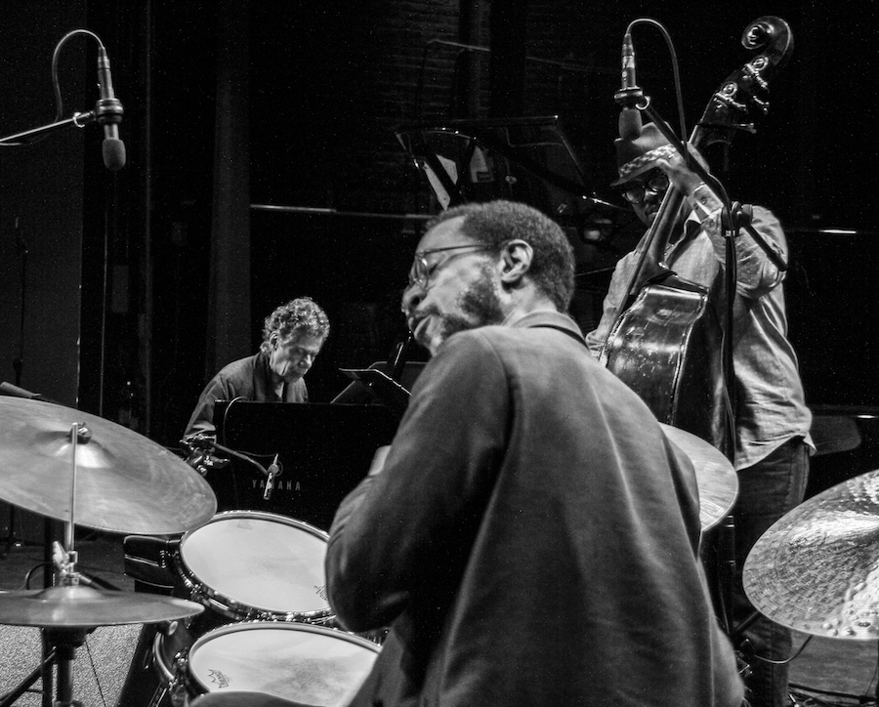

photo credit: Chick Corea Productions

**About Chick Corea:**

Born in 1941 in Massachusetts, the iconic keyboardist, composer and bandleader Chick Corea was a DownBeat Hall of Famer and NEA Jazz Master, as well as one of the most nominated artists in GRAMMY Awards history with 71 nods – and 27 wins, in addition to 5 Latin GRAMMYS. From straight-ahead to avant-garde, bebop to jazz-rock fusion, children’s songs to chamber and symphonic works, Corea touched an astonishing number of musical bases in his career since playing with the genre-shattering bands of Miles Davis in the late ’60s and early ’70s.

While one would expect the 20th century to have been the apex of Corea’s career, he was certainly as productive in the 21st. Whether playing acoustic piano or electric keyboards, leading multiple bands, performing solo or collaborating with a who’s who of musicians, Chick’s career never paused. Underscoring this, he was named Artist of the Year three times between 2014 and 2018 in the DownBeat Readers Poll, a publication that called him “a pianist virtually without peer.”

**Official Store:** [**https://found.ee/ChickCoreaTrilogyStore**](https://found.ee/ChickCoreaTrilogyStore)

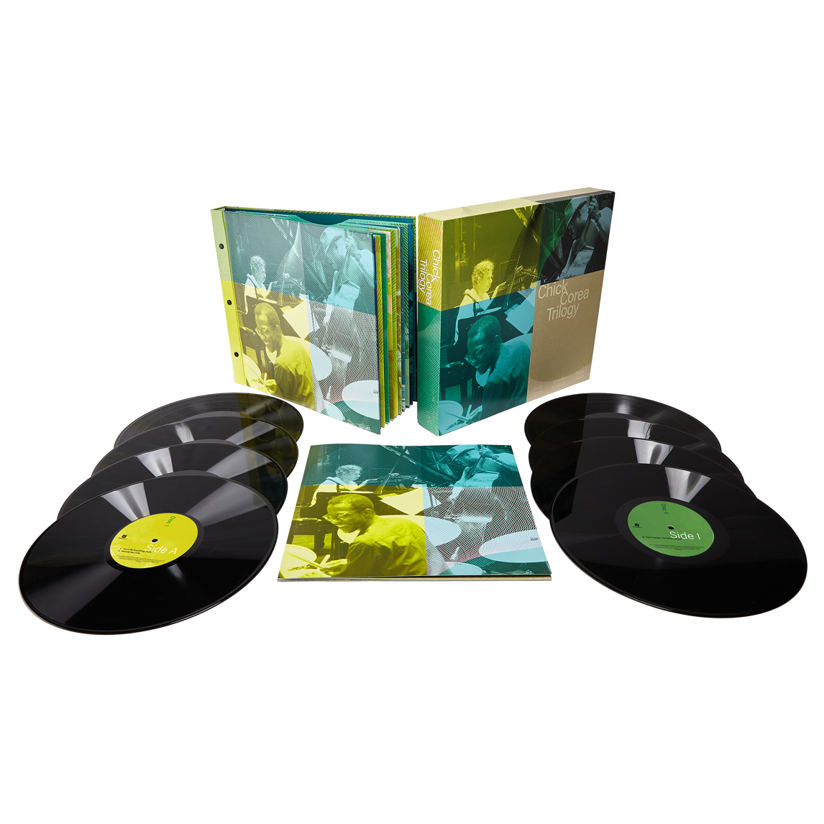

**Media contact:**

**Chart Room Media**

**Brendan Gilmartin**

**Brendan@chartroommedia.com**

**347-450-3048 – ph.**