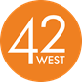

**JAZZ AND R&B HEAVYWEIGHT BONEY JAMES ANNOUNCES NINETEENTH STUDIO ALBUM *SLOW BURN* OUT OCTOBER 18th VIA CONCORD RECORDS; PRE-ORDER** [**HERE**](https://found.ee/BoneyJamesSlowBurn)

**FIRST SINGLE “ALL I WANT IS YOU” FEATURES RISING R&B VOCALIST OCTOBER LONDON; OUT ACROSS ALL STREAMING SERVICES TODAY; STREAM THE TRACK** [**HERE**](https://found.ee/BoneyJamesSlowBurn)

**WATCH “ALL I WANT IS YOU” MUSIC VIDEO** [**HERE**](https://found.ee/BoneyJames_AllIWantIsYouYT)

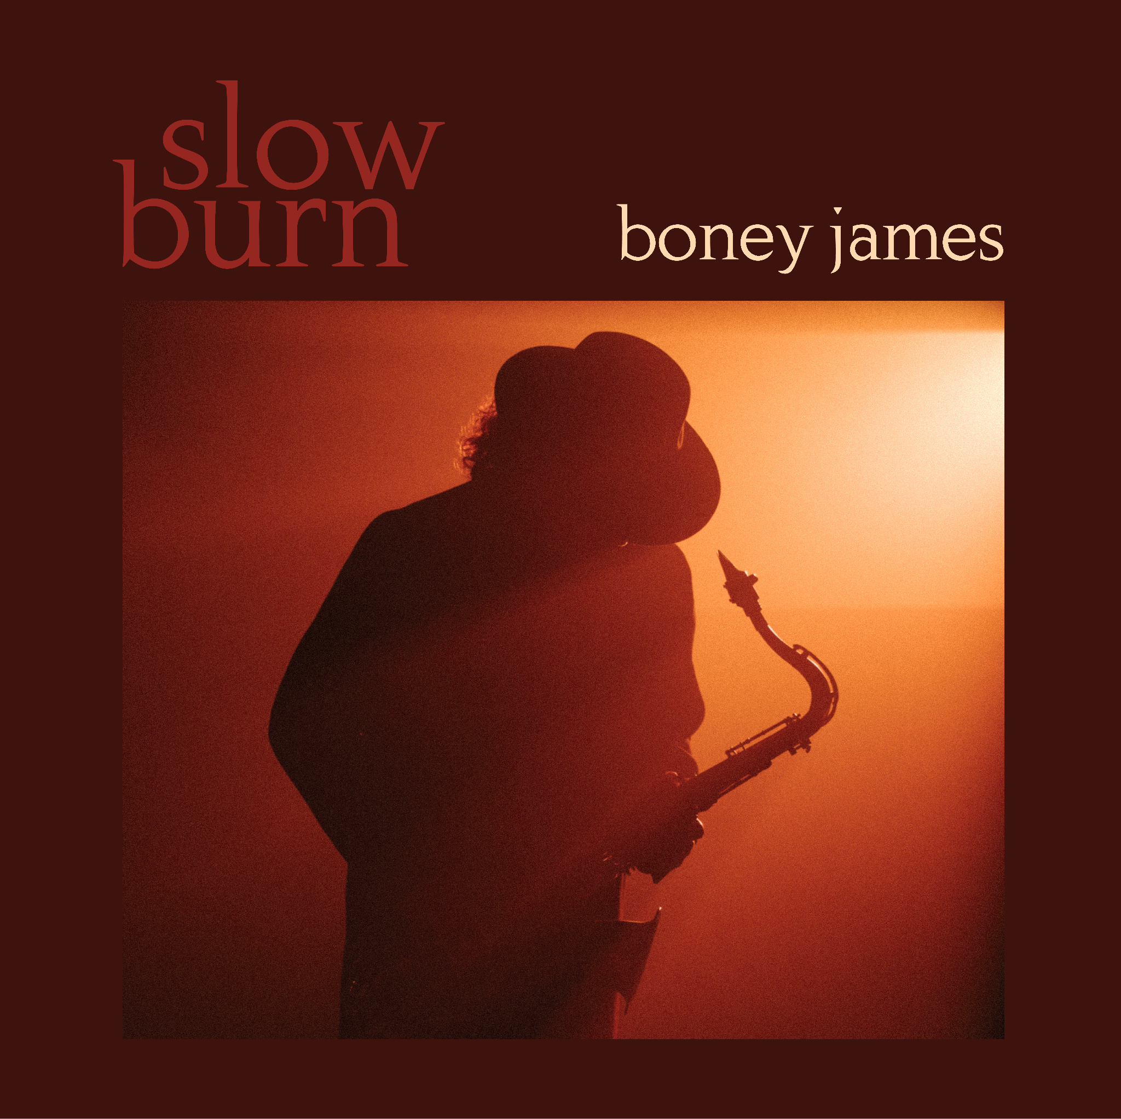

**LOS ANGELES (July 19th, 2024)** – Legendary saxophonist and composer **Boney James** will release his nineteenth studio album ***Slow Burn*** on October 18th through Concord Records. The news comes as the album’s first official single “***All I Want Is You***” featuring critically acclaimed R&B newcomer **October London** on vocals, releases today across all streaming services. The sleek and atmospheric music video for “*All I Want Is You*” also released earlier today which was revealed during a special YouTube livestream where Boney chatted with fans about the new album, and his collaboration with London.

**LISTEN TO “*ALL I WANT IS YOU*” FEATURING OCTOBER LONDON** [***HERE***](https://found.ee/BoneyJames_OctoberLondonYT)

**WATCH THE OFFICIAL MUSIC VIDEO** [***HERE***](https://found.ee/BoneyJames_AllIWantIsYouYT)

Featuring a collection of 10-new tracks produced by Boney, *Slow Burn* marks a new high point in the chart-topping, contemporary jazz icon’s remarkable three-decade career, one that includes a long list of accolades; four GRAMMY nominations, three NAACP Image Award nominations, a Soul Train Award for Best Jazz Album and four RIAA Gold Record certifications, to name just a few.

“When I mentioned the phrase ‘slow burn’ to people as a possible title, they said, ‘That also refers to your whole career in a way,’” James recently reflected. “This is my nineteenth record and I feel like I’m just hitting my stride.”

*Slow Burn* includes an impressive list of guest collaborators, starting with the legendary bass player Marcus Miller on “*Arcadia.*” Miller appears again on “*Butterfly*,” a remake of the Herbie Hancock and Bennie Maupin classic, along with internationally renowned jazz/gospel keyboardist Cory Henry. Multi-instrumentalist Jairus Mozee (Anderson.Paak, Anthony Hamilton, Nikki Minaj, etc.) co-wrote and co-produced four tracks on the album with Boney, including title track “*Slow Burn*.” As for the sultry first single “*All I Want Is You*” featuring rising R&B vocalist October London, James proclaims the track to be “one of the most exciting vocal collaborations I’ve ever recorded.”

James is scheduled to play select dates across the U.S. through the summer and fall. Promising to bring his iconic 30-year career to the live stage, including selections from *Slow Burn*, the upcoming shows will hit several markets over the next few months including Nashville, Milwaukee, Charlotte, and Boston among others. For further information please visit <https://boneyjames.com/>.

During his 30-year career, Boney James has released a staggering nineteen studio albums, with 1995’s *Seduction*, 1997’s *Sweet Thing*, and 1999’s *Body Language* all becoming RIAA certified gold. In 2015, Boney’s *futuresoul* spent eleven weeks atop the *Billboard* Contemporary Jazz chart and was the best-selling Contemporary Jazz Record of 2015, while his 2020 album *Solid* went on to become his highest charting release ever on the pop charts, peaking in the Top 10 on the *Billboard* 200.

With nearly a dozen of his albums landing at #1 on *Billboard*’s Contemporary Jazz Album chart, James’ past collaborators include a long list of critically acclaimed R&B and soul stars: Raheem DeVaughn, Faith Evans, George Benson, George Duke, Dwele, Al Jarreau, Philip Bailey, Anthony Hamilton, Jaheim, Eric Benét, Dave Hollister, Stokley Williams, Kenny Lattimore, Angie Stone, and Lalah Hathaway.

Boney James’ nineteenth studio album *Slow Burn* will be released through Concord Records on October 18th. Pre-order the album[*HERE*](https://found.ee/BoneyJamesSlowBurn). The album’s first official single “All I Want Is You,” featuring October London is available across all streaming platforms now. Stream the single [*HERE*](https://found.ee/BoneyJamesSlowBurn).

***Slow Burn* Track Listing**

1. Arcadia (Featuring Marcus Miller)

2. Butterfly (Featuring Cory Henry and Marcus Miller)

3. Slow Burn

4. All I Want Is You (Featuring October London)

5. Slide

6. A Little Romance

7. Gonna Have a Good Time

8. The Bounce

9. Between The Lines

10. Sugar (Featuring Rick Braun)

**Upcoming Boney James Tour Dates**

Sun, JUL 21 - Winter Park Jazz Fest - Winter Park, CO

Tues, JUL 30 - Lake Tahoe Shakespeare Fest - Incline Village, NV

Fri, AUG 2 - Southern Theater - Columbus, OH

Sat, AUG 3 - Iroquois Amphitheater - Louisville, KY

Sun, AUG 4 - The Fisher Center for the Performing Arts - Nashville, TN

Thu, AUG 22 - Ohio Theater - Cleveland, OH

Fri, AUG 23 – The Clyde Theater – Fort Wayne, IN

Sat, AUG 24 – Fresh Coast Jazz Festival – Milwaukee, WI

Fri, SEP 20 - Oklahoma City CC Visual and Performing Arts Center Theater - Oklahoma City, OK

Fri, SEP 27 – Newport Beach Jazz Festival – Newport Beach, CA

Sat, SEP 28 - Thornton Winery - Temecula, CA

Thu, OCT 17 – Clearwater Jazz Holiday – Clearwater, FL

Sat, OCT 19 - Rehoboth Beach Jazz Festival - Rehoboth Beach, DE

Sun, OCT 20 – The Birchmere – Alexandria, VA

Mon, OCT 21 – Rams Head On Stage – Annapolis, MD

Wed, OCT 23 – Charleston Music Hall – Charleston, SC

Fri, OCT 25 – Florida Theater – Jacksonville, FL

Sat, OCT 26 – Stockbridge Amphitheater – Stockbridge, GA

Sun, OCT 27 – Knight Theater – Charlotte, NC

Thu, OCT 31 – Lexington Opera House – Lexington, KY

Fri, NOV 1 – Byham Theater – Pittsburgh, PA

Sat, NOV 2 – The Palladium – Carmel, IN

Sun, NOV 3 – Ludlow Garage – Cincinnati, OH

Wed, NOV 6 – Kodak Center – Rochester, NY

Thu, NOV 7 – City Winery – Boston, MA

Fri, NOV 8 – Tarrytown Music Hall – Tarrytown, NY

Sun, NOV 10 – Patchogue Theater – Patchogue, NY

Wed, NOV 13 – Sound Board at MotorCity Casino – Detroit, MI

Fri, DEC 5 – Sun, DEC 8 – Dimitriou’s Jazz Alley – Seattle, WA

Sun, DEC 29 – Tues, DEC 31 – Yoshi’s Oakland – Oakland, CA

Fri, JAN 24 – Chandler Center for the Arts – Chandler, AZ

Sat, JAN 25 – The Smith Center for Performing Arts – Las Vegas, NV

**For more information:**

**Greg Cortez / 42 West**

[Greg.Cortez@42West.Net](mailto:Greg.Cortez@42West.Net)