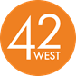

**JAZZ AND R&B ICON BONEY JAMES BRINGS THE FUNK ON NEW SINGLE “SLIDE”**

**WATCH NEW MUSIC VIDEO** [***HERE***](https://www.youtube.com/watch?v=ov_HvxnO0-0)

**MARKS LATEST RELEASE FROM UPCOMING 19TH STUDIO ALBUM *SLOW BURN* OUT OCTOBER 18th VIA CONCORD RECORDS; PRE-ORDER**[***HERE***](https://found.ee/BoneyJamesSlowBurn)

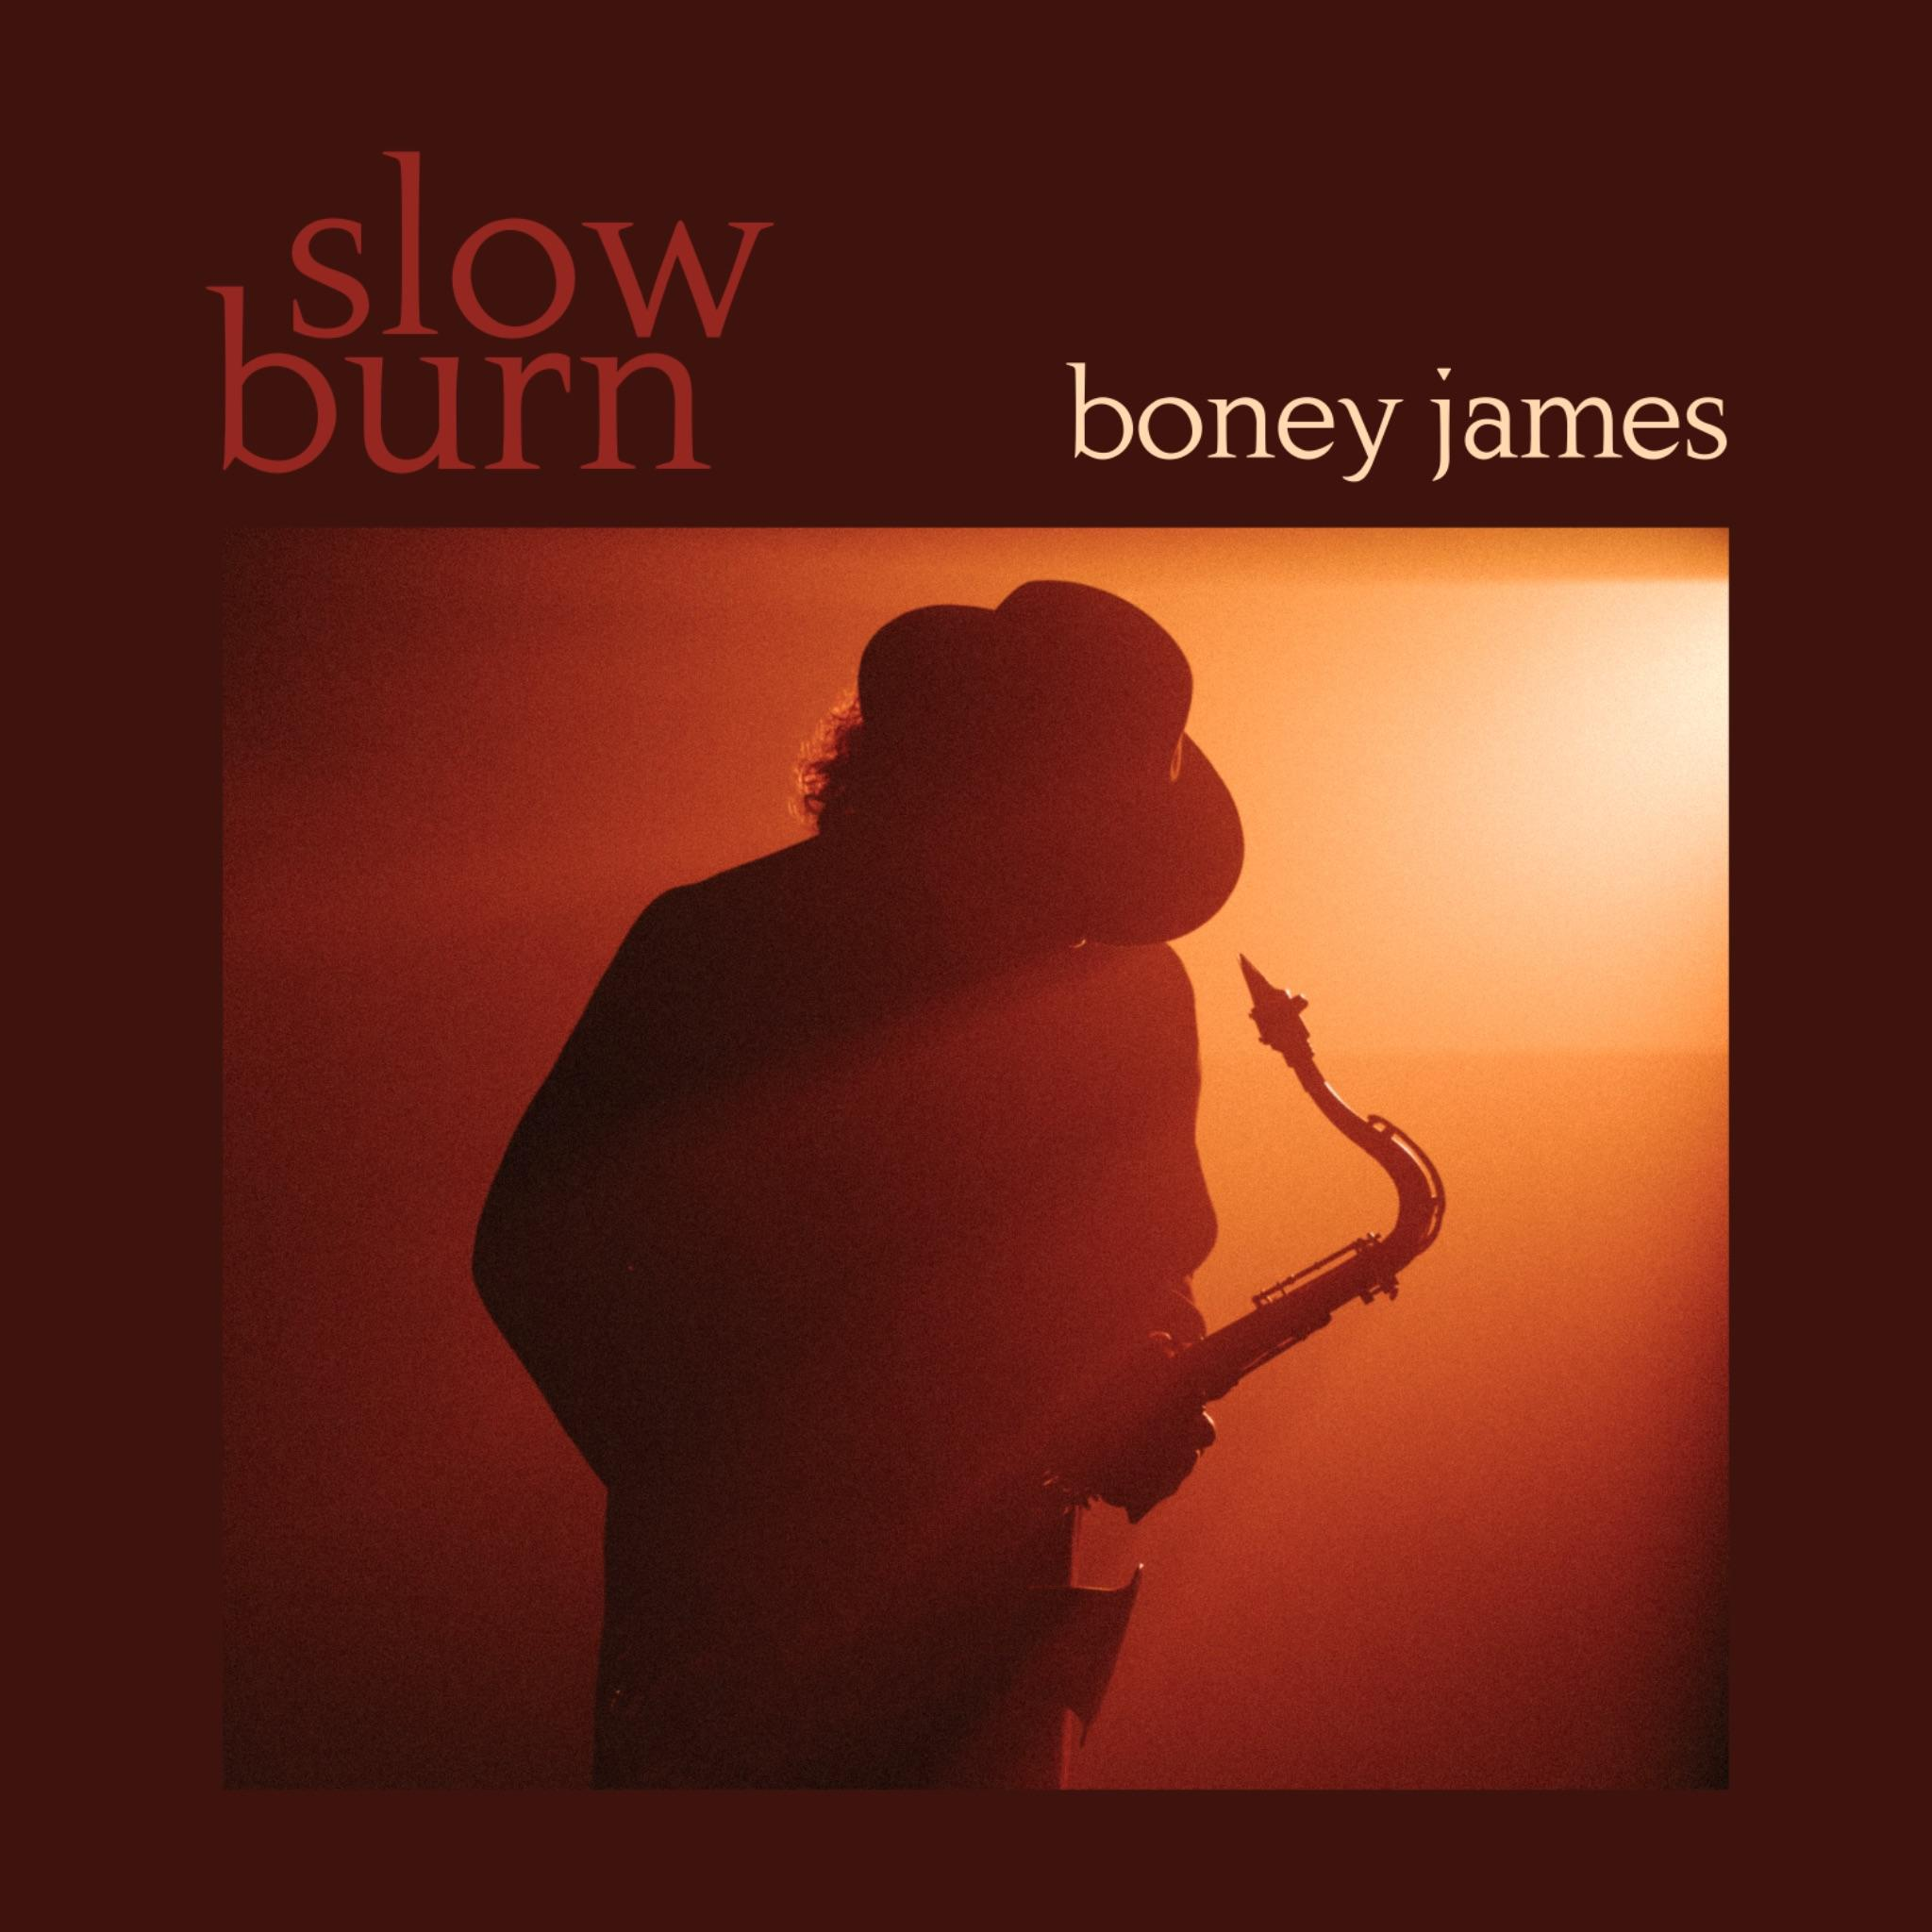

**Additional Press Assets Available** [***HERE***](https://omk.concordrecords.com/release/500/) **(Password: 1018Boney)**

**LOS ANGELES (September 27th, 2024)** – Today, legendary saxophonist and composer **Boney James** released his latest funk inspired single **“Slide**,**”** off his upcoming 19th studio album ***Slow Burn***, out October 18th through Concord Records. The infectious groove-laced track features James on tenor saxophone and keyboards backed by all the members of his infamous crack touring band.

“This song has a little Minneapolis feel,” noted James in a recent interview. “I got my start as a professional musician touring with Morris Day, but this is the first time I’ve copped this groove.”

**STREAM “SLIDE”** [***HERE***](https://found.ee/BoneyJamesSlowBurn)

**WATCH MUSIC VIDEO** [***HERE***](https://www.youtube.com/watch?v=ov_HvxnO0-0)

“Slide” comes on the heels of two recently released singles from the upcoming *Slow Burn* album; last August’s soulful “Butterfly” and July’s “All I Want Is You,” James’ smash summer single featuring critically acclaimed R&B newcomer October London on vocals. Since its July 19th release, “All I Want Is You” has gained steadily at R&B radio across the US, where it is currently a top 15 hit. The track also helped James achieve another recent major milestone this past summer, surpassing the one billion stream mark on Pandora last August, making him one of the few modern day jazz artists to achieve such a feat.

The upcoming *Slow Burn* features a collection of 10-new tracks produced by Boney, and marks a new high point in the chart-topping, contemporary jazz icon’s remarkable three-decade career, one that includes a long list of accolades; four GRAMMY nominations, three NAACP Image Award nominations, a Soul Train Award for Best Jazz Album and four RIAA Gold Record certifications, to name just a few.

“When I mentioned the phrase ‘slow burn’ to people as a possible title, they said, ‘That also refers to your whole career in a way,’” James recently reflected. “This is my nineteenth record and I feel like I’m just hitting my stride.”

The new album includes an impressive list of guest collaborators, starting with the legendary bass player Marcus Miller, who plays on “Butterfly,” in addition to the album’s opening track “Arcadia*.*” Multi-instrumentalist Jairus Mozee (Anderson.Paak, Anthony Hamilton, Nikki Minaj, etc.) also co-wrote and co-produced four tracks on the album with Boney, including title track “*Slow Burn*.” As for the seductive first single “All I Want Is You” featuring rising R&B vocalist October London, James proclaims the track to be “one of the most exciting vocal collaborations I’ve ever recorded.”

James will continue on the road for select dates across the U.S. through the fall and into early next year. Promising to bring James’ iconic 30-year career to the live stage, including selections from *Slow Burn*, the upcoming dates will hit a number of markets including New York, Philadelphia and Washington DC, among others. For further information on all tour dates and on-sale info, please visit <https://boneyjames.com/>.

During his 30-year career, Boney James has released a staggering 19 studio albums – including a pair of Christmas records -with 1995’s *Seduction*, 1997’s *Sweet Thing* and 1999’s *Body Language* all RIAA certified gold. In 2015, Boney’s *futuresoul* spent 11 weeks atop the *Billboard* Contemporary Jazz Chart and was the best-selling Contemporary Jazz Record of 2015, while his 2020 album *Solid* went on to become his highest charting release ever on the pop charts, peaking in the Top 10 on the *Billboard* 200.

With nearly a dozen of his albums having landed at #1 on *Billboard*’s Contemporary Jazz Album chart, James’ past collaborators include a Who’s Who of R&B and soul: Raheem DeVaughn, Faith Evans, George Benson, George Duke, Dwele, Al Jarreau, Philip Bailey, Anthony Hamilton, Jaheim, Eric Benét, Dave Hollister, Stokley Williams, Kenny Lattimore, Angie Stone, and Lalah Hathaway.

*Slow Burn*, the nineteenth studio album from Boney James will be released through Concord Records on October 18th. Pre-order the album[*HERE*](https://found.ee/BoneyJamesSlowBurn). “Slide” is out across all streaming platforms now. Stream the single [*HERE*](https://found.ee/BoneyJamesSlowBurn). Watch the music video [*HERE*](https://www.youtube.com/watch?v=ov_HvxnO0-0).

***Slow Burn* Track Listing**

1. Arcadia (Featuring Marcus Miller)

2. Butterfly (Featuring Cory Henry and Marcus Miller)

3. Slow Burn

4. All I Want Is You (Featuring October London)

5. Slide

6. A Little Romance

7. Gonna Have a Good Time

8. The Bounce

9. Between The Lines

10. Sugar (Featuring Rick Braun)

**Upcoming Boney James Tour Dates**

Fri, SEP 27 – Newport Beach Jazz Festival – Newport Beach, CA

Sat, SEP 28 - Thornton Winery - Temecula, CA

Wed, OCT 16 - The Parker - Ft Lauderdale, FL

Thu, OCT 17 – Clearwater Jazz Holiday – Clearwater, FL

Sat, OCT 19 - Rehoboth Beach Jazz Festival - Rehoboth Beach, DE

Sun, OCT 20 – The Birchmere – Alexandria, VA

Mon, OCT 21 – Rams Head On Stage – Annapolis, MD

Wed, OCT 23 – Charleston Music Hall – Charleston, SC

Thurs, OCT 24 - The Plaza - Orlando, FL

Fri, OCT 25 – Florida Theater – Jacksonville, FL

Sat, OCT 26 – Stockbridge Amphitheater – Stockbridge, GA

Sun, OCT 27 – Knight Theater – Charlotte, NC

Wed, OCT 30 - Minglewood Hall - Memphis, TN

Thu, OCT 31 – Lexington Opera House – Lexington, KY

Fri, NOV 1 – Byham Theater – Pittsburgh, PA

Sat, NOV 2 – The Palladium – Carmel, IN

Sun, NOV 3 – Ludlow Garage – Cincinnati, OH

Wed, NOV 6 – Kodak Center – Rochester, NY

Thu, NOV 7 – City Winery – Boston, MA

Fri, NOV 8 – Tarrytown Music Hall – Tarrytown, NY

SAT, NOV 9 - Miller Theater - Philadelphia, PA

Sun, NOV 10 – Patchogue Theater – Patchogue, NY

Mon, NOV 11 - Sony Hall - New York, NY

Wed, NOV 13 – Sound Board at MotorCity Casino – Detroit, MI

Fri, DEC 6 – Dimitriou’s Jazz Alley – Seattle, WA

Sat, DEC 7 – Dimitriou’s Jazz Alley – Seattle, WA

Sun, DEC 8 - Dimitriou’s Jazz Alley – Seattle, WA

Sun, DEC 29 – Yoshi’s Oakland – Oakland, CA

Mon, DEC 30 - Yoshi’s Oakland – Oakland, CA

Tues, DEC 31 – Yoshi’s Oakland – Oakland, CA

Fri, JAN 24 – Chandler Center for the Arts – Chandler, AZ

Sat, JAN 25 – The Smith Center for Performing Arts – Las Vegas, NV

**For more information:**

**Greg Cortez / 42 West**

[Greg.Cortez@42West.Net](mailto:Greg.Cortez@42West.Net)