***Milton + esperanza* Out August 9 (Concord Records)**

**Full Length Album Collaboration Between Brazilian Musical Icon Milton Nascimento and Decorated Musician/Composer esperanza spalding**

**Featuring Guests Paul Simon, Dianne Reeves, Lianne La Havas, Tim Bernardes, Maria Gadú, Guinga and More; Produced by esperanza spalding**

**Listen to "Outubro" Here:** [**https://found.ee/Milton-esperanza**](https://found.ee/Milton-esperanza) **+** [Visualizer](https://found.ee/Me_OutubroYouTube)

[**Album Trailer**](https://found.ee/Me_AlbumTrailer)

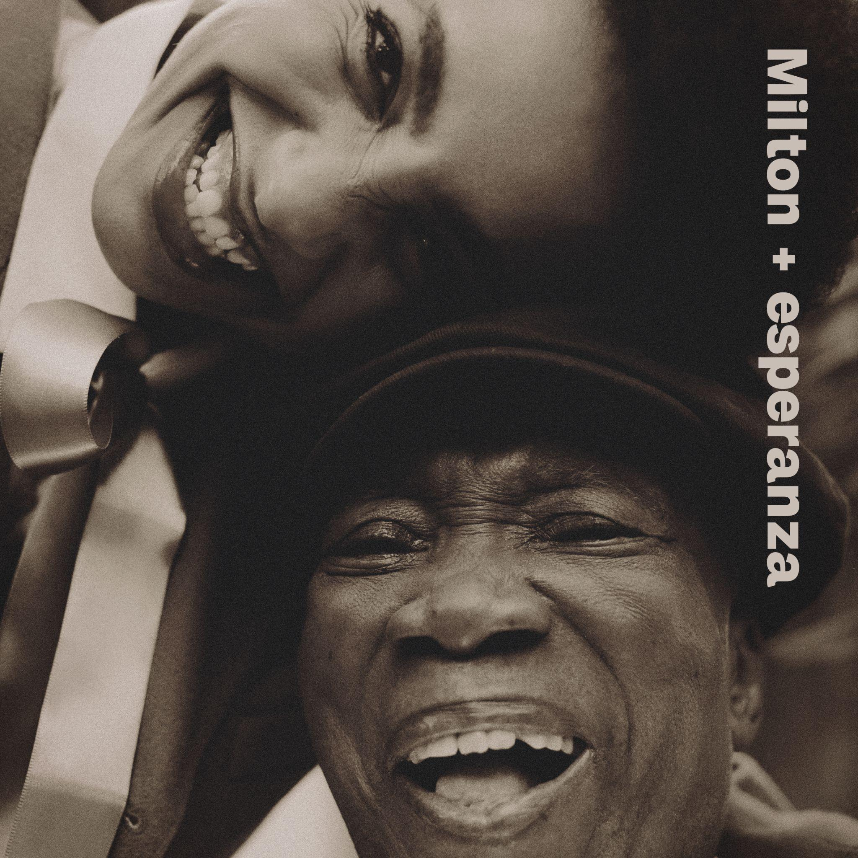

May 15, 2024 - - *Milton + esperanza* - a new album by Brazilian legend Milton Nascimento and decorated musician/composer esperanza spalding - will be released August 9 on Concord Records. Recorded in Brazil over the course of 2023, *Milton + esperanza* is a dream-come-true collaboration and musical representation of a friendship that was first kindled nearly 15 years ago. The album features 16 tracks that celebrate and reimagine five of Nascimento’s beloved classics, newly written originals by spalding, and fascinating interpretations of The Beatles’ “A Day In The Life” and Michael Jackson’s “Earth Song” among other works that lovingly explore the music of Brazil and far beyond. Special guest appearances include Paul Simon, Dianne Reeves, Lianne La Havas, Maria Gadú, Tim Bernardes, Carolina Shorter, Shabaka Hutchings and more. *Milton + esperanza* sparkles with duets between these two iconic voices, exquisite musicianship and what spalding identifies as a central theme of the album: the importance of younger generations creating with, learning from, and building new worlds with elders.

**Listen to "Outubro" Here:** [**https://found.ee/Milton-esperanza**](https://found.ee/Milton-esperanza)

**Watch Album Trailer Here:** [**https://found.ee/Me_AlbumTrailer**](https://found.ee/Me_AlbumTrailer)

Milton Nascimento is a once-in-a-generation talent, the pride of Brazil and beloved across the globe. The Brazilian pop vocalist Elis Regina once declared that “if God had a voice, it would be Milton’s.” Nascimento began making records in the late ‘60s and was immediately recognized as an evocative lyricist—his subject matter encompasses protest songs and the natural world; songs of friendship, love, and racial harmony—with the brilliant ability to create unpredictable melodies, textures, and harmonics.

Nascimento’s music has influenced generations of talents; including a young spalding, who first heard his music while hosting a dinner party with Brazilian friends. One of her guests put on *Native Dancer*, Nascimento’s 1975 collaboration with saxophonist and composer Wayne Shorter. “I get chills even thinking about it,” she says. It was a life-changing moment: “Ninety percent of things I write, I’m thinking of him. I’m thinking of his voice. I’m imagining singing it with him. He’s a very present part of my creative imagination.”

A dream that spalding never would have expected to come true, they met in Brazil and a friendship was formed (thanks in part to an introduction made by Herbie Hancock). Their first collaboration would be on spalding’s 2010 release *Chamber Music Society*, with Nascimento singing on “Apple Blossom.”

*Milton + esperanza* was made throughout 2023 and is produced, arranged and executive produced by spalding. Though some work was done in the States, much of the recording happened in Rio; authenticity and connection are crucial to the project. It features spalding’s core band of Matthew Stevens (guitar), Justin Tyson and Eric Doob (drums), Leo Genovese (piano), Corey D. King (vocals, synths), and several Brazilian musicians, including Orquestra Ouro Preto, percussionists Kainã Do Jêje and Ronaldinho Silva, and Lula Galvão and Guinga on guitar.

“Outubro,” originally from 1969 and released on *Courage*, is the oldest song of Nascimento’s on *Milton + esperanza*, and one of his most emotionally forceful. A truly soaring duet, it showcases just how dynamic the voices of Nascimento and spalding are as they swirl together. “Cais” is another towering entry in Nascimento’s catalog, featured on his 1972 double album *Clube Da Esquina*. Synthesizing the kaleidoscopic pop ambitions of the Beatles, the exploratory jazz of John Coltrane and Miles Davis, Western classical, and Indigenous Brazilian music, *Clube Da Esquina* is the kind of masterpiece that music lovers pass amongst themselves. It was awarded a 9.5 by Pitchfork in one of their coveted Sunday Reviews in 2018, deemed “one of the most ambitious albums in Brazilian history.”

spalding originals on the album include the exuberant “Wings for the Thought Bird” and “Get It By Now,” fresh additions to her ever-evolving catalog of dextrous work that both challenges and delights. Mystic interludes capture Nascimento and spalding in conversation, and on the opening track, sharing a deep joyful laugh that sets the tone for this celebratory album. It concludes with an expansive 9-minute take on Wayne Shorter’s “When You Dream,” from his 1985 release *Atlantis*. Featuring his wife Carolina Shorter, it’s a powerful and emotional bookend to a project that sought inspiration in connecting with our elders, as well as a way to honor Shorter, spalding’s mentor and collaborator who passed away in 2021.

*Milton + esperanza* is spalding’s first new album release since 2021's *songwrights apothecary lab*, which along with 2019’s *12 Little Spells,* both won GRAMMY Awards (Best Jazz Vocal Album). Last year spalding released a protest song entitled “Não Ao Marco Temporal” that was recorded in Rio and addresses the Temporal Framework, an initiative in Brazil that threatens Indigenous Brazilians’ land rights and poses a major risk to the Amazon rainforest. A 5-time GRAMMY winner and 11-time nominee, spalding has previously released 8 full length albums and in addition to working with her heroes including Nascimento and Shorter, she has collaborated with Q-Tip, Janelle Monae, Robert Glasper, Terri Lyne Carrington and many others. As a composer her credits include writing the libretto for the opera *Iphigenia* with Wayne Shorter, which premiered in 2021. She is also a philanthropist and advocate, and is currently working to create a BIPOC artist sanctuary in her hometown of Portland, OR.

spalding has also just announced her first major tour since 2019 with dates scheduled throughout 2024, as well as a 12-night residency at the Blue Note in New York City in February and March of 2025. Nascimento and spalding don’t currently plan on doing a tour to support the record; these performances feature esperanza with her band. Tickets are on sale now, see below for the full itinerary.

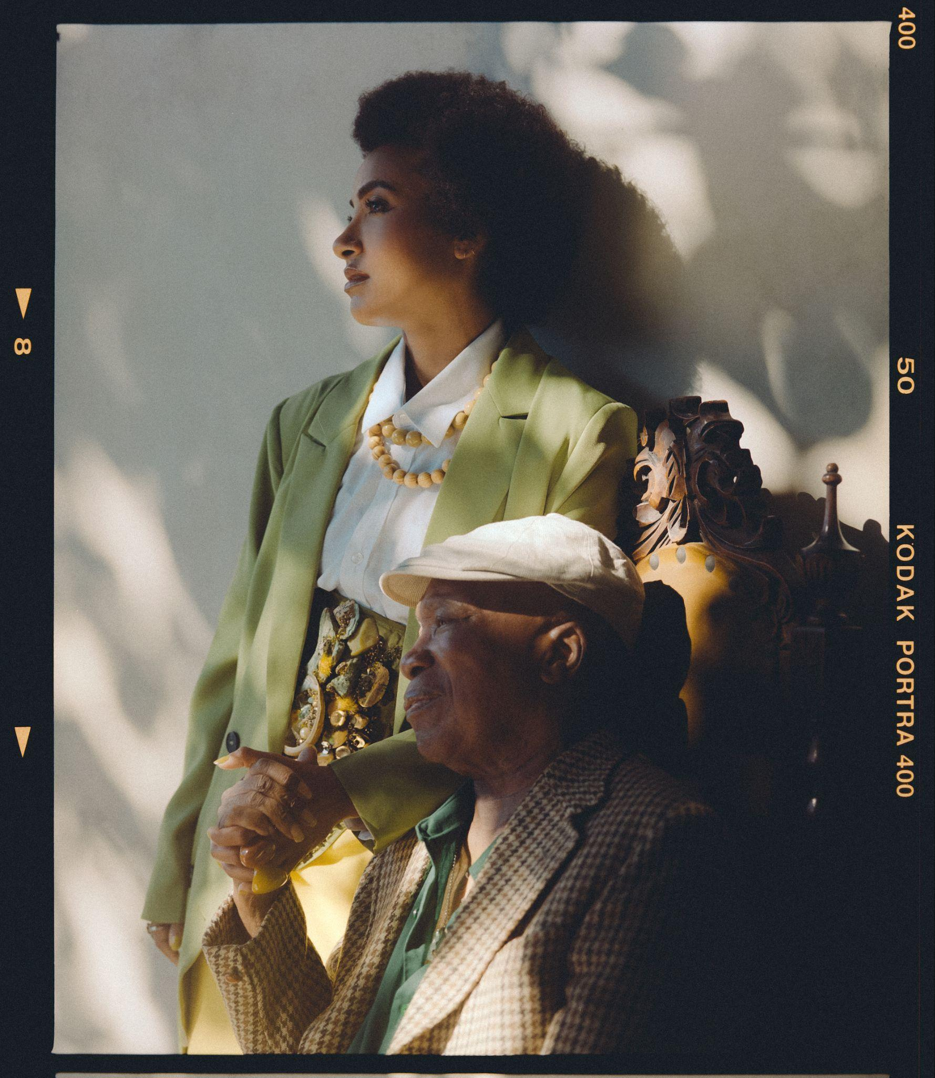

[Credit: Pedro Napolinário]

Pre-order: <https://found.ee/Milton-esperanza>

Official Artist Store (limited edition vinyl): <https://found.ee/Milton-esperanzaStore>

Shore Fire client page: <https://shorefire.com/roster/esperanza-spalding>

Esperanza website: [esperanzaspalding.com](http://www.esperanzaspalding.com/)

**Track List:**

1. the music was there
2. Cais
3. Late September
4. Outubro
5. A Day in the Life
6. Interlude for Saci
7. Saci (featuring Guinga)
8. Wings for the Thought Bird (featuring Elena Pinderhughes and Orquestra Ouro Preto)
9. The Way You Are
10. Earth Song (featuring Dianne Reeves)
11. Morro Velho (featuring Orquestra Ouro Preto)
12. Saudade Dos Aviões Da Panair (Conversando No Bar) (featuring Lianne La Havas, Maria Gadú, Tim Bernardes, Lula Galvão)
13. Um Vento Passou (para Paul Simon) (featuring Paul Simon)
14. Get It By Now
15. outra planeta
16. When You Dream (featuring Carolina Shorter)

**2024 U.S. esperanza spalding Tour Dates**

5/26 - Columbus, OH - Ohio Black Expo

6/1 - Ridgefield, CT - The Ridgefield Playhouse

6/2 - Princeton, NJ - McCarter Theatre Center

6/3 - Camden, NJ - Wiggins Waterfront Park

8/1 - Los Angeles, CA - Luckman Theatre

8/2 - Oakland, CA - Fox Theater

8/3 - Portland, OR - Vanport Jazz Festival

8/4 - Seattle, WA - Benaroya Hall

8/9 - Phoenix, AZ - Celebrity Theater

8/10 - Rio Rancho, NM - Rio Rancho Events Center

9/13 - Cincinnati, OH - Taft Theatre

9/14 - Indianapolis, IN - Murat Theatre

9/15 - St. Louis, MO - Music at the Intersection (Festival)

9/16 - Skokie, IL - North Shore Center for the Performing Arts

9/17 - Milwaukee, WI - Marcus Performing Arts Center

11/13 - New Orleans, LA - Orpheum Theater

11/14 - Austin, TX - Paramount Theatre

11/15 - Stillwater, OK - The McKnight Center for the Performing Arts

11/16 - Salina, KS - The Stiefel Theatre

###

For more information, please contact Chris Taillie and Casey Hansen at Shore Fire Media

[ctaillie@shorefire.com](mailto:ctaillie@shorefire.com)

[chansen@shorefire.com](mailto:chansen@shorefire.com)