**Preview “Set It Free”** [**HERE**](https://cmg.concordrep.com/play/37983/5b34d7331b47166df5d09a75ceba19afbdd82ebf/) **(DO NOT PUBLISH OR SHARE)**

**Visualizer** [**HERE**](https://drive.google.com/drive/folders/1wifB4iTKD1oPfIO-Wq9l8Ov_np4M3vdZ)

August 15th, 2024

**FOR IMMEDIATE RELEASE**

[judy@motormouthmedia.com](mailto:judy@motormouthmedia.com)

**NUBYA GARCIA**

**SHARES SINGLE**

**“SET IT FREE” FEAT. RICHIE**

**LISTEN** [**HERE**](https://odyssey.nubyagarcia.com/ClarityYT)

**NEW ALBUM**

***ODYSSEY***

**OUT 9/20 VIA CONCORD JAZZ**

**PRE-SAVE/PRE-ORDER *ODYSSEY*** [**HERE**](https://odyssey.nubyagarcia.com/Odyssey)

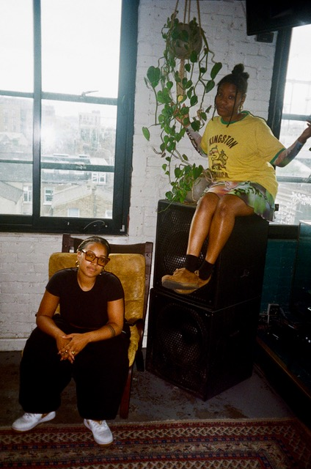

**Credit: Marina Garvey Birch, Hi-Res** [**HERE**](https://www.dropbox.com/scl/fo/ssn5w8tv89y1e6q1nsgvs/AHhyYR13__w7bfgmm9LWhic?rlkey=u9zvu7t3q79v219hcras1qbg4&st=khdraihb&dl=0)

Today, London-born saxophonist, composer, and bandleader **Nubya Garcia** shares new track **“Set It Free” feat Richie**. The new track follows earlier singles **“**[**Clarity**](https://www.youtube.com/watch?v=fnT9n81iP7w)**”** and **“**[**The Seer**](https://youtu.be/cZwK9M0CIow?si=EtEMQfzhmMwenncL)**”** from her forthcoming new album, ***Odyssey***, which arrives **September 20th** on **Concord Jazz**.

“Set It Free,” featuring vocalist Richie Seivwright of KOKOROKO, conveys the feeling of letting go. A neo-soul-centered tune, Richie doesn’t apologize for being one-of-one. “No other like me,” she asserts near the top of the song. “I’m sorry I’m not sorry, truth is what I speak,” she sings later. It conveys the sense of being confident and not apologizing for your greatness.

**Listen to “Set It Free” feat. Richie** [**HERE**](https://odyssey.nubyagarcia.com/ClarityYT)

**Pre-save/Pre-order *Odyssey*** [**HERE**](https://odyssey.nubyagarcia.com/Odyssey)

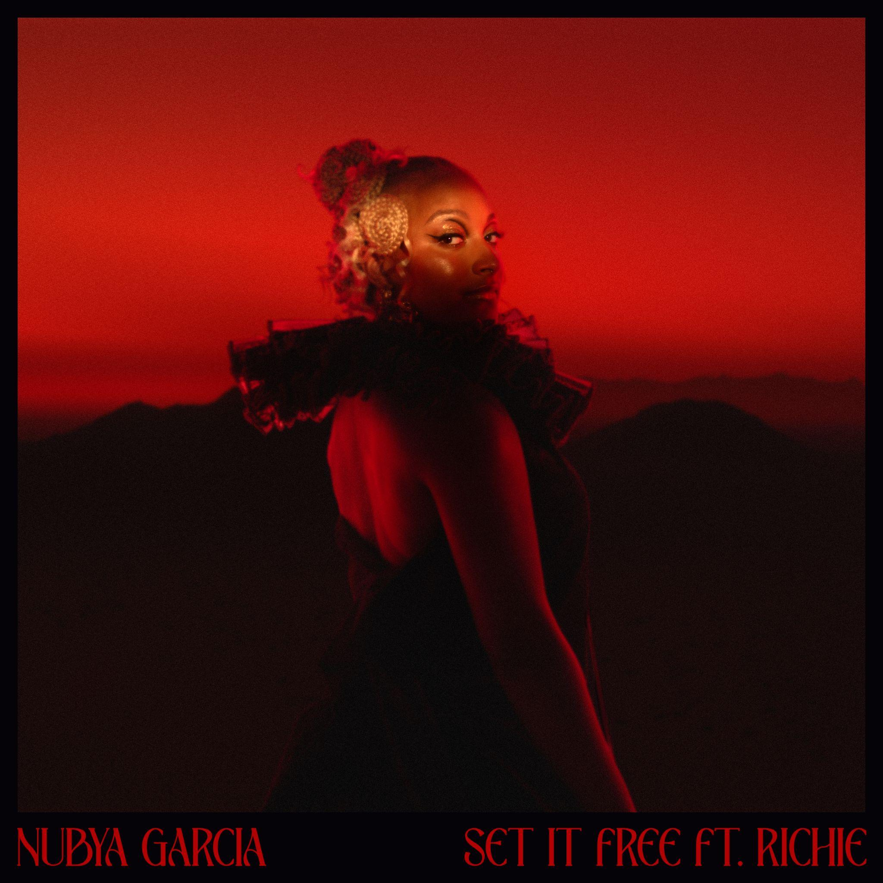

**“Set It Free” artwork, Hi-Res** [**HERE**](https://www.dropbox.com/scl/fo/0gsjij17xv7z05cfvvl1g/ABKbPc5dglZZmIh3wzY37Jc?rlkey=gha05fmoale4jxja91smhtbym&st=98d7hugt&dl=0)

Set to be released on 20th September via Concord Jazz, *Odyssey* is, as the title suggests, an ambitious, epic journey of an album. In a largely male-dominated scene, Garcia has carved herself a prominent space and she invites other brilliant Black women musicians to join her on this adventure, namely: **esperanza** **spalding**, **Richie** **Seivwright**, and **Georgia** **Anne** **Muldrow**. *Odyssey* is produced by Garcia and returning collaborator **Kwes**.

Describing *Odyssey*, Garcia says; *“It represents the notion of truly being on your own path, and trying to discard all the outside noise saying you should go this way or that way.”* It’s also inspired by life’s ever-changing, ever-continuing adventure, the twists and turns of living. Musically, the album finds Garcia orchestrating strings for the first time, having fallen back in love with composition and then studying a vast array of orchestral sounds. The bigger, bolder result is a widescreen soundscape that traverses jazz, classical, R&B and dub. Following Garcia’s widely celebrated and **Mercury Music Prize** nominated 2020 debut, ***Source***, the forthcoming album *Odyssey* is available to pre-save and pre-order [here](https://odyssey.nubyagarcia.com/Odyssey), and the artwork and track list are included below.

Nubya Garcia is a multi award-winning artist. She has toured extensively, playing venues and festivals across Latin America, Asia, Europe, Australia, and the United States. Her reputation as a DJ is also burgeoning; she helmed a popular radio residency on NTS, and plays a growing number of live sets across Europe. Garcia has collaborated with major brands such as Lululemon, Paul Smith, Labrum, Nicholas Daley and Burberry, and as a composer, her original music has been placed with Apple TV (*Ted Lasso*); OWN Network (*Cherish The Day*); FX TV (*Atlanta*); EPIC GAMES (*Fortnite*); and on multiple podcasts (including the theme tune for Anika Noni Rose’s Clio award-winning podcast *Being Seen*).

**Preorder/save *Odyssey*** [**HERE**](https://odyssey.nubyagarcia.com/Odyssey)

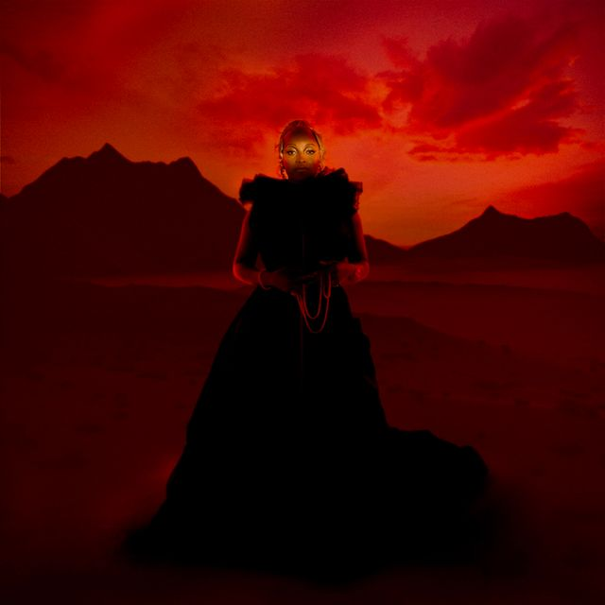

**LP Art, Hi-Res** [**HERE**](https://www.dropbox.com/scl/fo/ssn5w8tv89y1e6q1nsgvs/AHhyYR13__w7bfgmm9LWhic?rlkey=u9zvu7t3q79v219hcras1qbg4&st=wkrnfrf9&dl=0)

**Nubya Garcia / *Odyssey* (Concord)**

**Tracklist**

1. Dawn feat. esperanza spalding

2. Odyssey

3. Solstice

4. Set It Free feat. Richie

5. The Seer

6. Odyssey (Outerlude)

7. We Walk In Gold feat. Georgia Anne Muldrow

8. Water’s Path

9. Clarity

10. In Other Words, Living

11. Clarity (Outerlude)

12. Triumphance

**NUBYA GARCIA ONLINE**

[**INSTAGRAM**](https://www.instagram.com/nubya_garcia/?hl=en) **/** [**X**](https://twitter.com/nubya_garcia) **/** [**BANDCAMP**](https://nubyagarcia.bandcamp.com/) **/** [**FACEBOOK**](https://www.facebook.com/nubyagarciamusic/) **/** [**WEBSITE**](https://www.nubyagarcia.com/)