**Listen ONLY Link for “**[**Clarity**](https://s.disco.ac/vsfdykezkbjo)**”**

**Video preview of “Clarity”** [**HERE**](https://www.youtube.com/watch?v=fnT9n81iP7w&ab_channel=NubyaGarcia)

EMBARGO: 5 am PST

July 11th, 2024

**FOR IMMEDIATE RELEASE**

[judy@motormouthmedia.com](mailto:judy@motormouthmedia.com)

**NUBYA GARCIA**

**SHARES SINGLE**

**“CLARITY”**

**LISTEN** [**HERE**](https://odyssey.nubyagarcia.com/ClarityYT)

**NEW ALBUM**

***ODYSSEY***

**OUT 9/20 VIA CONCORD JAZZ**

**PRE-SAVE/PRE-ORDER *ODYSSEY*** [**HERE**](https://odyssey.nubyagarcia.com/Odyssey)

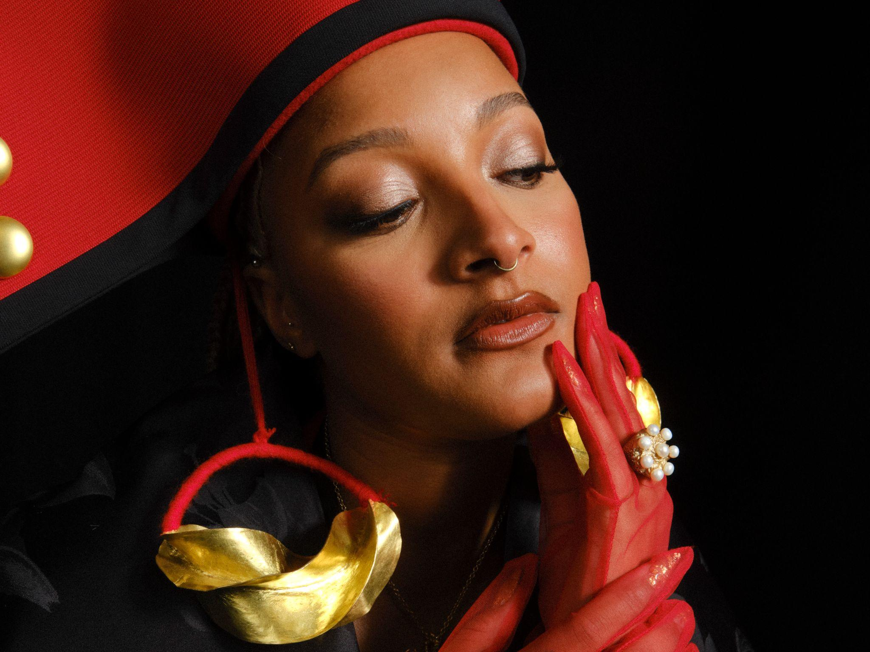

**Credit: Danika Lawrence, Hi-Res** [**HERE**](https://www.dropbox.com/scl/fo/ssn5w8tv89y1e6q1nsgvs/AHhyYR13__w7bfgmm9LWhic?rlkey=u9zvu7t3q79v219hcras1qbg4&st=khdraihb&dl=0)

Today, London-born saxophonist, composer and bandleader **Nubya Garcia** shares a gorgeous new single, **“Clarity,”** following last month’s lead track, **“The Seer,”** from her forthcoming new album, ***Odyssey***, which arrives **September 20th** on **Concord Jazz**.

The song “Clarity” is about wanting to find transparency during encounters with other people. Garcia communicates this through delicate, unfurling strings meant to uplift your mood. “*Clarity is created, it’s not passive,”* says Garcia.  *“It takes continued communication and honesty - with yourself, with others, with whatever you choose to apply it to.”*

**Listen to “Clarity”** [**HERE**](https://odyssey.nubyagarcia.com/ClarityYT)

**Pre-save/Pre-order *Odyssey*** [**HERE**](https://odyssey.nubyagarcia.com/Odyssey)

Set to be released on 20th September via Concord Jazz, *Odyssey* is, as the title suggests, an ambitious, epic journey of an album. In a largely male-dominated scene, Garcia has carved herself a prominent space and she invites other brilliant Black women musicians to join her on this adventure, namely: **esperanza** **spalding**, **Richie** **Seivwright**, and **Georgia** **Anne** **Muldrow**. *Odyssey* is produced by Garcia and returning collaborator **Kwes**.

Describing *Odyssey*, Garcia says; *“It represents the notion of truly being on your own path, and trying to discard all the outside noise saying you should go this way or that way.”* It’s also inspired by life’s ever-changing, ever-continuing adventure, the twists and turns of living. Musically, the album finds Garcia orchestrating strings for the first time, having fallen back in love with composition and then studying a vast array of orchestral sounds. The bigger, bolder result is a widescreen soundscape that traverses jazz, classical, R&B and dub. Following Garcia’s widely celebrated and **Mercury Music Prize** nominated 2020 debut, ***Source***, the forthcoming album *Odyssey* is available to pre-save and pre-order [here](https://odyssey.nubyagarcia.com/Odyssey), and the artwork and track list are included below.

Nubya Garcia is a multi award-winning artist. She has toured extensively, playing venues and festivals across Latin America, Asia, Europe, Australia, and the United States. Her reputation as a DJ is also burgeoning; she helmed a popular radio residency on NTS, and plays a growing number of live sets across Europe. Garcia has collaborated with major brands such as Lululemon, Paul Smith, Labrum, Nicholas Daley and Burberry, and as a composer, her original music has been placed with Apple TV (*Ted Lasso*); OWN Network (*Cherish The Day*); FX TV (*Atlanta*); EPIC GAMES (*Fortnite*); and on multiple podcasts (including the theme tune for Anika Noni Rose’s Clio award-winning podcast *Being Seen*).

**Preorder/save *Odyssey*** [**HERE**](https://odyssey.nubyagarcia.com/Odyssey)

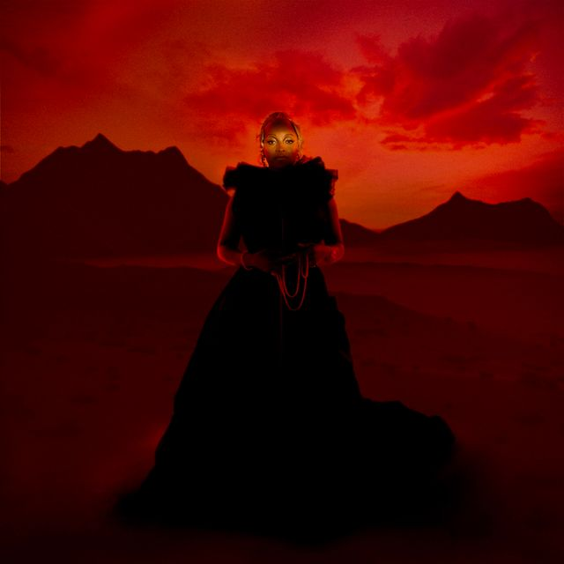

**LP Art, Hi-Res** [**HERE**](https://www.dropbox.com/scl/fo/ssn5w8tv89y1e6q1nsgvs/AHhyYR13__w7bfgmm9LWhic?rlkey=u9zvu7t3q79v219hcras1qbg4&st=wkrnfrf9&dl=0)

**Nubya Garcia / *Odyssey* (Concord)**

**Tracklist**

1. Dawn feat. esperanza spalding

2. Odyssey

3. Solstice

4. Set It Free feat. Richie

5. The Seer

6. Odyssey (Outerlude)

7. We Walk In Gold feat. Georgia Anne Muldrow

8. Water’s Path

9. Clarity

10. In Other Words, Living

11. Clarity (Outerlude)

12. Triumphance

**NUBYA GARCIA ONLINE**

[**INSTAGRAM**](https://www.instagram.com/nubya_garcia/?hl=en) **/** [**X**](https://twitter.com/nubya_garcia) **/** [**BANDCAMP**](https://nubyagarcia.bandcamp.com/) **/** [**FACEBOOK**](https://www.facebook.com/nubyagarciamusic/) **/** [**WEBSITE**](https://www.nubyagarcia.com/)