***Milton + esperanza* Out Today (Concord Records)**

**Full-Length Album Collaboration Between Brazilian Musical Icon Milton Nascimento and Decorated Musician/Composer esperanza spalding**

**Featuring Guests Paul Simon, Dianne Reeves, Lianne La Havas, Tim Bernardes, Maria Gadú, Guinga and More; Produced by esperanza spalding**

**Listen to "A Day in the Life" Here:**

[**https://found.ee/Milton-esperanza**](https://found.ee/Milton-esperanza)

**Watch Milton Nascimento & esperanza spalding discuss their new album**

***Milton + esperanza*** [**https://found.ee/Miltonesperanza_shortfilm**](https://found.ee/Miltonesperanza_shortfilm)

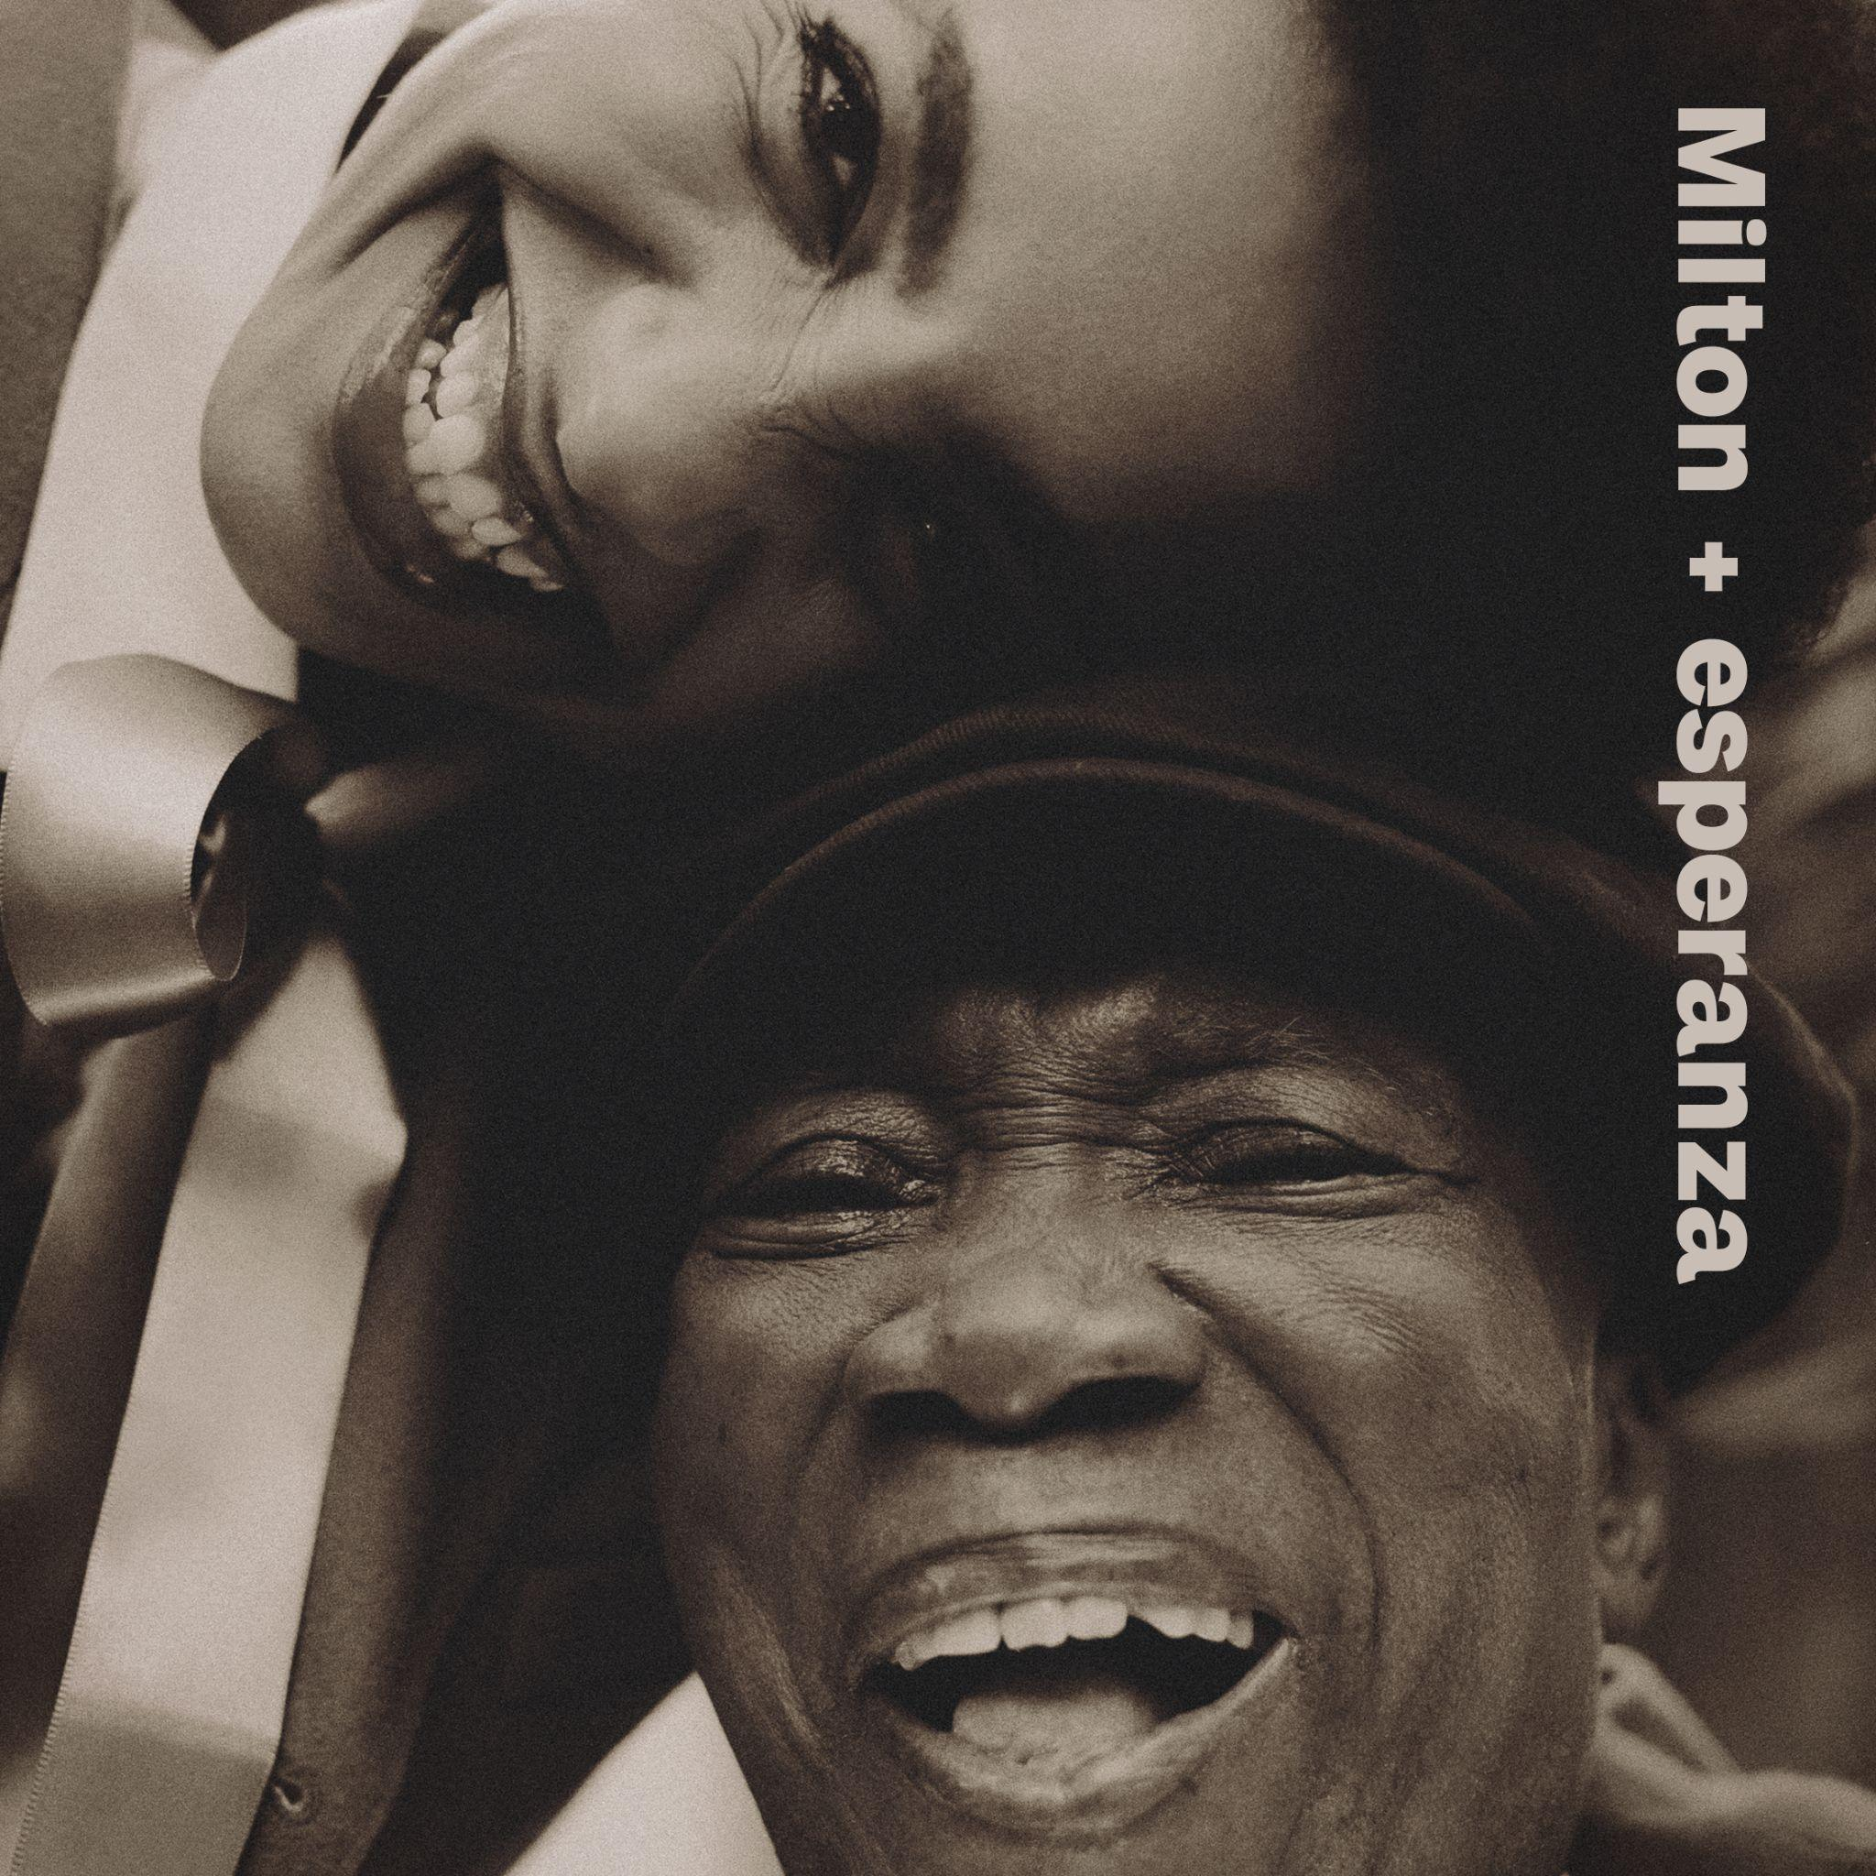

“*The affection between Nascimento and Spalding is palpable*” — **New York Times**

*“These two voices just sound heavenly together”* **— NPR**

*“A quixotic affair”* **— The Guardian**

*"An episodic, strikingly impressionistic album"* **— Rolling Stone**

*“Destined to be a remarkable project”* **— BET**

“*This might just be the biggest collaborative project of the year”* - **WXPN**

*“A dream-like realm of folkloric myth, plugged into nature’s heartbeat”* **— Uncut**

**August 9, 2024** - - Milton Nascimento and esperanza spalding have released their collaborative album, *Milton + esperanza,* today. Recorded in Brazil throughout 2023 and produced and arranged by spalding, the recordis a dream-come-true collaboration. It serves as a beautiful musical expression of a friendship that began nearly 15 years ago. The album has been met with early raves including a profile of the duo in [**New York Times**](https://www.nytimes.com/2024/08/01/arts/music/milton-nascimento-esperanza-spalding.html), an interview on **NPR’s Morning Edition**, a performance together for NPR’s [**Tiny Desk**](https://www.youtube.com/watch?v=jFUhTmOSdGQ&feature=youtu.be), and additional interviews in [**Rolling Stone**](https://www.rollingstone.com/music/music-latin/milton-nascimento-esperanza-spalding-album-1235075452/), [**SPIN**](https://www.spin.com/2024/08/esperanza-spalding-interview/)**,** and much more

**Listen to the duo’s interpretation of The Beatles’ "A Day in the Life" Here:** [**https://found.ee/Milton-esperanza**](https://found.ee/Milton-esperanza)

**Watch Milton Nascimento & esperanza spalding discuss their**

**new album *Milton + esperanza***

[**https://found.ee/Miltonesperanza_shortfilm**](https://found.ee/Miltonesperanza_shortfilm)

"The moment when I asked, 'Which songs do you want on this album?' He [Milton] said 'A Paul McCartney song.' And we couldn't remember the name. I remember that. Milton had a book at his house with every Paul McCartney song, we were looking for this song title that no one could remember. We read through every song. 'A Day in the Life', finally. In the original version, in the bridge Paul McCartney is singing solo and I thought, 'We can't sing this. We can't. 'It's so 'signature'… It's very crazy. Our version is very wild. It's beautiful, and very intentionally untethered." - **esperanza spalding**

The album was announced in May along with the release of [**“**](https://streaklinks.com/CC9tG_boqOHgqErrtA4ACepf/https://www.youtube.com/watch)[**Outubro**](https://streaklinks.com/CC9tG_XCQiQfY-YeyAXbD6hk/https://www.youtube.com/watch)[**,”**](https://streaklinks.com/CC9tG_LTExbRzPWiYg0FBKXW/https://www.youtube.com/watch) and covered enthusiastically by the NY Times, Pitchfork, The Fader, Stereogum and beyond. Since then, the duo released their collaboration with Paul Simon, “[**Um Vento Passou (para Paul Simon)**](https://streaklinks.com/CC9tHAECwl5mB_lFQwaSVPIW/https://www.youtube.com/watch),”for which Simon learned the Portuguese lyrics as well as "[**Saudade Dos Aviões Da Panair (Conversando No Bar)**](https://www.youtube.com/watch?v=mpe-JuLQJEo&feature=youtu.be)" featuring Lianne La Havas, Maria Gadú, Tim Bernardes, Lula Galvão.

*Milton + esperanza* features 16 tracks that celebrate and reimagine Nascimento’s beloved classics, new pieces written by spalding with Nascimento in mind, and interpretations of The Beatles’ “A Day in the Life” and Michael Jackson’s “Earth Song.” Guests include Dianne Reeves, Lianne La Havas, Maria Gadú, Tim Bernardes, Carolina Shorter, Elena Pinderhughes, Shabaka Hutchings, Guinga and more. The album features spalding’s core band of Matthew Stevens (guitar), Justin Tyson and Eric Doob (drums), Leo Genovese (piano), Corey D. King (vocals, synths), and several Brazilian musicians, including Orquestra Ouro Preto, percussionists Kainã Do Jêje and Ronaldinho Silva and Lula Galvão.

“It’s like a magic, that you know when it’s happening, and you can help make it happen. It’s like you can invite it to come visit you. You can invite it to come through you. And it’s magic, that I guess, I’m always hoping will descend, you know, into the music. The whole time I was always praying for the album to feel like a big ship, that’s traveling through the cosmic waters of the world. And the ship is going so smooth, and you’re [Milton] standing at the back going like this, “Wa, wa.” Like throwing magic out from your hands to everybody who’s seen the boat go by. And I wanted the album to feel like that, to feel like this magical wow-thing going by; and after it passes, you just feel like wow. That was the inspiration for the album.” – **esperanza spalding**

*Milton + esperanza* sparkles with duets between these two voices, exquisite musicianship and what spalding identifies as a central theme of the album: the importance of younger generations creating with, learning from, and building new worlds with elders. A guiding spirit for the project was Wayne Shorter, whose collaboration with Nascimento, *Native Dancer*, was released nearly 50 years ago. “This was all about Wayne,” spalding stated in a recent interview with WRTI. “I think at the end of the day, he is that guiding light for both of us to dare and be expansive, and also go for broke.”

The genesis for this album goes back to the very first time spalding heard a Nascimento recording, at a dinner party when a friend put on Native Dancer. “I get chills even thinking about it,” she says.” “Ninety percent of things I write, I’m thinking of him. He’s a very present part of my creative imagination.” They would finally meet (thanks in part to an introduction made by Herbie Hancock) and began to collaborate, record and perform live together. In 2022, Nascimento, now 81, embarked on a farewell tour, and invited spalding to perform on a couple of shows. At dinner on the eve of her participation in Nascimento’s Boston performance, his son asked her to produce Nascimento’s next album. A dream had come true. She worked in Brazil throughout 2023 recording and producing the album.

*Milton + esperanza* is spalding’s first new album release since 2021's *Songwrights Apothecary Lab*, which along with 2019’s 12 *Little Spells*, both won GRAMMY Awards (Best Jazz Vocal Album). Last year spalding released a protest song entitled “Não Ao Marco Temporal” that was recorded in Rio and addresses the Temporal Framework, an initiative in Brazil that threatens Indigenous Brazilians’ land rights and poses a major risk to the Amazon rainforest. A 5-time GRAMMY winner and 11-time nominee, spalding has previously released 8 full-length albums and in addition to working with her heroes including Nascimento and Shorter, she has collaborated with Prince, Herbie Hancock, Janelle Monae, Robert Glasper, Terri Lyne Carrington and many others. As a composer, her credits include writing the libretto for the opera “...(Iphigenia)” with Wayne Shorter, which premiered in 2021. She is also a philanthropist and advocate, and currently co-directs a non-profit BIPOC artist sanctuary in her hometown of Portland, OR.

spalding is also touring this year, with dates scheduled throughout 2024, as well as a 12-night residency at the Blue Note in New York City in February and March of 2025. Nascimento and spalding haven't confirmed whether or not they will tour to support the record; these performances feature esperanza with her band. Tickets are on sale now, see below for the full itinerary.

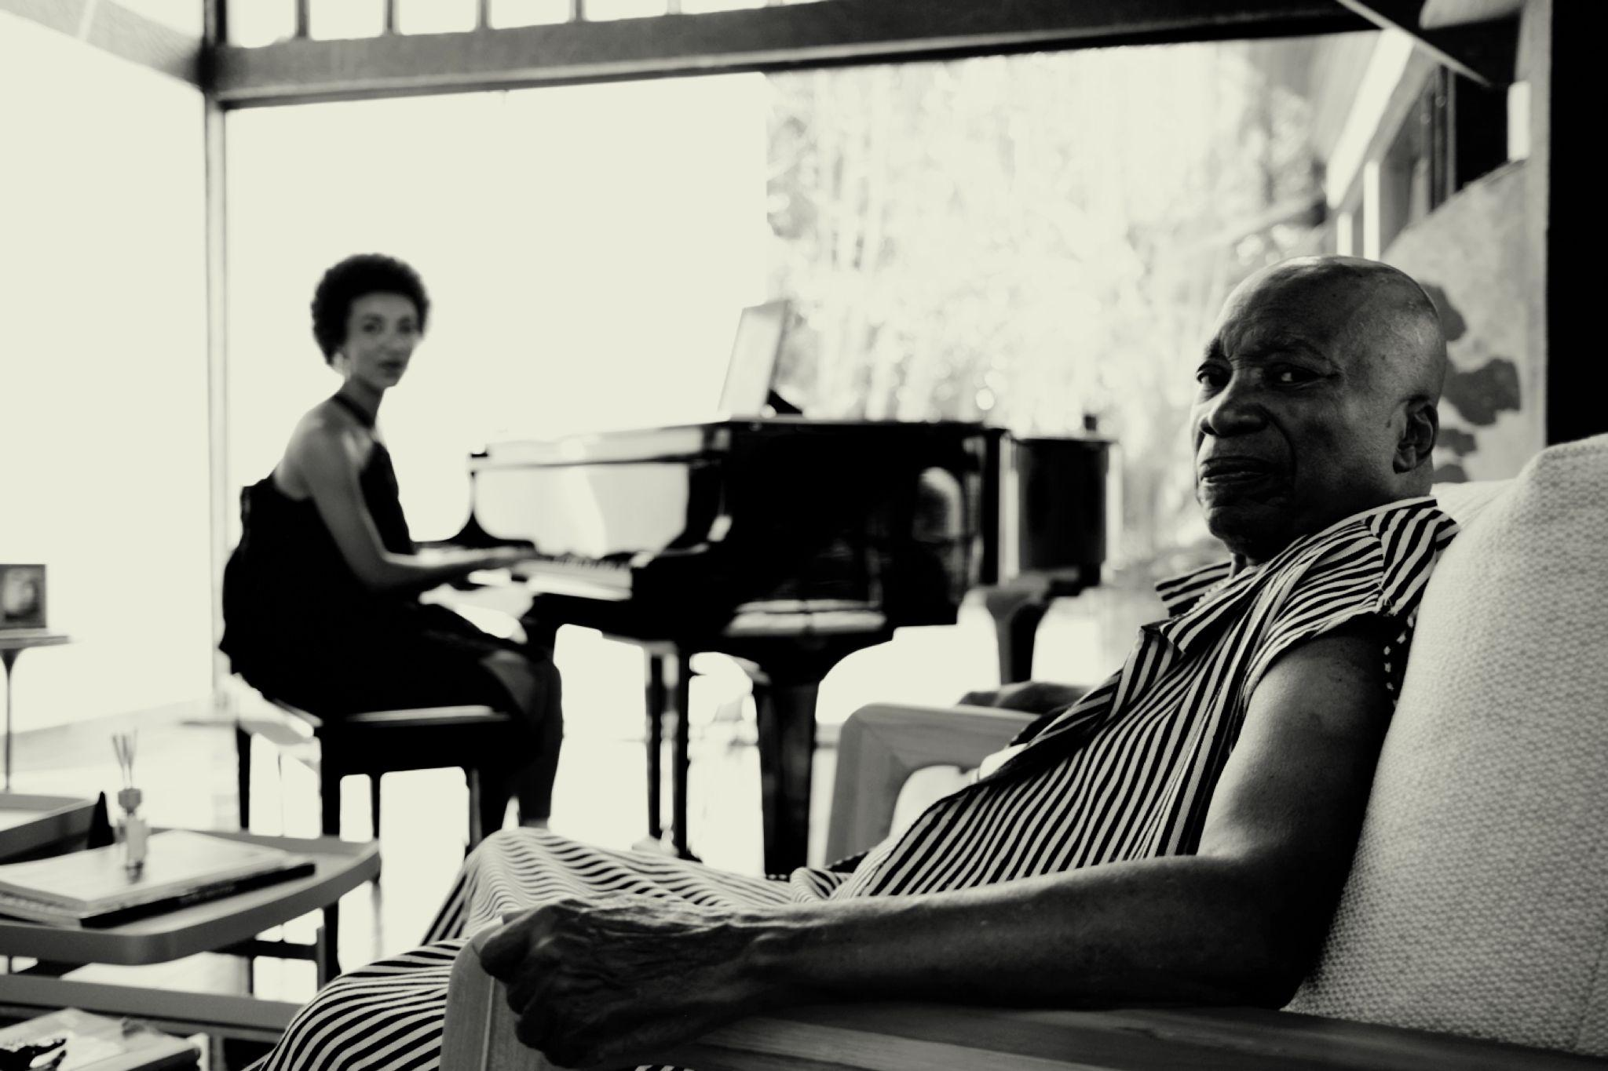

[Credit: Lucas Nogueira]

Official Artist Store (signed limited edition vinyl): <https://found.ee/Milton-esperanzaStore>

Shore Fire client page: <https://shorefire.com/roster/esperanza-spalding>

Esperanza website: [esperanzaspalding.com](http://www.esperanzaspalding.com/)

**Track List:**

1. the music was there
2. Cais
3. Late September
4. Outubro
5. A Day in the Life
6. Interlude for Saci
7. Saci (featuring Guinga)
8. Wings for the Thought Bird (featuring Elena Pinderhughes and Orquestra Ouro Preto)
9. The Way You Are
10. Earth Song (featuring Dianne Reeves)
11. Morro Velho (featuring Orquestra Ouro Preto)
12. Saudade Dos Aviões Da Panair (Conversando No Bar) (featuring Lianne La Havas, Maria Gadú, Tim Bernardes, Lula Galvão)
13. Um Vento Passou (para Paul Simon) (featuring Paul Simon)
14. Get It By Now
15. outro planeta
16. When You Dream (featuring Carolina Shorter)

**2024 U.S. esperanza spalding Tour Dates**

9/13 - Cincinnati, OH - Taft Theatre

9/14 - Indianapolis, IN - Murat Theatre

9/15 - St. Louis, MO - Music at the Intersection (Festival)

9/16 - Skokie, IL - North Shore Center for the Performing Arts

9/17 - Milwaukee, WI - Marcus Performing Arts Center

11/13 - New Orleans, LA - Orpheum Theater

9/19 - Madison, WI - Wisconsin Union Theater

10/24 - Subiaco, Australia - Regal Theatre

11/1 - 横浜市, 神奈川県, 日本 - ビルボードライブ横浜

11/3 - 港区, 東京都, 日本 - ビルボードライブ東京

11/4 - 港区, 東京都, 日本 - ビルボードライブ東京

11/13 - New Orleans, LA - Orpheum Theatre

11/14 - Austin, TX - Paramount Theatre

11/15 - Stillwater, OK - The McKnight Center for the Performing Arts

11/16 - Salina, KS - The Stiefel Theatre

2/4 - Fort Lauderdale, FL - Botti at Sea ‘25

###

For more information, please contact Chris Taillie and Casey Hansen at Shore Fire Media: [ctaillie@shorefire.com](mailto:ctaillie@shorefire.com)

[chansen@shorefire.com](mailto:chansen@shorefire.com)