Violinist and Dancer Lindsey Stirling Announces 2024 North American Duality Tour
Playing Iconic Venues like Los Angeles’ Greek Theatre, New York City’s Radio City Music Hall, Colorado’s Red Rocks Amphitheatre, Boston’s MGM Music Hall at Fenway & more

Support from Indie Pop Outfits Walk off the Earth and Saint Motel on Select Dates

New Album Duality out on June 14th via Concord Records

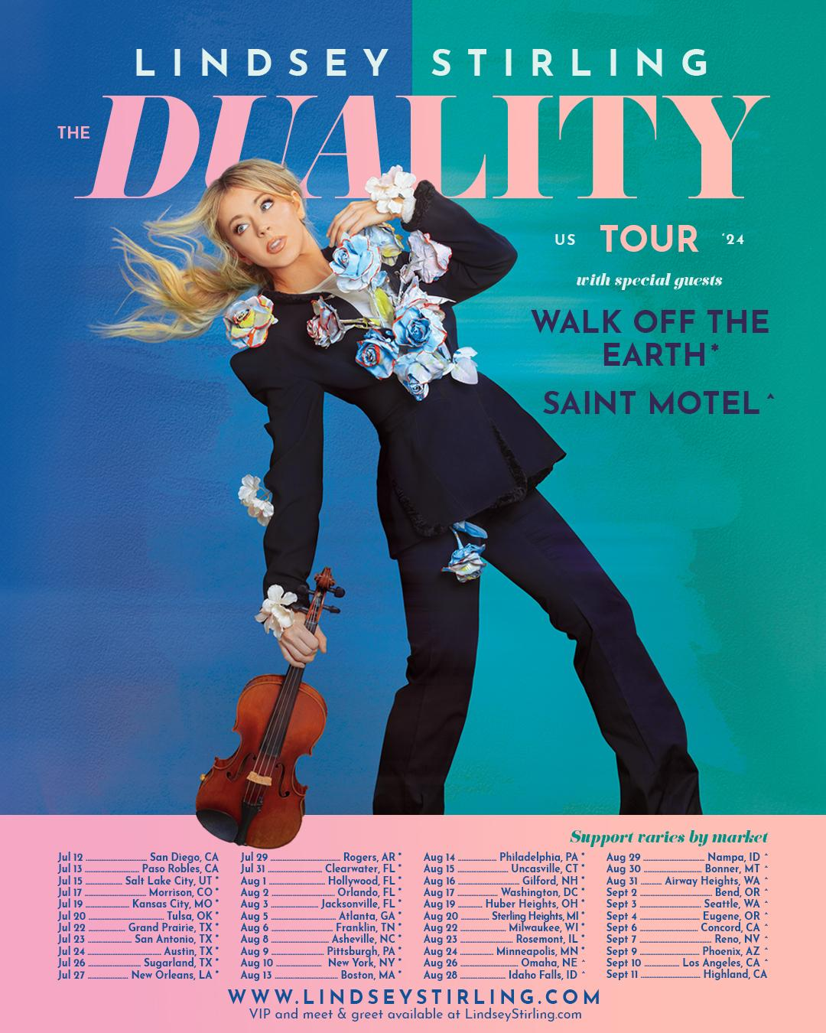

Monday, March 18 - Today, violinist, dancer, and entertainer extraordinaire Lindsey Stirling announces her North American Duality 2024 tour, set to kick off in San Diego, CA on July 12th and culminate in Highland, CA on September 11th.
In support of her forthcoming album, Duality (out June 14th via Concord Records) Lindsey will embark across the United States hitting 40+ cities, performing at iconic venues including New York City’s Radio City Music Hall, Boston’s MGM Music Hall at Fenway Park, Colorado’s Red Rocks Amphitheatre, Philadelphia’s The Met, Washington D.C.’s The Anthem, and more. Plus, she’ll close out the tour with a special hometown performance at Los Angeles’ Greek Theatre. Canadian indie pop band Walk off the Earth and LA-based indie pop band Saint Motel will perform as support for select dates. See full tour routing below.
Not only a multi-award-winning musician known for her genre-bending virtuosity on electronic violin, Lindsey has endlessly dazzled audiences with her extraordinary talents as a dancer—an element she brings to the stage as part of her spectacular live show.
Lindsey’s shows are eye-catching and inspiring. She seamlessly integrates intricate choreography, breathtaking aerial lyra acts, and stunning costumes, all of which she designs herself and seamlessly blends music, dance, and visual artistry into a singular, unforgettable experience, leaving audiences spellbound and inspired. Not to mention, she’s sold over 1M tickets throughout her career.
VIP on sale begins Tuesday, March 19th at 10:00 AM local time. CITI Cardmember presale begins Tuesday, March 19th at 10:00 AM local time. Artist presale begins Tuesday, March 19th at 12:00 PM local time. Local presale begins Thursday, March 21st at 10:00 AM local time. Public on sale is Friday, March 22nd at 10:00 AM local time.
Several VIP experiences will be available, including a Meet & Greet and intimate Q&A with Lindsey plus access to the Duality Pre-Show Experience complete with interactive photo opportunities, a gallery curated by Lindsey Stirling, and refreshments. All VIP packages include a reserved seat and exclusive merchandise. Learn more at LindseyStirlingVIP.com.
Get tickets here: https://www.lindseystirling.com/tour

Duality encompasses a dozen songs showcasing Stirling’s refined musicality and gift for sculpting deeply expressive melodies. But while the album’s first half centers on a grandiose and elaborate composed sound informed by Celtic music and other global influences, its latter half leans toward a boldly original form of left-of-center pop. A profoundly imaginative songwriter, Stirling makes brilliant use of each sonic setting by exploring intricate questions of intuition and truth.
More information about Duality here: https://shorefire.com/releases/entry/lindsey-stirling-announces-new-studio-album-duality-out-june-14th-via-concord-records

Watch the video for lead single “Eye of the Untold Her,” which serves as a journey through the kaleidoscope of Lindsey’s evolving personas and distinctive looks over the years here:
https://www.youtube.com/watch?v=rWwfyzX2OeM
2024 North American Duality Tour Routing:
Friday, July 12, 2024 - San Diego, CA - San Diego Civic Theatre
Saturday, July 13, 2024 - Paso Robles, CA - Vina Robles Amphitheatre
Monday, July 15, 2024 - Salt Lake City, UT - Maverik Center
Wednesday, July 17, 2024 - Morrison, CO - Red Rocks Amphitheatre
Friday, July 19, 2024 - Kansas City, MO - Starlight Theatre
Saturday, July 20, 2024 - Tulsa, OK - BOK Center
Monday, July 22, 2024 - Grand Prairie, TX - Texas Trust CU Theatre
Tuesday, July 23, 2024 - San Antonio, TX - Majestic Theatre
Wednesday, July 24, 2024 - Austin, TX - Moody Center ATX
Friday, July 26, 2024 - Sugar Land, TX - Smart Financial Centre
Saturday, July 27, 2024 - New Orleans, LA - Saenger Theatre
Monday, July 29, 2024 - Rogers, AR - Walmart AMP
Wednesday, July 31, 2024 - Clearwater, FL - The Sound
Thursday, August 1, 2024 - Hollywood, FL - Hard Rock Live
Friday, August 2, 2024 - Orlando, FL - Walt Disney Theater
Saturday, August 3, 2024 - Jacksonville, FL - Daily's Place
Monday, August 5, 2024 - Atlanta, GA - Cadence Bank Amphitheatre at Chastain Park
Tuesday, August 6, 2024 - Franklin, TN - FirstBank Amphitheater
Thursday, August 8, 2024 - Asheville, NC - ExploreAsheville.com Arena
Friday, August 9, 2024 - Pittsburgh, PA - Stage AE
Saturday, August 10, 2024 - New York, NY - Radio City Music Hall
Tuesday, August 13, 2024 - Boston, MA - MGM Music Hall at Fenway
Wednesday, August 14, 2024 - Philadelphia, PA - The Met Philadelphia presented by Highmark
Thursday, August 15, 2024 - Uncasville, CT - Mohegan Sun Arena
Friday, August 16, 2024 - Gilford, NH - BankNH Pavilion
Saturday, August 17, 2024 - Washington, DC - The Anthem
Monday, August 19, 2024 - Huber Heights, OH - The Rose Music Center at The Heights
Tuesday, August 20, 2024 - Sterling Heights, MI - Michigan Lottery Amphitheatre at Freedom Hill
Thursday, August 22, 2024 - Milwaukee, WI - Miller High Life Theatre
Friday, August 23, 2024 - Rosemont, IL - Rosemont Theatre
Saturday, August 24, 2024 - Minneapolis, MN - The Armory
Monday, August 26, 2024 - Omaha, NE - The Astro Amphitheater
Wednesday, August 28, 2024 - Idaho Falls, ID - Hero Arena at the Mountain America Center
Thursday, August 29, 2024 - Nampa, ID - Ford Idaho Center Amphitheater
Friday, August 30, 2024 - Bonner, MT - KettleHouse Amphitheater
Saturday, August 31, 2024 - Airway Heights, WA - Northern Quest Resort & Casino
Monday, September 2, 2024 - Bend, OR - Hayden Homes Amphitheater
Tuesday, September 3, 2024 - Seattle, WA - WAMU Theater
Wednesday, September 4, 2024 - Eugene, OR - Cuthbert Amphitheater
Friday, September 6, 2024 - Concord, CA - Toyota Pavilion at Concord
Saturday, September 7, 2024 - Reno, NV - Grand Sierra Resort and Casino
Monday, September 9, 2024 - Phoenix, AZ - Footprint Center
Tuesday, September 10, 2024 - Los Angeles, CA - Greek Theatre
Wednesday, September 11 2024 - Highland, CA - Yaamava’ Theater

ABOUT LINDSEY STIRLING
Few artists embody boundless creativity quite like Lindsey Stirling. Not only a multi-award-winning musician known for her genre-bending virtuosity on electronic violin, she’s endlessly dazzled audiences with her extraordinary talents as a dancer—an element she brings to the stage as part of her spectacular live show, touring with a stunning frequency and continually selling out iconic venues all around the world. Her groundbreaking vision has gained her millions of adoring fans worldwide, four Billboard chart-topping albums, and two Billboard Music Awards including Top Dance/Electronic Album for her third studio release, Brave Enough. Her holiday album, Warmer in Winter, catapulted to the #1 spot on Billboard, Amazon and iTunes Holiday Album charts upon release and lead single “Carol of the Bells” made history as the only instrumental song ever to reach the Top 10 at AC Radio. Also a New York Times bestselling author (and creator of her own comic book), the platinum-selling star felt compelled to push her boundaries even further for her seventh full-length effort, ultimately embracing a whole new level of freedom in her songwriting. A visionary meditation on inner wisdom, personal strength, and the ever-shifting nature of identity, Duality arrives as Stirling’s most sonically daring and emotionally complex album date. Lindsey has amassed over 27M million subscribers, nearly 3.5 billion views and 13.9M subscribers on YouTube, 4.8M million followers and 105M likes on Tik Tok, and over 500k user generated creations across Tik Tok and Instagram reels.

LINDSEY STIRLING ON THE WEB
WEBSITE
PRESS KIT
YOUTUBE
TIK TOK
INSTAGRAM
FACEBOOK
TWITTER

FOR MORE INFORMATION ON LINDSEY STIRLING, PLEASE CONTACT:
Rebecca Shapiro (rshapiro@shorefire.com)
Mikaela Duhs (mduhs@shorefire.com)
Becca Bloch (rbloch@shorefire.com)

