**Multi-Talented Artist Lindsey Stirling Releases Genre-Bending New Single Featuring Royal & The Serpent**

**New Album *Duality* out June 14th via Concord Records**

**Set to Embark On Her North American Duality Tour and Play Iconic Venues like Los Angeles’ Greek Theatre, New York City’s Radio City Music Hall, Red Rocks, Boston’s MGM Music Hall at Fenway & more**

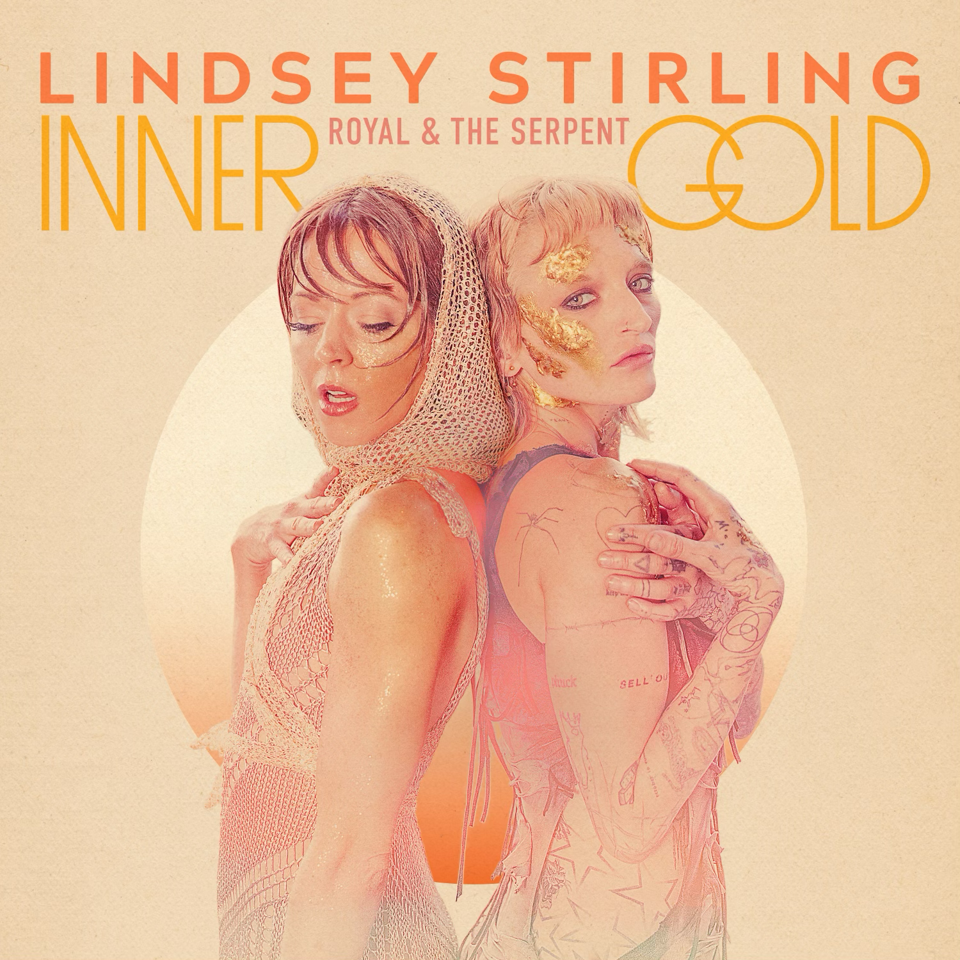

**Friday, April 12th** - Today, multi-talented violinist, dancer, and entertainer extraordinaire Lindsey Stirling releases her transcendent new single “Inner Gold” featuring the alt artist **Royal & the Serpent**. Featuring strutting rhythms, luminous textures, and the gorgeously strange vocals of Royal, “Inner Gold” tells the tale of suffering through deception and emerging with a renewed sense of self-reliance.

**Listen here:** <https://found.ee/LS_InnerGold>

The “Inner Gold” music video, which is also out today, sees Lindsey and Royal donning intricate burnt orange costumes and lots of glitter at a dance tryout, encouraging viewers to follow their inner gold.

**Watch here:** <https://found.ee/LS_InnerGoldVideo>

*Duality* (out June 14th via Concord Records) encompasses a dozen songs showcasing Stirling’s refined musicality and gift for sculpting deeply expressive melodies. But while the album’s first half centers on a grandiose and elaborate composed sound informed by Celtic music and other global influences, its latter half leans toward a boldly original form of left-of-center pop. A profoundly imaginative songwriter, Stirling makes brilliant use of each sonic setting by exploring intricate questions of intuition and truth. More information [here](https://shorefire.com/releases/entry/lindsey-stirling-announces-new-studio-album-duality-out-june-14th-via-concord-records).

“Inner Gold” is the second release off Lindsey’s new album, *Duality*, and the counterpart song to recently released single “Eye Of The Untold Her.” While both songs are about trusting an inner voice, “Eye Of The Untold Her” explores intuition, “Inner Gold” traverses knowledge.

Not only a multi-award-winning musician known for her genre-bending virtuosity on electronic violin, Lindsey has endlessly dazzled audiences with her extraordinary talents as a dancer—an element she brings to the stage as part of her spectacular live show.

This summer, Lindsey will embark across the United States hitting 40+ cities, performing at iconic venues including New York City’s Radio City Music Hall, Red Rocks, Boston’s MGM Music Hall at Fenway Park, Philadelphia’s The Met, Washington D.C.’s The Anthem. Plus, she’ll close out the tour with a special hometown performance at Los Angeles’ Greek Theatre. Canadian indie pop band Walk off the Earth and LA-based indie pop band Saint Motel will perform as support for select dates. See full tour routing below.

Lindsey’s shows are eye-catching and inspiring. She seamlessly integrates intricate choreography, breathtaking aerial lyra acts, and stunning costumes, all of which she designs herself and seamlessly blends music, dance, and visual artistry into a singular, unforgettable experience, leaving audiences spellbound and inspired. Not to mention, she’s sold over 1M tickets throughout her career.

Get tickets here: <https://www.lindseystirling.com/tour>

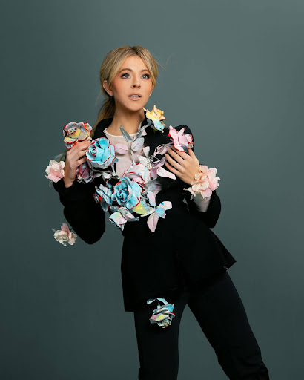

Photo Credit: Ashley Obsorne

**2024 North American Duality Tour Routing:**

Friday, July 12, 2024 - San Diego, CA - San Diego Civic Theater

Saturday, July 13, 2024 - Paso Robles, CA - Vina Robles Amphitheatre

Monday, July 15, 2024 - Salt Lake City, UT - Maverik Center

Wednesday, July 17, 2024 - Morrison, CO - Red Rocks Amphitheatre

Friday, July 19, 2024 - Kansas City, MO - Starlight Theatre

Saturday, July 20, 2024 - Tulsa, OK - BOK Center

Monday, July 22, 2024 - Grand Prairie, TX - Texas Trust CU Theatre

Tuesday, July 23, 2024 - San Antonio, TX - Majestic Theatre

Wednesday, July 24, 2024 - Austin, TX - Moody Center ATX

Friday, July 26, 2024 - Sugar Land, TX - Smart Financial Centre

Saturday, July 27, 2024 - New Orleans, LA - Saenger Theatre

Monday, July 29, 2024 - Rogers, AR - Walmart AMP

Wednesday, July 31, 2024 - Clearwater, FL - The Sound

Thursday, August 1, 2024 - Hollywood, FL - Hard Rock Live

Friday, August 2, 2024 - Orlando, FL - Walt Disney Theater

Saturday, August 3, 2024 - Jacksonville, FL - Daily's Place

Monday, August 5, 2024 - Atlanta, GA - Cadence Bank Amphitheatre at Chastain Park

Tuesday, August 6, 2024 - Franklin, TN - FirstBank Amphitheater

Thursday, August 8, 2024 - Asheville, NC - Harrah's Cherokee Center

Friday, August 9, 2024 - Pittsburgh, PA - Stage AE

Saturday, August 10, 2024 - New York, NY - Radio City Music Hall

Tuesday, August 13, 2024 - Boston, MA - MGM Music Hall at Fenway

Wednesday, August 14, 2024 - Philadelphia, PA - The Met Philadelphia

Thursday, August 15, 2024 - Uncasville, CT - Mohegan Sun Arena

Friday, August 16, 2024 - Gilford, NH - BankNH Pavilion

Saturday, August 17, 2024 - Washington, DC - The Anthem

Monday, August 19, 2024 - Huber Heights, OH - The Rose Music Center at The Heights

Tuesday, August 20, 2024 - Sterling Heights, MI - Michigan Lottery Amphitheatre at Freedom Hill

Thursday, August 22, 2024 - Milwaukee, WI - Miller High Life Theatre

Friday, August 23, 2024 - Rosemont, IL - Rosemont Theatre

Saturday, August 24, 2024 - Minneapolis, MN - The Armory

Monday, August 26, 2024 - Omaha, NE - The Astro

Wednesday, August 28, 2024 - Idaho Falls, ID - Hero Arena at the Mountain America Center

Thursday, August 29, 2024 - Nampa, ID - Ford Idaho Center Amphitheater

Friday, August 30, 2024 - Bonner, MT - KettleHouse Amphitheater

Saturday, August 31, 2024 - Airway Heights, WA - Northern Quest Resort & Casino

Monday, September 2, 2024 - Bend, OR - Hayden Homes Amphitheater

Tuesday, September 3, 2024 - Seattle, WA - WAMU Theater

Wednesday, September 4, 2024 - Eugene, OR - Cuthbert Amphitheater

Friday, September 6, 2024 - Concord, CA - Toyota Pavilion at Concord

Saturday, September 7, 2024 - Reno, NV - Grand Sierra Resort and Casino

Monday, September 9, 2024 - Phoenix, AZ - Footprint Center

Tuesday, September 10, 2024 - Los Angeles, CA - Greek Theatre

Wednesday, September 11 2024 - Highland, CA - Yaamava’ Theater

**ABOUT LINDSEY STIRLING:**

Few artists embody boundless creativity quite like Lindsey Stirling. Not only a multi-award-winning musician known for her genre-bending virtuosity on electronic violin, she’s endlessly dazzled audiences with her extraordinary talents as a dancer—an element she brings to the stage as part of her spectacular live show, touring with a stunning frequency and continually selling out iconic venues all around the world. Her groundbreaking vision has gained her millions of adoring fans worldwide, four Billboard chart-topping albums, and two Billboard Music Awards including Top Dance/Electronic Album for her third studio release, Brave Enough. Her holiday album, Warmer in Winter, catapulted to the #1 spot on Billboard, Amazon and iTunes Holiday Album charts upon release and lead single “Carol of the Bells” made history as the only instrumental song ever to reach the Top 10 at AC Radio. Also a New York Times bestselling author (and creator of her own comic book), the platinum-selling star felt compelled to push her boundaries even further for her seventh full-length effort, ultimately embracing a whole new level of freedom in her songwriting. A visionary meditation on inner wisdom, personal strength, and the ever-shifting nature of identity, Duality arrives as Stirling’s most sonically daring and emotionally complex album date. Lindsey has amassed over 27M million subscribers, nearly 3.5 billion views and 14M subscribers on YouTube, 4.9M million followers and 106M likes on Tik Tok, and over 500k user generated creations across Tik Tok and Instagram reels.

**LINDSEY STIRLING ON THE WEB**

[**WEBSITE**](https://www.lindseystirling.com/)

[**PRESS KIT**](https://streaklinks.com/BoVzEzjn54-e22KHgAN4G58l/https%3A%2F%2Fshorefire.com%2Froster%2Flindsey-stirling)

[**YOUTUBE**](https://streaklinks.com/BoVzEznwMHDPUTAHGQzAv7_o/https%3A%2F%2Fwww.youtube.com%2Fchannel%2FUCyC_4jvPzLiSkJkLIkA7B8g)

[**TIK TOK**](https://streaklinks.com/BoVzEzjCAsnuXk_FUQYthP9a/https%3A%2F%2Fwww.tiktok.com%2F%40lindseystirling%3Fis_from_webapp%3D1%26sender_device%3Dpc)

[**INSTAGRAM**](https://streaklinks.com/BoVzEzjjY7g77UPDVgHkNzLz/https%3A%2F%2Fwww.instagram.com%2Flindseystirling%2F%3Fhl%3Den)

[**FACEBOOK**](https://streaklinks.com/BoVzEzj-vrOhIh7ptQYP60pF/https%3A%2F%2Fwww.facebook.com%2Flindseystirlingmusic)

[**TWITTER**](https://streaklinks.com/BoVzEzjt7ZFIVwrsGg3UuD6v/https%3A%2F%2Ftwitter.com%2FLindseyStirling%3Fref_src%3Dtwsrc%255Egoogle%257Ctwcamp%255Eserp%257Ctwgr%255Eauthor)

**FOR MORE INFORMATION ON LINDSEY STIRLING, PLEASE CONTACT:**

Rebecca Shapiro (rshapiro@shorefire.com)

Mikaela Duhs ([**mduhs@shorefire.com**](mailto:mduhs@shorefire.com))

Becca Bloch (**rbloch@shorefire.com**)