**LINDSEY STIRLING RELEASES NEW ALBUM *DUALITY* VIA CONCORD RECORDS: A VISIONARY ON INNER WISDOM AND THE NATURE OF IDENTITY**

**WATCH THE “SURVIVE” FEATURING WALK OFF THE EARTH’S SARAH BLACKWOOD MUSIC VIDEO** [**HERE**](https://found.ee/LS_SurviveVideo)

**SET TO EMBARK ON HER NORTH AMERICAN DUALITY TOUR AND PLAY ICONIC VENUES LIKE LOS ANGELES’ GREEK THEATRE, NEW YORK CITY’S RADIO CITY MUSIC HALL, BOSTON’S MGM MUSIC HALL AT FENWAY & MORE**

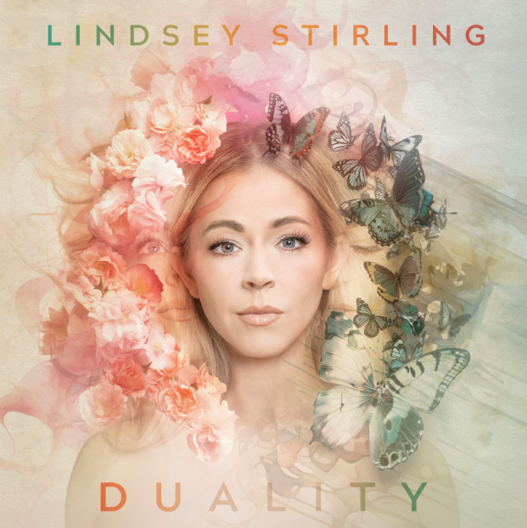

**Friday, June 14th: New York, NY** – Today, pop-violinist and entertainer extraordinaire **Lindsey Stirling** releases her new album, ***Duality*,** a visionary meditation on inner wisdom, personal strength, and the ever-shifting nature of identity **via Concord Records.**

Made with producers/co-writers like Graham Muron (Thirty Seconds to Mars, Skrillex) and Lucky West (Walk the Moon, Dreamers), Duality encompasses a dozen songs showcasing Stirling’s refined musicality and gift for sculpting deeply expressive melodies. But while the album’s first half centers on a grandiose and elaborate composed sound informed by Celtic music and other global influences, its latter half leans toward a boldly original form of left-of-center pop. A profoundly imaginative songwriter, Stirling makes brilliant use of each sonic setting by exploring intricate questions of intuition and truth.

**Listen to “Duality” here:** [**https://found.ee/LS_DualityOutNow**](https://found.ee/LS_DualityOutNow)

Focus track “Survive” finds Walk off the Earth vocalist Sarah Blackwood joining Stirling for a sublime interpolation of Gloria Gaynor’s disco classic “I Will Survive.” With its sleek beats and unstoppable grooves, the soul-stirring anthem channels a mood of joyful abandon thanks in large part to Stirling’s lush and vibrant violin melodies and Blackwood’s fierce yet full-hearted vocal performance.

*“Right as I was finishing my album, my relationship of 3 years came to a sudden screeching end and I was heartbroken,”* **Lindsey shares about her process in writing the song.** *“I had just enough time to write one last song and rather than writing how I felt in that raw post breakup time, I wrote the song about how I knew I would eventually feel. I wrote what I KNEW was true, not what I FELT was true at that moment. So I wrote “Survive”, an empowering breakup anthem about how we can all thrive and live our best lives after being hurt. To all my ladies who’ve ever been cheated on, his actions have nothing to do with your worth and everything to do with his stupidity and his own small feelings of inadequacy. You are a queen and we are all better off without them. If there is ever a true queen that needed to be on this song, it is Sarah Blackwood from Walk Off The Earth, who truly made the song come to life.”*

The “Survive” music video, which is also out today, features the duo as detectives on a mission to catch cheating boyfriends, blending humorous detective tropes with retro visuals, capturing the essence of 80s pop culture, complete with colorful sparkly costumes and jazzercise dance sequences.

**Watch the music video for “Survive” featuring Walk off the Earth’s Sarah Blackwood here:**

[**https://found.ee/LS_SurviveVideo**](https://found.ee/LS_SurviveVideo)

After a period of struggling to hone in on her vision for the LP, she experienced a breakthrough with a track called “Untamed”: a thrillingly majestic piece matching her mesmerizing violin work with ferocious guitar riffs, bombastic rhythms, and sudden bursts of otherworldly vocals. Partly inspired by Glennon Doyle’s philosophically rooted memoir of the same name, “Untamed” soon catalyzed the writing of Duality’s opening track, the stormy but exhilarating “Evil Twin.” In shining a light on the more shadowy aspects of our being, Stirling dreamed up an exquisitely frenetic track whose whirlwind energy builds to a formidable drop at the chorus. With its dizzying back-and-forth between bright and dark, chaos and control, “Evil Twin” makes for a potent introduction to Duality’s infinitely shapeshifting soundscape.

After kicking off with “The Scarlet Queen” (the haunting counterpart to “Evil Twin”), Duality’s second half shifts into the strutting rhythms and luminous textures of “Inner Gold”—a pop-tinged twist on “Eye Of The Untold Her.” “All of the songs line up from one side of the album to the other,” Stirling explains. “In the case of ‘Eye Of The Untold Her’ and ‘Inner Gold,’ both are about trusting that inner voice but sonically they’re very different.” Featuring the gorgeously strange vocals of alt-pop artist Royal & the Serpent, “Inner Gold” tells the tale of suffering through deception and emerging with a renewed sense of self-reliance. Duality arrives as Stirling’s most sonically daring and emotionally complex album date.

**Watch the music video for “Eye of the Untold Her” here:** [https://www.youtube.com/watch?v=rWwfyzX2OeM\](https://www.youtube.com/watch?v=rWwfyzX2OeM%5C)

**Watch the music video for “Inner Gold” ft Royal & the Serpent here:** <https://www.youtube.com/watch?v=VnHIe_USfL4>

**Watch the music video for “Evil Twin” here:** <https://www.youtube.com/watch?v=kxGrd7mlB5M>

Not only is she a multi-award-winning musician known for her genre-bending virtuosity on electronic violin, Lindsey has endlessly dazzled audiences with her extraordinary talents as a dancer—an element she brings to the stage as part of her spectacular live show.

This summer, Lindsey will embark across the United States hitting 40+ cities, performing at iconic venues including New York City’s Radio City Music Hall, Boston’s MGM Music Hall at Fenway Park, Philadelphia’s The Met, Washington D.C.’s The Anthem. Plus, she’ll close out the tour with a special hometown performance at Los Angeles’ Greek Theatre. Canadian indie pop band Walk off the Earth and LA-based indie pop band Saint Motel will perform as support for select dates. See full tour routing below.

Lindsey’s shows are eye-catching and inspiring. She seamlessly integrates intricate choreography, breathtaking aerial lyra acts, and stunning costumes, all of which she designs herself and seamlessly blends music, dance, and visual artistry into a singular, unforgettable experience, leaving audiences spellbound and inspired. Not to mention, she’s sold over 1M tickets throughout her career. Following her tour of North America, Lindsey will head to Europe and the UK for a sprawling run of 20+ dates hitting cities like London, Dublin, Paris, Stockholm and many more.

Get tickets here: <https://www.lindseystirling.com/tour>

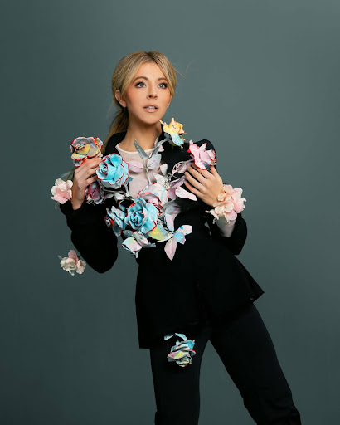

Photo Credit: Ashley Osborne

**DUALITY TRACKLISTING:**

SIDE ONE:

Evil Twin

Eye Of The Untold Her

Surrender

Serenity Found

Untamed

Purpose

SIDE TWO:

The Scarlet Queen

Inner Gold (feat. Royal & the Serpent)

Survive (feat. Walk Off The Earth)

Kintsugi

Firefly Alley

Les Fées

**2024 North American Duality Tour Routing:**

Friday, July 12, 2024 - San Diego, CA - San Diego Civic Theater

Saturday, July 13, 2024 - Paso Robles, CA - Vina Robles Amphitheatre

Monday, July 15, 2024 - Salt Lake City, UT - Maverik Center

Wednesday, July 17, 2024 - Morrison, CO - Red Rocks Amphitheatre

Friday, July 19, 2024 - Kansas City, MO - Starlight Theatre

Saturday, July 20, 2024 - Tulsa, OK - BOK Center

Monday, July 22, 2024 - Grand Prairie, TX - Texas Trust CU Theatre

Tuesday, July 23, 2024 - San Antonio, TX - Majestic Theatre

Wednesday, July 24, 2024 - Austin, TX - Moody Center ATX

Friday, July 26, 2024 - Sugar Land, TX - Smart Financial Centre

Saturday, July 27, 2024 - New Orleans, LA - Saenger Theatre

Monday, July 29, 2024 - Rogers, AR - Walmart AMP

Wednesday, July 31, 2024 - Clearwater, FL - The Sound

Thursday, August 1, 2024 - Hollywood, FL - Hard Rock Live

Friday, August 2, 2024 - Orlando, FL - Walt Disney Theater [SOLD OUT]

Saturday, August 3, 2024 - Jacksonville, FL - Daily's Place

Monday, August 5, 2024 - Atlanta, GA - Cadence Bank Amphitheatre at Chastain Park

Tuesday, August 6, 2024 - Franklin, TN - FirstBank Amphitheater

Thursday, August 8, 2024 - Asheville, NC - Harrah's Cherokee Center

Saturday, August 10, 2024 - New York, NY - Radio City Music Hall

Monday, August 12, 2024 - Pittsburgh, PA - Stage AE [DATE CHANGE - PREVIOUSLY 8/9]

Tuesday, August 13, 2024 - Boston, MA - MGM Music Hall at Fenway

Wednesday, August 14, 2024 - Philadelphia, PA - The Met Philadelphia

Thursday, August 15, 2024 - Uncasville, CT - Mohegan Sun Arena

Friday, August 16, 2024 - Gilford, NH - BankNH Pavilion

Saturday, August 17, 2024 - Washington, DC - The Anthem

Monday, August 19, 2024 - Huber Heights, OH - The Rose Music Center at The Heights

Tuesday, August 20, 2024 - Sterling Heights, MI - Michigan Lottery Amphitheatre at Freedom Hill

Thursday, August 22, 2024 - Milwaukee, WI - Miller High Life Theatre

Friday, August 23, 2024 - Rosemont, IL - Rosemont Theatre

Saturday, August 24, 2024 - Minneapolis, MN - The Armory

Monday, August 26, 2024 - Omaha, NE - The Astro

Wednesday, August 28, 2024 - Idaho Falls, ID - Hero Arena at the Mountain America Center

Thursday, August 29, 2024 - Nampa, ID - Ford Idaho Center Amphitheater

Friday, August 30, 2024 - Bonner, MT - KettleHouse Amphitheater

Saturday, August 31, 2024 - Airway Heights, WA - Northern Quest Resort & Casino

Monday, September 2, 2024 - Bend, OR - Hayden Homes Amphitheater

Tuesday, September 3, 2024 - Seattle, WA - WAMU Theater

Wednesday, September 4, 2024 - Eugene, OR - Cuthbert Amphitheater

Friday, September 6, 2024 - Concord, CA - Toyota Pavilion at Concord

Saturday, September 7, 2024 - Reno, NV - Grand Sierra Resort and Casino

Monday, September 9, 2024 - Phoenix, AZ - Footprint Center

Tuesday, September 10, 2024 - Los Angeles, CA - Greek Theatre

Wednesday, September 11, 2024 - Highland, CA - Yaamava’ Theater

**ABOUT LINDSEY STIRLING:**

Few artists embody boundless creativity quite like Lindsey Stirling. Not only a multi-award-winning musician known for her genre-bending virtuosity on electronic violin, she’s endlessly dazzled audiences with her extraordinary talents as a dancer—an element she brings to the stage as part of her spectacular live show, touring with a stunning frequency and continually selling out iconic venues all around the world. Her groundbreaking vision has gained her millions of adoring fans worldwide, four Billboard chart-topping albums, and two Billboard Music Awards including Top Dance/Electronic Album for her third studio release, Brave Enough. Her holiday album, Warmer in Winter, catapulted to the #1 spot on Billboard, Amazon and iTunes Holiday Album charts upon release and lead single “Carol of the Bells” made history as the only instrumental song ever to reach the Top 10 at AC Radio. Also a New York Times bestselling author (and creator of her own comic book), the platinum-selling star felt compelled to push her boundaries even further for her seventh full-length effort, ultimately embracing a whole new level of freedom in her songwriting. A visionary meditation on inner wisdom, personal strength, and the ever-shifting nature of identity, Duality arrives as Stirling’s most sonically daring and emotionally complex album date. Lindsey has amassed over 27M million subscribers, nearly 3.5 billion views and 13.9M subscribers on YouTube, 4.8M million followers and 105M likes on Tik Tok, and over 500k user generated creations across Tik Tok and Instagram reels.

**LINDSEY STIRLING ON THE WEB**

[**WEBSITE**](https://streaklinks.com/B4b6uptBAZKx7V_9KAwqsIVb/https%3A%2F%2Fwww.lindseystirling.com%2F)  | [**PRESS KIT**](https://streaklinks.com/B4b6upxU1DgMz5_AGgto3IDh/https%3A%2F%2Fshorefire.com%2Froster%2Flindsey-stirling) | [**FACEBOOK**](https://streaklinks.com/B4b6upxCwjUgvWL91gHY8XTk/https%3A%2F%2Fwww.facebook.com%2Flindseystirlingmusic) | [**TWITTER**](https://streaklinks.com/B4b6uuKlpTOgytd34wr50fvt/https%3A%2F%2Ftwitter.com%2FLindseyStirling%3Fref_src%3Dtwsrc%255Egoogle%257Ctwcamp%255Eserp%257Ctwgr%255Eauthor) | [**YOUTUBE**](https://streaklinks.com/B4b6up5Z2aG_d4LQuQrPxcwU/https%3A%2F%2Fwww.youtube.com%2Fchannel%2FUCyC_4jvPzLiSkJkLIkA7B8g) | [**INSTAGRAM**](https://streaklinks.com/B4b6upxyMn12S_k5awm8nMKy/https%3A%2F%2Fwww.instagram.com%2Flindseystirling%2F%3Fhl%3Den) | [**TIK TOK**](https://streaklinks.com/B4b6uptLy4_aQY4e2QM9PBXO/https%3A%2F%2Fwww.tiktok.com%2F%40lindseystirling%3Fis_from_webapp%3D1%26sender_device%3Dpc)

**FOR MORE INFORMATION, PLEASE CONTACT:**

Mikaela Duhs ([mduhs@shorefire.com](mailto:mduhs@shorefire.com))

Rebecca Shapiro ([rshapiro@shorefire.com](mailto:rshapiro@shorefire.com))