For Immediate Release
June 5, 2025

LUKE TYLER SHELTON ANNOUNCES HIS DEBUT EP, BLUE SKY,
SET FOR RELEASE ON JULY 18 VIA CONCORD RECORDS — PRE-SAVE

TODAY RELEASES NOSTALGIC, ROAD-WORN NEW SINGLE
“A BUS AIN’T A HOME” — STREAM / WATCH THE VISUALIZER

PRODUCED BY SHOOTER JENNINGS & JONATHAN WILSON

UPCOMING TOUR DATES SUPPORTING OLE 60 + PERFORMANCES AT FAIRWELL FESTIVAL AND EVANSTON FOLK FESTIVAL
— SEE ALL DATES HERE
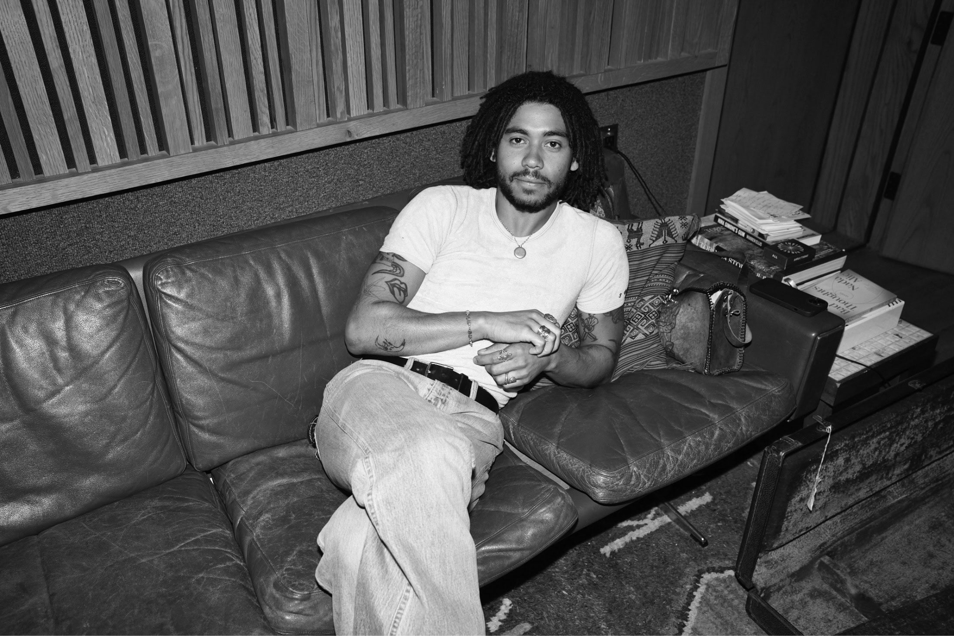
Press photo by Sunny Davis [Download]

“...a lighthearted and easygoing request to roll the windows down and let the sun in.”

“Evoking the lush Laurel Canyon sounds of The Eagles, Jackson Browne, Crosby, Stills, Nash, & Young, and so on, Luke Tyler Shelton is a fresh face with an old soul…No, this isn’t the 1970s; this is right here, right now – and we all get to join him for what will surely be the adventure of a lifetime.”


Sonic wanderer and time traveler Luke Tyler Shelton today announces that his debut EP Blue Sky will be released on July 18 via Concord Records. He heralds this news with the new single “A Bus Ain’t A Home.” Like a sonic sunset as the horizon shrinks in the rearview mirror, Shelton sings nostalgically of all those he misses while out on tour. The warm, familiar tone of the piano and the twangy lilt of the pedal steel guide the listener across the country with their heart still tethered at home — Stream “A Bus Ain’t A Home” / Pre-save Blue Sky.

Shelton shared, “‘A Bus Ain’t A Home’ is the second release from my recent sessions at Sunset Sound. It’s the first song I’ve written about being on the road and the experience of having to leave a loved one for extended periods of time.”

Recorded with a full band in Hollywood alongside Shooter Jennings and Jonathan Wilson, Shelton set out to create a sound that is less produced and more authentic. The result is soul-soothing rock-and-roll at a windows-down, cruising pace. With a style informed by his DIY community that holds a mirror to the near-mythic creative hotbed of early-70s Laurel Canyon, Shelton calls back a faraway time at the crossroads of country-rock, folk-pop, and Southern soul.

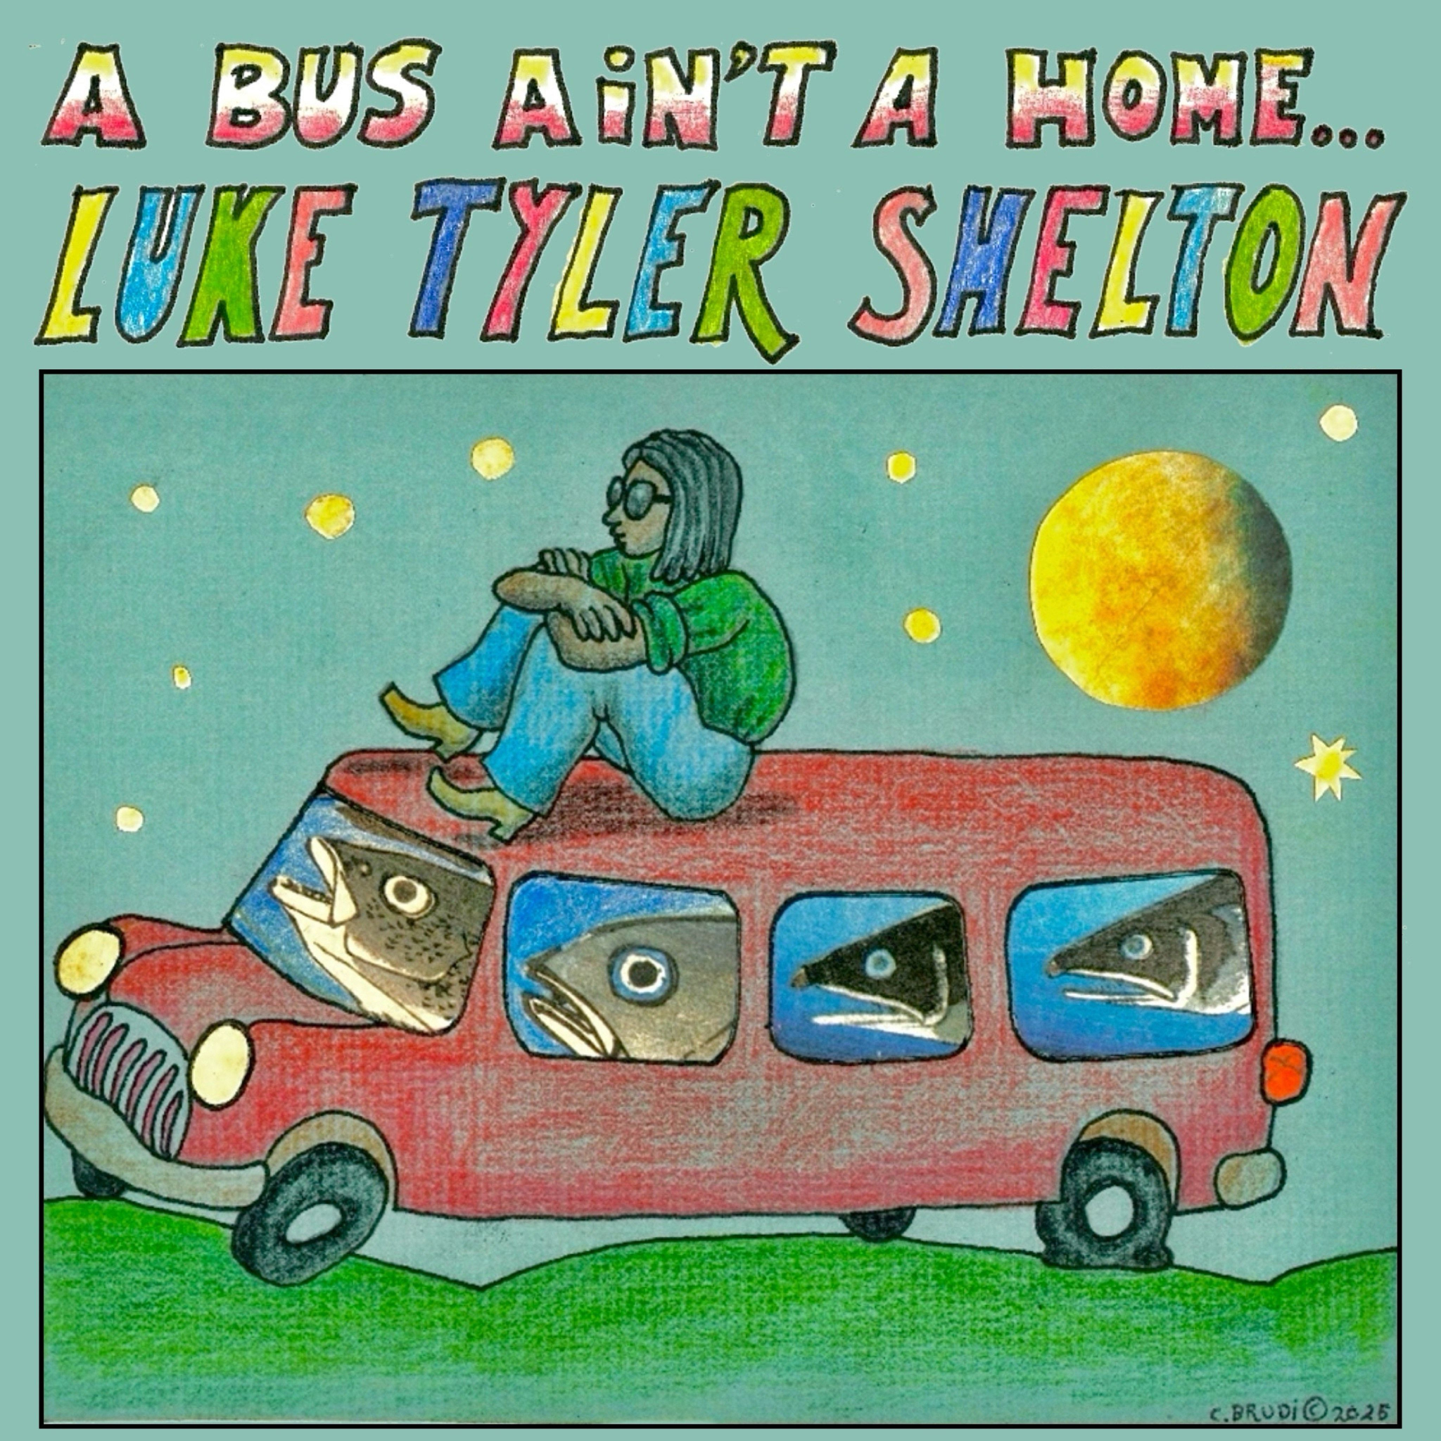
“A Bus Ain’t A Home” artwork [Download]

Already this year, Shelton has spent time out on the road supporting The Dip and Joy Oladokun, as well as making his SXSW debut at Willie Nelson’s Luck Reunion. He is currently playing in the touring band of Malcolm Todd across North America. Over the summer, he will play a handful of shows with Ole 60, and make festival appearances at FairWell Festival and Evanston Folk Festival. See all upcoming tour dates here and below.

UPCOMING TOUR DATES
July 17 - Showbox SoDo - Seattle, WA*
July 18 - FairWell Festival - Redmond, Oregon
July 19 - Knitting Factory - Spokane, WA*
Sep. 6 - 7 - Evanston Folk Festival - Evanston, IL

* supporting Ole 60
All tour info here

ABOUT LUKE TYLER SHELTON:
Born in the new millennium, Luke Tyler Shelton makes soul-soothing rock-and-roll with all the ineffable charm of a faraway time. With a profound gift for dreaming up heavenly melodies and fantastically loose grooves, the Los Angeles native found his sound as part of a close-knit scene of young musicians and artists—a DIY-minded community whose spirit and sensibilities recall the near-mythic creative hotbed of early-’70s Laurel Canyon. Produced by Shooter Jennings (Brandi Carlile, Tanya Tucker) and Jonathan Wilson (Father John Misty, Angel Olsen), Luke’s debut body of work merges country-rock, folk-pop, and Southern soul into songs that immediately transport the audience into a state of enchanted ease.

A mostly self-taught musician, Luke was steeped in music from an early age thanks to his father (a reggae singer hailing from Hawaii) and mother (a classic-rock obsessive who bought him his first guitar). Originally from the San Fernando Valley, he got his first drum kit at age four, took piano lessons in elementary school, and played in a psych-rock band for most of high school—an experience that involved spending untold hours honing his chops in his family’s garage, steadily developing the potent sense of rhythm that still informs his sound today. As he began exploring the artists and bands he now names among his essential influences (Neil Young, Faces, George Harrison, Bob Dylan, and Peter Green-era Fleetwood Mac), he taught himself to play guitar and started writing songs soon after finishing high school in 2019, and shortly thereafter, stumbled upon the vibrant creative community that would radically alter his musical path.

“There were all these people my age who were making art and clothes and music, and they were all so talented and put so much personality into what they were creating,” he says. “I started playing with people I’d met through that scene, and now it’s turned into this revolving-door kind of thing where we all play in each other’s bands and share bills at shows.”

As he continued sharpening his songcraft and building up a following online, Luke caught the attention of Concord Records and signed a deal with the label after playing a gig outside a warehouse art show near the beach. Not long after the signing, he linked up with Jennings and Wilson and set to work on his first batch of songs, all recorded to tape with his circle of friends at Wilson’s studio in the bohemian enclave of Topanga Canyon.

Mixed by four-time Grammy-winner Trina Shoemaker (Sheryl Crow, Queens Of The Stone Age)—and also featuring Jennings’ longtime bandmate Ted Russell Kamp on bass and Wilson on drums, guitar, and Moog synth—Luke’s debut singles achieve a certain rarefied magic, matching their exquisitely orchestrated sound with a free-flowing energy that instantly transfers onto the listener.

Now at work on his debut album, Luke ultimately hopes to impart others with the same sense of exhilarated wonder he felt upon discovering the music that most inspires him. “That era of music happened so long ago that, for someone my age, it doesn’t seem completely real—it’s almost like folklore,” he says. “That’s what really pulled me into it, and made me want to figure out how those sounds could be made. I hope my music gives people that same kind of excitement and joy, like they’re experiencing something that they’ve never heard made in their lifetime.”

###

For more information on Luke Tyler Shelton, please visit:
Website | Instagram | YouTube | Spotify | Apple Music | TikTok

For all Luke Tyler Shelton press materials and inquiries, please contact:
Emily Ginsberg | ginsberg@bighassle.com
Madi Florence | madi@bighassle.com

