

BUTCHER BROWN REIMAGINES RUN-DMC CLASSIC ‘DOWN WITH THE KING’ IN COLLABORATION WITH ESPN’S ACC NETWORK

Atlantic-Bred Collective Provides Powerhouse Soundtrack to 2023-2024 ACC Men’s Basketball Season

Listen to “Down With the King” by Butcher Brown HERE
Single Cover Art HERE

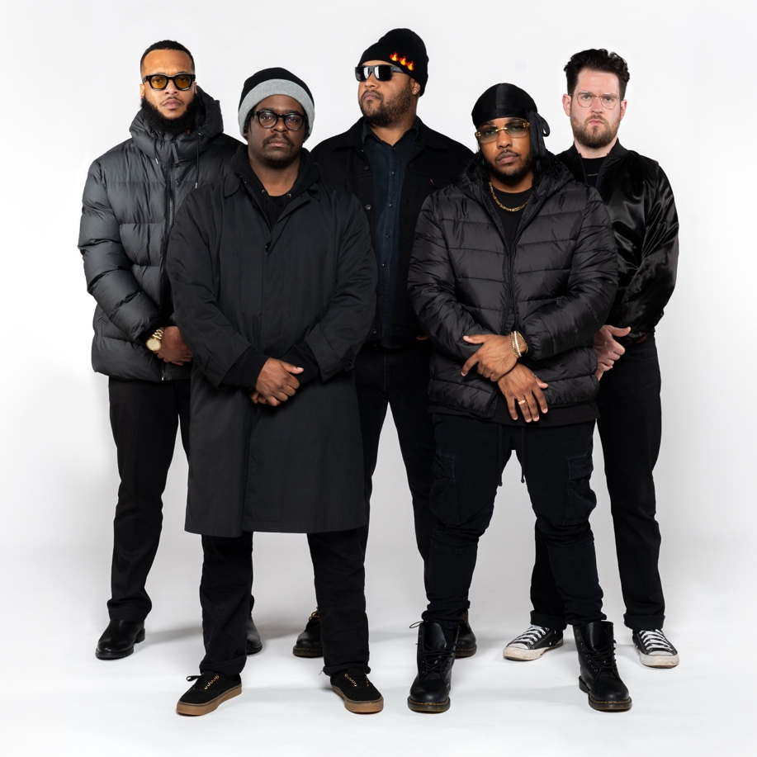

January 5, 2024 – Today, acclaimed jazz/hip-hop collective Butcher Brown releases a dynamic rendition of Run-DMC’s 1993 classic “Down With the King” in collaboration with ACC Network, ESPN’s 24/7 national network dedicated to Atlantic Coast Conference sports.

The Virginia-bred group’s modern take on the hip-hop classic will air in promotional spots throughout ACCN’s coverage of the men’s basketball season, starting this Saturday, Jan. 6 when No. 14 Duke visits Notre Dame. In addition to being heard in live event game windows, the anthemic track will also play during the network’s signature studio basketball show, Nothing But Net. ACC Network’s programming includes live game coverage of all 15 member-institutions of the ACC, a conference that has captured three of the last eight NCAA Championships.

This marks the second such collaboration between ESPN and Butcher Brown, following the successful initiative that saw the group’s modernized single of Little Richard’s “Rip it Up” serve as the pre-kickoff hype song for Monday Night Football’s 50th anniversary season in 2020.

Recorded in Butcher Brown’s hometown of Richmond, the new treatment to “Down With the King” pays respectful tribute to Run-DMC’s groundbreaking original recording, while simultaneously pushing the song into new sonic territory.

“We approached ‘Down With the King’ with the openness to make it our own,” said Butcher Brown keyboardist and renowned producer Devonne “DJ” Harrison. “This record is a classic, and we wanted to breathe new life into the sound without losing the spirit of the composition.”

The collection of schools in the Atlantic Coast Conference is as unique as the different genres of music that Butcher Brown likes to work in – hip-hop, jazz, rock, funk, pop and beyond – making the group ideal harbingers of an updated soundtrack for the new season.

“Virginia music is one-of-a-kind, and always has been, just like the ACC,” said Butcher Brown lyricist and horn player Marcus Tennishu. “The Richmond aesthetic comes from a place where everyone is really diehard and blue collar – you work for what you get. We wanted this remake to be derivative of the original, but we had to put our own twist on it.”

The new single comes on the heels of Butcher Brown’s critically lauded album Solar Music. Released in October 2023 via Concord Jazz, the record reached No. 1 on the College Radio Hip Hop Chart and No. 8 on the Billboard 200 Contemporary Jazz Chart, garnering praise from national outlets such as the New York Times, Washington Post, All Music and The Fader.

About Butcher Brown:
Butcher Brown, a multifaceted band from Richmond, Virginia, includes friends and bandmates Corey Fonville (drums), Andrew Randazzo (bass), Morgan Burrs (guitar), Marcus “Tennishu” Tenney (trumpet, saxophone, vocals), and Devonne “DJ Harrison” Harris (keyboard, multi-instrumentalist). Their music is a seamlessly blended amalgam of sounds including jazz, hip-hop, rock, funk, R&B, alternative, soul, country, house, bossa nova, pop, and more. For more information, visit butcherbrown.com.

About ACC Network:
Owned and operated by ESPN in partnership with the Atlantic Coast Conference, ACC Network (ACCN) and its digital platform ACCNX is a 24/7 national network dedicated to ACC sports that launched on August 22, 2019. ACCN televises more than 500 regular-season and tournament games from across the conference’s 27 sponsored sports plus a complement of news and information shows and original programming. Together, ACCN and its digital platform, ACCNX, combine to feature more than 1,500 ACC events each year. ESPN has been televising ACC content since 1979 and has exclusive rights to every conference-controlled game across all sports and championships. All ACCN games are also available on the ESPN App with TV Everywhere credentials.

For more information about Butcher Brown, contact Regina Joskow: regina.joskow@rounder.com

Media contacts at ACC Network:
Colin Bradley
colin.bradley@espn.com

Butcher Brown Social Links
Instagram
Facebook
Twitter
TikTok
Spotify
Apple Music
YouTube
#butcherbrown
#downwiththeking

ACC Network Social Links
Instagram
Facebook
X
TikTok

