**BUTCHER BROWN SHARES LATEST SINGLE FROM IMMINENT NEW ALBUM, "MOVE (RIDE)" FEATURING JAY PRINCE**

***SOLAR MUSIC* OUT THIS FRIDAY, OCT. 6 VIA CONCORD JAZZ**

Butcher Brown by Jacky Flav (Download hi-res assets [HERE](https://drive.google.com/drive/folders/1Q7UFLHisXEWNvMxsnYCwK8mECKUctVpE?usp=share_link))

**"MOVE (RIDE)" featuring Jay Prince**

**WATCH:** [**https://found.ee/BB_MOVERIDEYT**](https://found.ee/BB_MOVERIDEYT)

**LISTEN:** [**https://found.ee/BB_SolarMusic**](https://found.ee/BB_SolarMusic)

*"A spirit of generous communion runs through 'Solar Music'"*

**The New York Times**

*"... a leather-smooth guided tour through a rip in spacetime"*

**The FADER**

**(October 3, 2023) -** Butcher Brown, Richmond, Virginia’s forward-thinking collective of jazz and hip-hop aficionados, today shares "MOVE(RIDE)," the final single ahead of their forthcoming album *Solar Music* out this Friday, Oct. 6. The lively new track features East London artist and producer Jay Prince, who breathes London's lifestyle and spirit of jazz into the party-driven song. "MOVE (RIDE)" widens the aperture for what fans can expect from Butcher Brown's latest effort, combining elements of funk, house and hip-hop into a feel-good earworm.

“‘MOVE (RIDE)’ was inspired by the house music community in cities such as Baltimore, Chicago, Detroit and London. Our goal was to capture the essence of a nightclub with everyone dancing.” says drummer Corey Fonville.

Over the years, Butcher Brown’s musicality-driven sound has garnered praise from fans and critics alike, from Pitchfork to [NPR’s Tiny Desk (Home)](https://www.npr.org/2021/04/21/989176978/butcher-brown-tiny-desk-home-concert). In anticipation of the new album, *The New York Times* included *Solar Music* in its [Fall Music Preview](https://www.nytimes.com/2023/09/04/arts/music/albums-tours-festivals-fall.html), highlighting the cohesion of the accomplished musicians that Butcher Brown have brought into the fold on this album. Each collaborator embodies the bending of genres all in their own ways, including Pink Siifu and Keyon Harrold who feature on the band's previous single "Eye Never Knew," which was highlighted as a [Song You Need](https://www.thefader.com/2023/09/19/song-you-need-butcher-brown-pink-siifu-keyon-harrold-eye-never-knew) by The FADER and was spotlighted on Spotify's “BUTTER” playlist.

Described by Butcher Brown bandmates as “having something for just about everybody under the sun,” *Solar Music* collectively demonstrates the band's dynamic approach to the jazz format, and incorporates their own rich lineage of musical influences from their diverse musical upbringings – fusing elements of jazz, funk, rock, gogo and hip-hop, into a universal sound. Prior to “MOVE (RIDE),” Butcher Brown teased *Solar Music* with additional single releases, including "DYKWYD" featuring Braxton Cook, "This Side Of Sunshine" and "I Can Say To You" featuring Vanisha Gould, which saw support across BBC Radio from the likes of Benji B, Gilles Peterson and Huey Morgan.

Releasing digitally (including Atmos), on CD and double LP at 45 RPM, the new album incorporates longtime friends and new unexpected guests into their approach, with additional appearances including Charlie Hunter, Nappy Nina and Michael Millions throughout the album’s 17 tracks. Exclusive *Solar Music* limited edition 'Solar Red' vinyl, signed CDs/vinyl and merchandise are all available [HERE](https://found.ee/BB_SolarMusic).

Butcher Brown will perform an extensive 2023 Solar Music Global Tour, with fall dates across the U.S. and Europe October-December in support of the new album. The tour brings Butcher Brown’s explosive live show to 13 states from California to Washington, D.C. Standout performances include New York City Oct. 18 at Le Poisson Rouge (LPR), Philadelphia Oct. 21 at World Cafe Live and a hometown show in Richmond, Virginia Nov. 24 at the Broadberry. In between their North American runs, Butcher Brown heads over the pond to six European countries with anticipated performances in London, England Nov. 6 at the Forge; in Berlin, Germany alongside B. Cool-Aid Nov. 8 at Zenner; and in Paris, France Nov. 15 at Le Trabendo.

Listen to "MOVE (RIDE)" featuring Jay Prince today and listen to *Solar Music* in its entirety on Friday, Oct. 6. For more information, visit [butcherbrown.com](https://www.butcherbrown.com).

**Butcher Brown 2023 Solar Music Global Tour Dates**

10/12 - Reno, NV - **University of Nevada, Reno** - Nightingale Concert Hall

10/17 - **Boston, MA** - Brighton Music Hall

10/18 - **New York, NY** - (Le) Poisson Rouge

10/20 - **Charlottesville, VA** - The Southern Café and Music Hall

10/21 - **Philadelphia, PA** - World Cafe Live (upstairs)

10/22 - **Pittsburgh, PA** - Club Cafe

10/24 - **Minneapolis, MN** - Dakota

10/25 - **Chicago, IL** - Sleeping Village

10/26 - **Detroit, MI** - El Club

10/27 - **Indianapolis, IN** - Jazz Kitchen

11/4 - **Eindhoven, NL** - So What’s Next?

11/6 - **London, UK** - The Forge

11/7 - **Antwerp, BE** - De Roma

11/8 - **Berlin, DE** - J.A.W. (Zenner)

11/9 - **Mannheim, DE** - Alte Feuerwache

11/10 - **Técou, FR** - Coco Jazz

11/11 - **Groningen, NL** - Rockit

11/12 - **Rotterdam, NL** - Rooterdam / Bird

11/13 - **Amsterdam, N**L - Bimhuis

11/14 - **Charloeroi, BE** - Palais des Beaux Arts

11/15 - **Paris, FR** - Le Trabendo

11/18 - **Eilat, IL** - Red Sea Jazz Festival

11/24 - **Richmond, VA** - The Broadberry

11/25 - **Washington, DC** - Atlantis

12/5 - **Seattle, WA** - Madame Lou’s

12/6 - **Portland, OR** - The Get Down

12/7 - **San Francisco, CA** - The Independent

12/8 - **Santa Cruz, CA** - Kuumbwa Jazz

12/9 - **Los Angeles, CA** - Lodge Room

12/10 - **San Diego, CA** - House of Blues, Voodoo Room

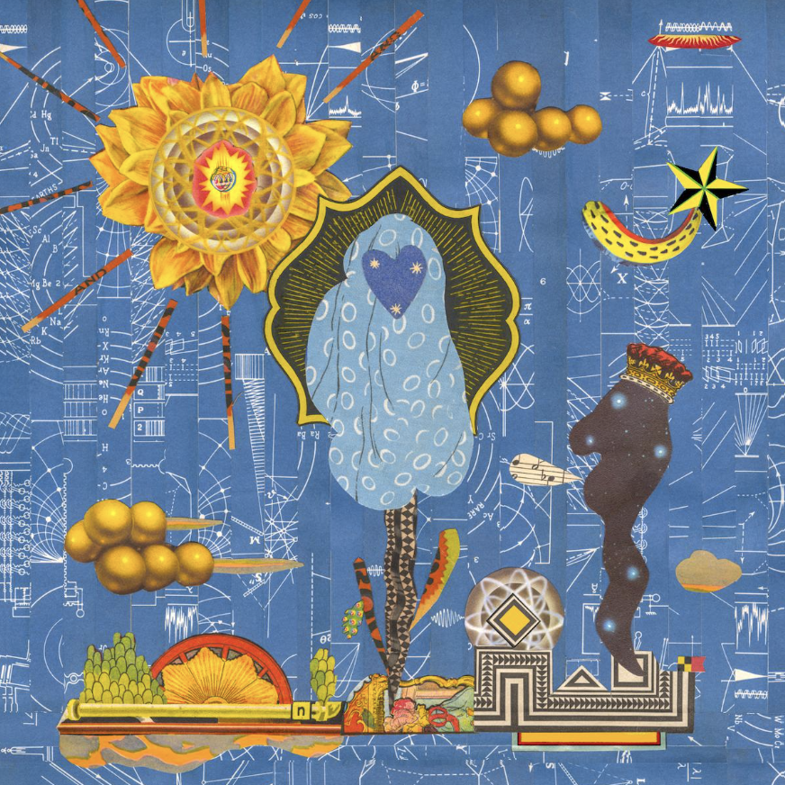

**Butcher Brown**

***Solar Music***

**Concord Jazz**

**October 6, 2023**

1. Cozumel

2. Espionage featuring Charlie Hunter

3. I Can Say To You featuring Vanisha Gould

4. MOVE (RIDE) featuring Jay Prince

5. Turismo featuring Julia Shuren

6. Eye Never Knew featuring Pink Siifu and Keyon Harrold

7. No Way Around It

8. Half of It featuring Nappy Nina

9. DYKWYD featuring Braxton Cook

10. Happy Hourrr

11. Run It Up featuring Pink Siifu

12. Pink Fur featuring Michael Millions

13. This Side Of Sunshine

14. BubbleBath

15. Touring Pains

16. It Was Me

17. Around For A While

**More about Butcher Brown:**

“So, what kind of music do you make?” This question is the bane of every musician’s existence because it requires that they shrink down the wide expanse of their creativity to an easily (mis)understood genre description.

No matter how vivid or elaborate the description, “show” will always be more powerful than “tell.” The words we use to describe music don’t encapsulate what the listener’s experiences as much as give context clues.

That’s why Butcher Brown – the multifaceted band from Richmond, Virginia – call their sound and their follow up to 2020’s *#KingButch* and their second release on Concord Jazz, *Solar Music*.

“Solar music” is not simply a description; it’s an invitation to listen and an invitation to *feel*.

Friends and bandmates Corey Fonville (drums), Andrew Randazzo, (bass), Morgan Burrs (guitar), Marcus “Tennishu” Tenney, (trumpet, saxophone, vocals) and Devonne “DJ Harrison” Harris (multi-instrumentalist) make music that is as diverse as their own varied tastes and backgrounds. It’s a seamlessly blended amalgam of sounds including jazz, hip-hop, rock, funk, R&B, alternative, soul, country, house, bossa nova, pop, and more. “We *are* the melting pot. We *are* the mix,” says Devonne. “I feel like that's what we represent and that's what this album represents.”

But Butcher Brown’s eclecticism isn’t for the sake of musical masturbation or to impress chin-stroking critics. Theirs is music of, and for, the people. “It’s music for everybody," says Tennishu reflecting on how well-received they’ve been on stages across the globe. “You can see it on all kinds of different faces, young, old, big, small, short, tall, they all start dancing eventually. It’s literally music for the whole solar system.”

So how did this band of brothers make the sun come out on this new album? They challenged themselves to break from routine and old formulas. “[In the past] we'd make a record, like [2014’s] *All Purpose Music* and put constraints on what we do in the studio with the thought of the live show, thinking ‘let's make this something that we can recreate at the show,’” explains Andrew. “We did that for a few records but then #*KingButch* was the one where we kind of departed from that idea and took more of a *Sgt. Pepper …* approach of, let's just explore what we can present in the studio, even if it's not something that we can pull off live.”

Realizing that listening to their albums and their live show are two distinct experiences unlocked a new level of creativity for the band. Now Butcher Brown could allow themselves to explore new sounds and approaches to songwriting and production. This new unbridled creativity informed their approach to making *Solar Music* over the course of many sessions in 2021 and 2022 at go-to studios Montrose Recording, Minimum Wage Studios, and their homebase Jellowstone.

Of course the sun is at the center of the solar system, giving us warmth, lighting our days and keeping the planet revolving around it. Similarly, when it came time to create *Solar Music* the band saw themselves at the center of their sound drawing in other like-minded musicians with gravitational pull.

What could have been an insular musical conversation between the five became a collaboration with some of their friends and faves including Oakland-bred wordsmith Nappy Nina (“Half of It”), hip-hop iconoclast Pink Siifu (“Eye Never Know,” “Run It Up”), East London rapper Jay Prince (“Move”), real-life guitar hero Charlie Hunter (“Espionage”) and more.

On the new album, Butcher Brown flexes their musicianship not only as players but also songwriters, producers, and composers collaborating with guests. “We can do everything on our own, sure, and we have done that for forever, but it's also cool to have other people come in and get their perspectives,” explains Morgan. “Butcher Brown is evolving, maturing, and we’re growing as people,” adds Corey, reflecting on the making of *Solar Music*.

The results of these collabs are extraordinary. Take the album’s first single, “I Can Say To You” for instance. “You’ll find your way/ tomorrow or today/ there’s nothing else I can say to you …,” sings guest Vanisha Gould in a voice that sounds both angelic and ancestral. “She has a voice that almost sounds like a sample, almost like Billie Holiday or something, " says Corey who sought her out to feature on the song. “It’s got that warmth, like somebody’s mama singing to you.”

Warmth, light, and connection through a sound that like the sun itself is for everyone. Welcome to *Solar Music*.

**﻿(Download hi-res assets** [**HERE**](https://drive.google.com/drive/folders/1Q7UFLHisXEWNvMxsnYCwK8mECKUctVpE?usp=share_link)**)**

**Connect with Butcher Brown:**

[**Instagram**](https://www.instagram.com/butcherbrown/?hl=en) **|** [**Twitter**](https://twitter.com/butcherbrwn) **|** [**Facebook**](https://www.facebook.com/butcherbrownband) **|** [**TikTok**](https://www.tiktok.com/@butcherbrown)

**For all Butcher Brown inquiries please contact Kevin at Orienteer:**

[**kevin@orienteer.us**](mailto:kevin@orienteer.us)

**--**

**Kevin Cordon**

**Orienteer**

**Los Angeles, CA | New York, NY**

**﻿**