Hiromi Explores Synths and Deep Grooves On Sonicwonderland, Out Today on Telarc

Hiromi’s New Band Sonicwonder Features Hadrien Feraud (Bass), Gene Coye (Drums) and Adam O'Farrill (Trumpet)

Listen Here: https://found.ee/Hiromi_Sonicwonderland

Watch Her NPR Tiny Desk Debut Here:
https://found.ee/Hiromi_TinyDeskYT

North American Tour October 7-20

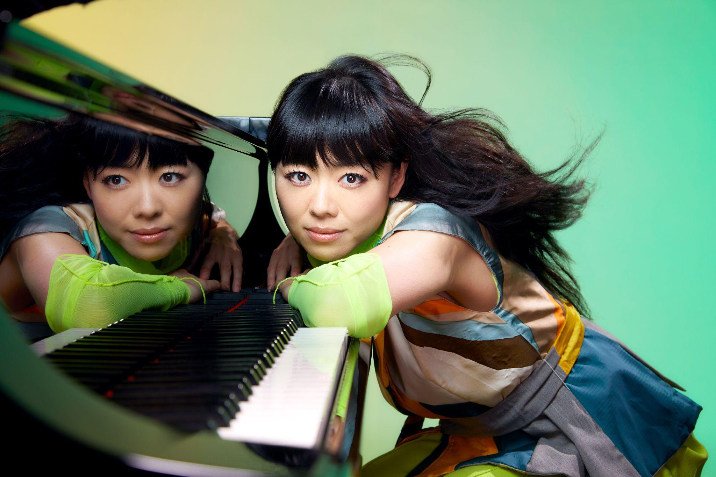
[Press photo: Mitsuru Nishimura]

October 6, 2023 - Hiromi has released her 12th studio album Sonicwonderland (Telarc), a new musical adventure for the GRAMMY-winning pianist and composer. Recorded with a new quartet called Hiromi’s Sonicwonder, the album features 9 new tracks that burst with synthesizer and deep-in-the-pocket grooves. The record stands as Hiromi’s heaviest, funkiest work yet, marking a significant evolution in her musical journey into genre-defying territory.

Listen to Sonicwonderland Here: https://found.ee/Hiromi_Sonicwonderland

“Whenever I play shows or make an album, I feel like it's a journey to find the people who can feel a deep connection to what I'm doing right now. Hopefully, with Sonicwonderland, I can connect to fans that listened to my music before and to new listeners, too.” - Hiromi

Hiromi shared two pieces from the record in advance of today’s release: the title track "Sonicwonderland" (watch the video here) and the second single "Reminiscence" featuring UK singer/songwriter/keyboardist Oli Rockberger (watch the video here) along with an album trailer here. She's also released a 1-minute Collab Dance Video, featuring hip-hop dancer Salah the Entertainer, for the "Sonicwonderland" single here.

Hiromi’s North American tour begins tomorrow night in Vancouver, and includes two performances at Sony Hall in NYC on October 13th and 14th. She also just made her NPR Tiny Desk debut, performing two pieces featured on the new album. NPR said “She plays with great command but yet she is also at ease, as her notes ripple from her fingertips like streams of water.” The Tiny Desk has over 800,000 views and even rapper Action Bronson weighed in, calling it “the best Tiny Desk ever”: https://www.youtube.com/watch?v=pnISpahN2dM

Hiromi’s Sonicwonder is a quartet featuring blossoming young talents Hadrien Feraud (bass), Gene Coye (drums), and Adam O'Farrill (trumpet) and began performing live together earlier this spring. Sonicwonderland was recorded May 25-28 at Skywalker Sound Stage in Nicasio, California, where Hiromi also recorded her 2019 solo piano album Spectrum. In addition to new works written for this project, the album includes songs that were released on her "One Minute Portrait" YouTube initiative during the pandemic and rearranged for this band.

“Sonicwonderland,” the album’s title track, kicks off with a thumping sequenced synthesizer groove that’s more dance club than jazz club. It’s fast-paced, fun, and unfurls into an 8-minute adventure of open space and improvisation. While other songs feature quick tempos, funk grooves and synth work (“Trial and Error,” “Go Go”), Hiromi works gracefully on acoustic piano extensively throughout, her elegant playing and composition work shines on pieces such as “Polaris” and “Utopia.” The closing track, “Bonus Stage,” is a lively, modern take on traditional jazz.

Hiromi is a prolific artist who has explored a number of musical spheres over the course of her career. Earlier this year she recorded the soundtrack to Blue Giant, a motion picture film based on the manga series of the same name. 2021's Silver Lining Suite features her with a string quartet and 2019's Spectrum a solo piano recording. Her work has been celebrated by the New York Times, NPR and NPR Music, the Washington Post and beyond, and she was a featured performer at the Tokyo Olympics opening ceremony in 2021. She has worked with Stanley Clark, Chick Corea, Ahmad Jamal (who produced her first album and was her mentor), and many other jazz luminaries throughout her career, is a perennial favorite on DownBeat’s Annual Critics Poll, and has performed at the world’s finest jazz festivals.

The Sonicwonderland cover was created by Lou Beach, famous for his Weather Report album covers, not to mention Blink 182's Dude Ranch and albums by Flying Burrito Brothers, Madonna and Weird Al.

Sonicwonderland is available on CD, as a 2-LP set (180 grams at 45 RPM) and digitally HERE. Signed CDs, vinyl and exclusive merchandise available HERE.
**Vinyl is set for release on November 10th

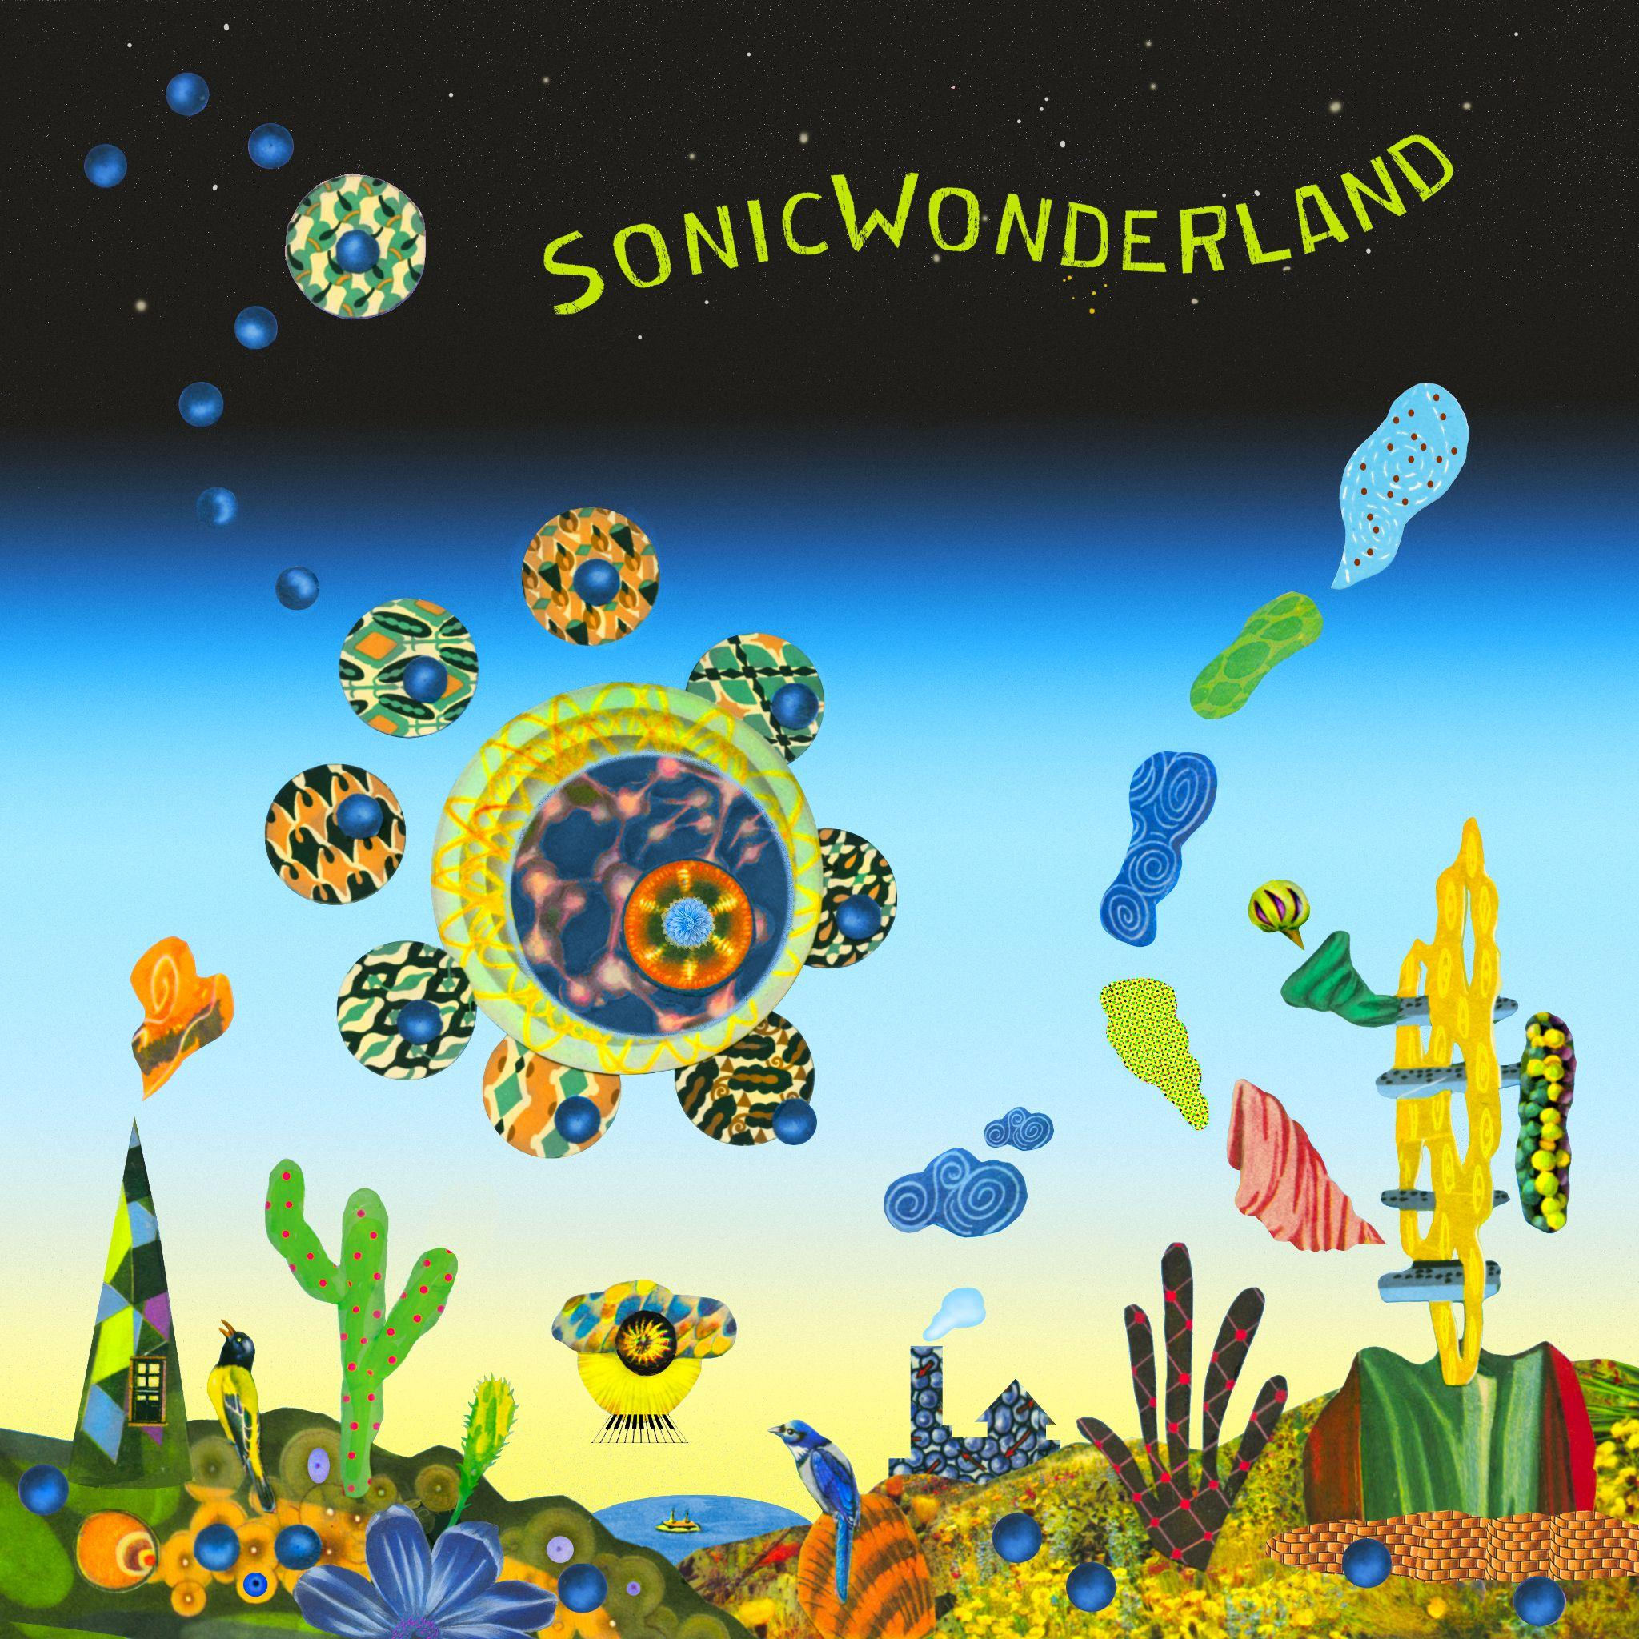

TRACK LIST:
- Wanted
- Sonicwonderland
- Polaris
- Go Go
- Up
- Reminiscence (feat. Oli Rockberger)
- Trial and error
- Utopia
- Bonus stage

TOUR DATES:
October 7 - Chan Center for the Performing Arts (Hiromi’s Sonicwonder) Vancouver, Canada

October 8 - Town Hall (Hiromi’s Sonicwonder) Seattle, WA

October 10 - Kuumbwa Jazz Center (Hiromi’s Sonicwonder) Santa Cruz, CA

October 11 - Bing Concert Hall (Hiromi’s Sonicwonder) Stanford, CA

October 13 - Sony Hall (Hiromi’s Sonicwonder) New York, NY

October 14 - Sony Hall (Hiromi’s Sonicwonder) New York, NY

October 18 - Flato Markham Theater (Hiromi’s Sonicwonder) Toronto, Canada

October 19 - Strathmore (Hiromi’s Sonicwonder) Bethesda, MD

October 20 - Stewart Theater, NC State University (Hiromi’s Sonicwonder) Raleigh, NC

Follow Hiromi:
Website: http://www.hiromiuehara.com
Facebook: https://www.facebook.com/hiromifan
Instagram: https://www.instagram.com/hiromimusic/
TikTok: https://www.tiktok.com/@hiromimusic

###

