

**BUTCHER BROWN RECRUITS PINK SIIFU & KEYON HARROLD FOR LATEST SINGLE "EYE NEVER KNEW"**

**﻿ACCLAIMED JAZZ AND HIP-HOP COLLECTIVE SET TO RELEASE NEW ALBUM SOLAR MUSIC OCT. 6 VIA CONCORD JAZZ**

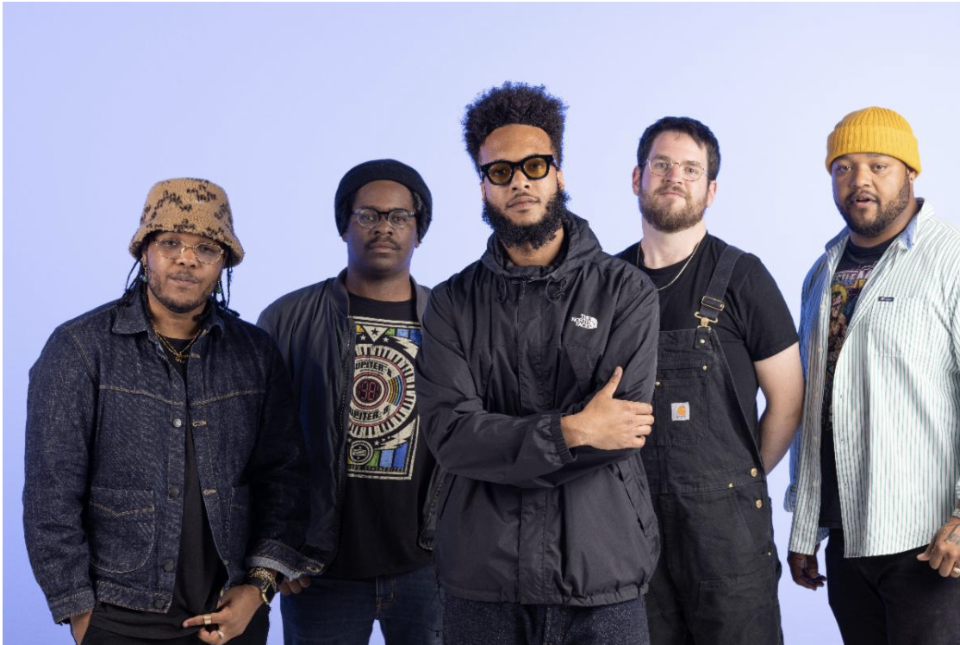

Butcher Brown by Jacky Flav (Download hi-res assets [HERE](https://drive.google.com/drive/folders/1Q7UFLHisXEWNvMxsnYCwK8mECKUctVpE?usp=share_link))

**"Eye Never Knew"**

**WATCH:** [**https://found.ee/BB_EyeNeverKnewYT**](https://found.ee/BB_EyeNeverKnewYT)

**LISTEN:** [**https://found.ee/BB_SolarMusic**](https://found.ee/BB_SolarMusic)

***Solar Music***

**PRE-ORDER/ PRE-SAVE:** [**https://found.ee/BB_SolarMusic**](https://found.ee/BB_SolarMusic)

*"A spirit of generous communion runs through 'Solar Music'"*

**The New York Times**

**(September 19, 2023) –** Critically acclaimed jazz and hip-hop fusionists Butcher Brown share "Eye Never Knew," featuring genre-agnostic artist Pink Siifu and world-class trumpeter Keyon Harrold, the latest single from the group’s forthcoming album *Solar Music,* out Oct. 6 via Concord Jazz. The album includes previously released singles "DYKWYD" featuring Braxton Cook, "This Side Of Sunshine," and "I Can Say To You," which has seen support across BBC Radio from the likes of Benji B, Gilles Peterson and Huey Morgan.

"Eye Never Knew," collides two of the musical pedigrees that have been central to the band's core since its inception. The song brings the forward-thinking and inventive delivery of hip-hop/soul/punk polymath Pink Siifu and pairs it with Butcher Brown's masterclass of jazz instrumentation. With accents from accomplished trumpeter Keyon Harrold, the result is a sonic collage that creates one of Butcher Brown's most memorable and experimental collaborations to date.

The song enlists Keyon Harrold, who contributed all trumpet playing in the Miles Davis biopic “Miles Ahead” and has worked with the likes of Diana Ross, Nas, D'Angelo, and many more. Additionally with Pink Siifu, whose 2021 *Gumbo!* album was praised by [Pitchfork](https://pitchfork.com/reviews/albums/pink-siifu-gumbo/), they collectively curate an other-worldly ambiance while maintaining their own signature sounds. Separate from "Eye Never Knew," Butcher Brown and Pink Siifu also share a number of critically acclaimed collaborations, one of which being Siifu's B.Cool-Aid Album with Ahwlee, *Leather Blvd.*, which was released earlier this year.

Described by Butcher Brown bandmates as “having something for just about everybody under the sun,” *Solar Music* collectively demonstrates the band's dynamic approach to the jazz format, and incorporates their own rich lineage of musical influences from their upbringing in Richmond – fusing elements of soul, funk, rock, and hip-hop, into a universal sound. Releasing digitally, on CD and double LP at 45 RPM, the new album incorporates longtime friends and new unexpected guests into their approach, with additional appearances by Charlie Hunter, Jay Prince, Nappy Nina, Braxton Cook and Michael Millions throughout its 17 tracks. Exclusive *Solar Music* limited edition 'Solar Red' vinyl, signed CDs/vinyl and merchandise are all available [HERE](https://found.ee/BB_SolarMusic).

Butcher Brown will perform an extensive 2023 Solar Music Global Tour, with dates across the U.S. and Europe throughout the Fall in support of the new album. The tour heads to 13 states and 7 countries and will feature domestic appearances from California to Washington, D.C., including performances at Le Poisson Rouge in New York City Oct. 18, NPR’s World Cafe Live Oct. 21, and a hometown show Nov. 24 at the Broadberry in Richmond, Virginia. In between their North American runs, Butcher Brown will bring their infectious live performances to six countries across Europe including shows at The Forge in London Nov. 6, Zenner in Berlin alongside B. Cool-Aid Nov. 8, and Le Trabendo in Paris Nov. 15.

To learn more about Butcher Brown, read the full bio below or watch their 2021 [NPR Tiny Desk (Home) performance](https://www.youtube.com/watch?v=ZfqmSZ-6Cgo). Listen to "Eye Never Knew" featuring Pink Siifu and Keyon Harrold and pre-order/ pre-save *Solar Music* above, and stay tuned for more new music from Butcher Brown coming soon.

**Butcher Brown 2023 Solar Music Global Tour Dates:**

9/22 - Harrisonburg, VA @ James Madison University

10/12 - Reno, NV @ University of Nevada

10/17 - Boston, MA @ Brighton Music Hall

10/18 - New York, NY @ (Le) Poisson Rouge

10/20 - Charlottesville, VA @ The Southern Café and Music Hall

10/21 - Philadelphia, PA @ World Cafe Live (upstairs)

10/22 - Pittsburgh, PA @ Club Cafe

10/24 - Minneapolis, MN @ Dakota

10/25 - Chicago, IL @ Sleeping Village

10/26 - Detroit, MI @ El Club

10/27 - Indianapolis, IN @ Jazz Kitchen

11/4 - Eindhoven, NL @ So What’s Next?

11/6 - London, UK @ The Forge

11/7 - Antwerp, BE @ De Roma

11/8 - Berlin, DE @ J.A.W. (Zenner)

11/9 - Mannheim, DE @ Alte Feuerwache

11/10 - Técou, FR @ Coco Jazz

11/11 - Groningen, NL @ Rockit

11/12 - Rotterdam, NL @ Rooterdam / Bird

11/13 - Amsterdam, NL @ Bimhuis

11/14 - Charloeroi, BE @ Palais des Beaux Arts

11/15 - Paris, FR @ Le Trabendo

11/18 - Eilat, IL @ Red Sea Jazz Festival

11/24 - Richmond, VA @ The Broadberry

11/25 - Washington, DC @ Atlantis

12/5 - Seattle, WA @ Madame Lou’s

12/6 - Portland, OR @ The Get Down

12/7 - San Francisco, CA @ The Independent

12/8 - Santa Cruz, CA @ Kuumbwa

12/9 - Los Angeles, CA @ Lodge Room

12/10 - San Diego, CA @ House of Blues - Voodoo Room

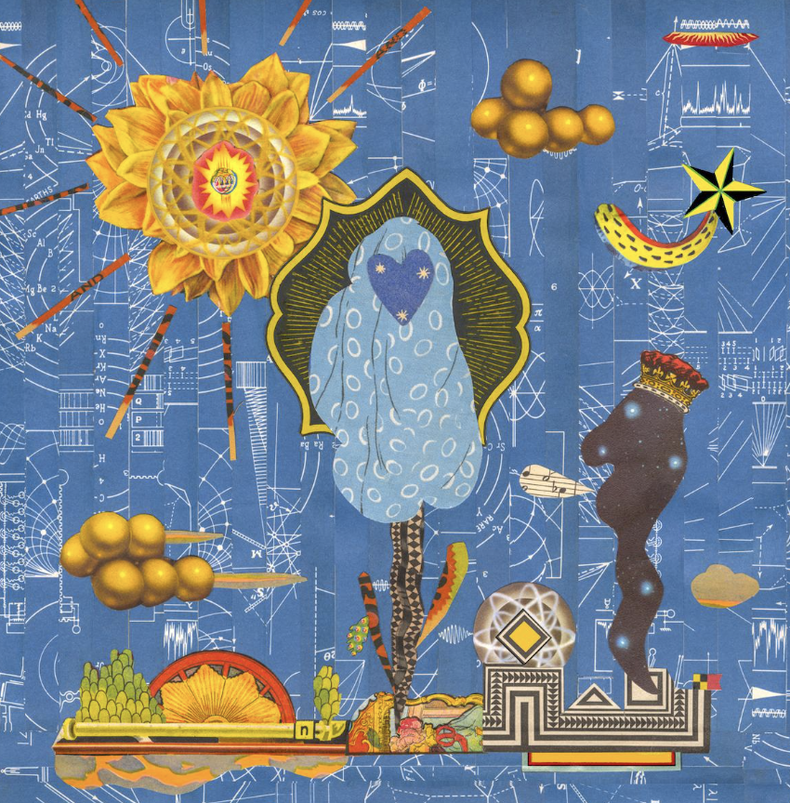

**Butcher Brown**

***Solar Music***

**Concord Jazz**

**October 6th, 2023**

1. Cozumel

2. Espionage featuring Charlie Hunter

3. I Can Say To You featuring Vanisha Gould

4. MOVE (RIDE) featuring Jay Prince

5. Turismo featuring Julia Shuren

6. Eye Never Knew featuring Pink Siifu and Keyon Harrold

7. No Way Around It

8. Half of It featuring Nappy Nina

9. DYKWYD featuring Braxton Cook

10. Happy Hourrr

11. Run It Up featuring Pink Siifu

12. Pink Fur featuring Michael Millions

13. This Side Of Sunshine

14. BubbleBath

15. Touring Pains

16. It Was Me

17. Around For A While

**More about Butcher Brown:**

“So, what kind of music do you make?” This question is the bane of every musician’s existence because it requires that they shrink down the wide expanse of their creativity to an easily (mis)understood genre description.

No matter how vivid or elaborate the description, “show” will always be more powerful than “tell.” The words we use to describe music don’t encapsulate what the listener’s experiences as much as give context clues.

That’s why Butcher Brown – the multifaceted band from Richmond, Virginia – call their sound and

their follow up to 2020’s *#KingButch* and their second release on Concord Jazz, *Solar Music*.

“Solar music” is not simply a description; it’s an invitation to listen and an invitation to *feel*.

Friends and bandmates Corey Fonville (drums), Andrew Randazzo, (bass), Morgan Burrs (guitar), Marcus “Tennishu” Tenney, (trumpet, saxophone, vocals) and Devonne “DJ Harrison” Harris (multi-instrumentalist) make music that is as diverse as their own varied tastes and backgrounds. It’s a seamlessly blended amalgam of sounds including jazz, hip-hop, rock, funk, R&B, alternative, soul, country, house, bossa nova, pop, and more. “We *are* the melting pot. We *are* the mix,” says Devonne. “I feel like that's what we represent and that's what this album represents.”

But Butcher Brown’s eclecticism isn’t for the sake of musical masturbation or to impress chin-stroking critics. Theirs is music of, and for, the people. “It’s music for everybody," says Tennishu reflecting on how well-received they’ve been on stages across the globe. “You can see it on all kinds of different faces, young, old, big, small, short, tall, they all start dancing eventually. It’s literally music for the whole solar system.”

So how did this band of brothers make the sun come out on this new album? They challenged themselves to break from routine and old formulas. “[In the past] we'd make a record, like [2014’s] *All Purpose Music* and put constraints on what we do in the studio with the thought of the live show, thinking ‘let's make this something that we can recreate at the show,’” explains Andrew. “We did that for a few records but then #*KingButch* was the one where we kind of departed from that idea and took more of a *Sgt. Pepper …* approach of, let's just explore what we can present in the studio, even if it's not something that we can pull off live.”

Realizing that listening to their albums and their live show are two distinct experiences unlocked a new level of creativity for the band. Now Butcher Brown could allow themselves to explore new sounds and approaches to songwriting and production. This new unbridled creativity informed their approach to making *Solar Music* over the course of many sessions in 2021 and 2022 at go-to studios Montrose Recording, Minimum Wage Studios, and their homebase Jellowstone.

Of course the sun is at the center of the solar system, giving us warmth, lighting our days and keeping the planet revolving around it. Similarly, when it came time to create *Solar Music* the band saw themselves at the center of their sound drawing in other like-minded musicians with gravitational pull.

What could have been an insular musical conversation between the five became a collaboration with some of their friends and faves including Oakland-bred wordsmith Nappy Nina (“Half of It”), hip-hop iconoclast Pink Siifu (“Eye Never Know,” “Run It Up”), East London rapper Jay Prince (“Move”), real-life guitar hero Charlie Hunter (“Espionage”) and more.

On the new album, Butcher Brown flexes their musicianship not only as players but also songwriters, producers, and composers collaborating with guests. “We can do everything on our own, sure, and we have done that for forever, but it's also cool to have other people come in and get their perspectives,” explains Morgan. “Butcher Brown is evolving, maturing, and we’re growing as people,” adds Corey, reflecting on the making of *Solar Music*.

The results of these collabs are extraordinary. Take the album’s first single, “I Can Say To You” for instance. “You’ll find your way/ tomorrow or today/ there’s nothing else I can say to you …,” sings guest Vanisha Gould in a voice that sounds both angelic and ancestral. “She has a voice that almost sounds like a sample, almost like Billie Holiday or something, " says Corey who sought her out to feature on the song. “It’s got that warmth, like somebody’s mama singing to you.”

Warmth, light, and connection through a sound that like the sun itself is for everyone. Welcome to *Solar Music*.

**﻿(Download hi-res assets** [**HERE**](https://drive.google.com/drive/folders/1Q7UFLHisXEWNvMxsnYCwK8mECKUctVpE?usp=share_link)**)**

**Connect with Butcher Brown:**

[**Instagram**](https://www.instagram.com/butcherbrown/?hl=en) **|** [**Twitter**](https://twitter.com/butcherbrwn) **|** [**Facebook**](https://www.facebook.com/butcherbrownband) **|** [**TikTok**](https://www.tiktok.com/@butcherbrown)

**For all Butcher Brown inquiries please contact Kevin at Orienteer:**

[**kevin@orienteer.us**](mailto:kevin@orienteer.us)

--

Kevin Cordon

Orienteer

Los Angeles, CA | New York, NY

﻿