

**BUTCHER BROWN SHARES SLOW BURNING NEW SINGLE**

**"DYWYKD" FEATURING GUEST SAXOPHONIST BRAXTON COOK**

**Acclaimed Jazz and Hip-Hop Collective Set To Release New Album *SOLAR MUSIC* Oct. 6 Via Concord Jazz**

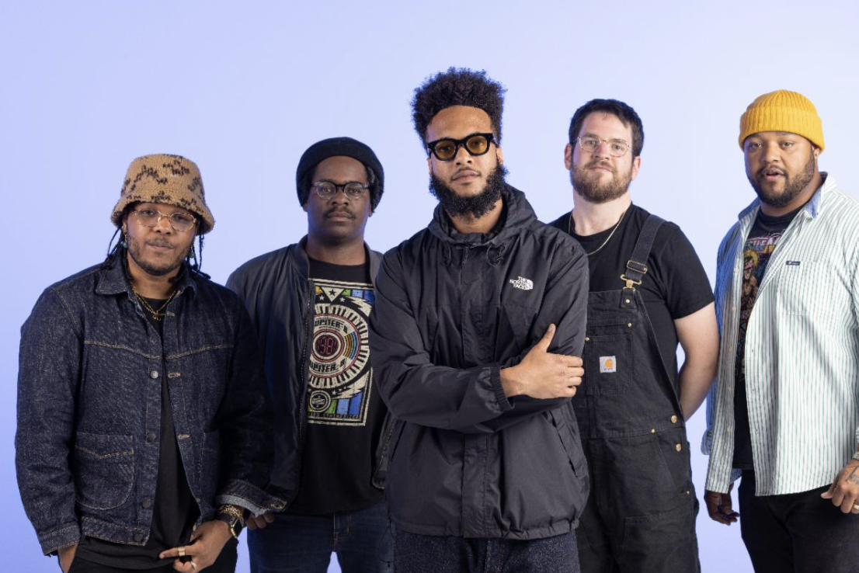

Butcher Brown by Jacky Flav (Download hi-res assets [HERE](https://drive.google.com/drive/folders/1Q7UFLHisXEWNvMxsnYCwK8mECKUctVpE?usp=share_link))

**"DYKWYD" feat. Braxton Cook**

**Watch:** [**https://found.ee/BB_DYKWYDLyricVideo**](https://found.ee/BB_DYKWYDLyricVideo)

**LISTEN:** [**LINK**](https://found.ee/BB_SolarMusic)

***Solar Music***

**PRE-ORDER:** [**https://found.ee/BB_SolarMusic**](https://found.ee/BB_SolarMusic)

(August 15, 2023) – Critically acclaimed jazz and hip-hop fusionists Butcher Brown today celebrate the release of "DYKWYD," the third single from the group’s forthcoming album *Solar Music,* out Oct. 6 via Concord Jazz.

The song – an acronym for “Do You Know What You’re Doing” – features Emmy Award-winning saxophonist [Braxton Cook](https://www.braxtoncook.com/bio), a rising voice in the urban jazz scene whose talents have been called upon by Rihanna, Mac Miller and Jon Batiste. "DYWYD" puts technical and creative musicality on display as it glides between classic R&B sounds and funk-laden bass and guitar, demonstrating the many sonic influences that have formed Butcher Brown's identity. MC Marcus Tennishu's raps carry the song's smooth momentum into Cook’s standout sax solo halfway through the song. The end result is four minutes of sonic clarity that beautifully holds the space between jazz, hip-hop and neo-soul.

Described by Butcher Brown bandmates as “having something for just about everybody under the sun,” the *Solar Music* collectively demonstrates the band's dynamic approach to the jazz format, and incorporating their own rich lineage of musical influences from their upbringing in Richmond – fusing elements of soul, funk, rock, and hip-hop, into a universal sound. Releasing digitally, on CD and double LP, the new album incorporates longtime friends and new unexpected guests into their approach, with additional appearances by Pink Siifu, Charlie Hunter, Jay Prince, Nappy Nina, Keyon Harrold and Michael Millions throughout its 17 tracks.

Following a lauded performance at Newport Jazz Festival earlier this month, Butcher Brown will embark on an extensive global tour with dates across the U.S. and Europe this fall in support of the new album. The global tour – which heads to 13 states and 7 countries – will feature domestic appearances from California to Washington DC, including a performance at NPR’s World Cafe Live Oct. 21 and a hometown show Nov. 24 at the Broadberry in Richmond, Virginia.

To learn more about Butcher Brown, read the full bio below or watch their 2021 [NPR Tiny Desk (Home) performance](https://www.youtube.com/watch?v=ZfqmSZ-6Cgo). Listen to "DYKWYD" and pre-order *Solar Music* above, and stay tuned for more new music from Butcher Brown coming soon.

**Upcoming Tour Dates:**

8/24 - Virginia Beach, VA @ Elevation 27

8/25 - Charleston, SC @ Charleston Pour House

8/26 - Asheville, NC @ Salvage Station

9/2 - Stuart, VA @ Front Porch Fest

9/22 - Harrisonburg, VA @ James Madison University

10/12 - Reno, NV @ University of Nevada

10/17 - Boston, MA @ Brighton Music Hall

10/18 - New York, NY @ Le Poisson Rouge

10/20 - Charlottesville, VA @ The Southern

10/21 - Philadelphia, PA @ World Cafe Live (upstairs)

10/22 - Pittsburgh, PA @ Club Cafe

10/24 - Minneapolis, MN @ Dakota

10/25 - Chicago, IL @ Sleeping Village

10/26 - Detroit, MI @ El Club

10/27 - Indianapolis, IN @ Jazz Kitchen\

11/4 - Eindhoven, NL @ So What’s Next?

11/6 - London, UK @ The Forge

11/7 - Antwerp, BE @ De Roma

11/8 - Berlin, DE @ J.A.W. (Zenner)

11/9 - Mannheim, DE @ Alte Feuerwache

11/10 - Técou, FR @ Coco Jazz

11/11 - Groningen, NL @ Rockit

11/12 - Rotterdam, NL @ Rooterdam / Bird

11/13 - Amsterdam, NL @ Bimhuis

11/14 - Charloeroi, BE @ Palais des Beaux Arts

11/16 - Geneva, CH @ TBA

11/24 - Richmond, VA @ The Broadberry

11/25 - Washington, DC @ Atlantis

12/5 - Seattle, WA @ Madame Lou’s

12/6 - Portland, OR @ The Get Down

12/7 - San Francisco, CA @ The Independent

12/8 - Santa Cruz, CA @ Kuumbwa

12/9 - Los Angeles, CA @ Lodge Room

12/10 - San Diego, CA @ Voodoo Room

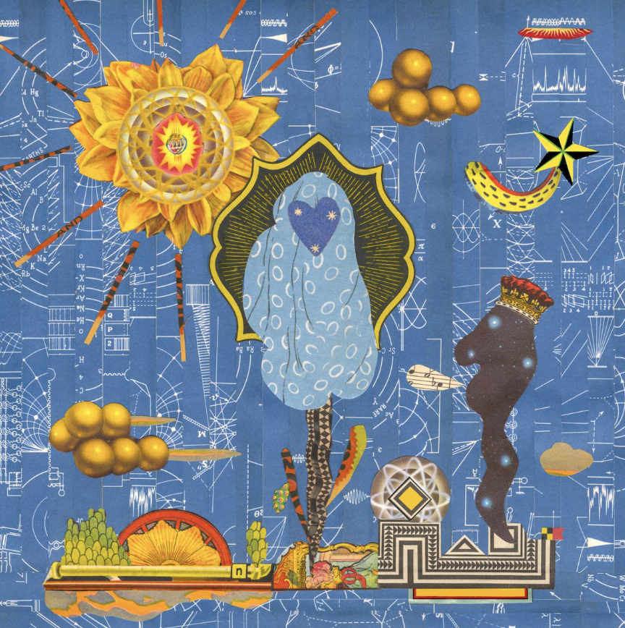

**Butcher Brown**

***Solar Music***

**Concord Jazz**

**October 6th, 2023**

1. Cozumel

2. Espionage featuring Charlie Hunter

3. I Can Say To You featuring Vanisha Gould

4. MOVE (RIDE) featuring Jay Prince

5. Turismo featuring Julia Shuren

6. Eye Never Knew featuring Pink Siifu and Keyon Harrold

7. No Way Around It

8. Half of It featuring Nappy Nina

9. DYKWYD featuring Braxton Cook

10. Happy Hourrr

11. Run It Up featuring Pink Siifu

12. Pink Fur featuring Michael Millions

13. This Side Of Sunshine

14. BubbleBath

15. Touring Pains

16. It Was Me

17. Around For A While

**More about Butcher Brown:**

“So, what kind of music do you make?” This question is the bane of every musician’s existence because it requires that they shrink down the wide expanse of their creativity to an easily (mis)understood genre description.

No matter how vivid or elaborate the description, “show” will always be more powerful than “tell.” The words we use to describe music don’t encapsulate what the listener’s experiences as much as give context clues.

That’s why Butcher Brown – the multifaceted band from Richmond, Virginia – call their sound and their follow up to 2020’s *#KingButch* and their second release on Concord Jazz, *Solar Music*.

“Solar music” is not simply a description; it’s an invitation to listen and an invitation to *feel*.

Friends and bandmates Corey Fonville (drums), Andrew Randazzo, (bass), Morgan Burrs (guitar), Marcus “Tennishu” Tenney, (trumpet, saxophone, vocals) and Devonne “DJ Harrison” Harris (multi-instrumentalist) make music that is as diverse as their own varied tastes and backgrounds. It’s a seamlessly blended amalgam of sounds including jazz, hip-hop, rock, funk, R&B, alternative, soul, country, house, bossa nova, pop, and more. “We *are* the melting pot. We *are* the mix,” says Devonne. “I feel like that's what we represent and that's what this album represents.”

But Butcher Brown’s eclecticism isn’t for the sake of musical masturbation or to impress chin-stroking critics. Theirs is music of, and for, the people. “It’s music for everybody," says Tennishu reflecting on how well-received they’ve been on stages across the globe. “You can see it on all kinds of different faces, young, old, big, small, short, tall, they all start dancing eventually. It’s literally music for the whole solar system.”

So how did this band of brothers make the sun come out on this new album? They challenged themselves to break from routine and old formulas. “[In the past] we'd make a record, like [2014’s] *All Purpose Music* and put constraints on what we do in the studio with the thought of the live show, thinking ‘let's make this something that we can recreate at the show,’” explains Andrew. “We did that for a few records but then #*KingButch* was the one where we kind of departed from that idea and took more of a *Sgt. Pepper …* approach of, let's just explore what we can present in the studio, even if it's not something that we can pull off live.”

Realizing that listening to their albums and their live show are two distinct experiences unlocked a new level of creativity for the band. Now Butcher Brown could allow themselves to explore new sounds and approaches to songwriting and production. This new unbridled creativity informed their approach to making *Solar Music* over the course of many sessions in 2021 and 2022 at go-to studios Montrose Recording, Minimum Wage Studios, and their homebase Jellowstone.

Of course the sun is at the center of the solar system, giving us warmth, lighting our days and keeping the planet revolving around it. Similarly, when it came time to create *Solar Music* the band saw themselves at the center of their sound drawing in other like-minded musicians with gravitational pull.

What could have been an insular musical conversation between the five became a collaboration with some of their friends and faves including Oakland-bred wordsmith Nappy Nina (“Half of It”), hip-hop iconoclast Pink Siifu (“Eye Never Know,” “Run It Up”), East London rapper Jay Prince (“Move”), real-life guitar hero Charlie Hunter (“Espionage”) and more.

On the new album, Butcher Brown flexes their musicianship not only as players but also songwriters, producers, and composers collaborating with guests. “We can do everything on our own, sure, and we have done that for forever, but it's also cool to have other people come in and get their perspectives,” explains Morgan. “Butcher Brown is evolving, maturing, and we’re growing as people,” adds Corey, reflecting on the making of *Solar Music*.

The results of these collabs are extraordinary. Take the album’s first single, “I Can Say To You” for instance. “You’ll find your way/ tomorrow or today/ there’s nothing else I can say to you …,” sings guest Vanisha Gould in a voice that sounds both angelic and ancestral. “She has a voice that almost sounds like a sample, almost like Billie Holiday or something, " says Corey who sought her out to feature on the song. “It’s got that warmth, like somebody’s mama singing to you.”

Warmth, light, and connection through a sound that like the sun itself is for everyone. Welcome to *Solar Music*.

**﻿(Download hi-res assets** [**HERE**](https://drive.google.com/drive/folders/1Q7UFLHisXEWNvMxsnYCwK8mECKUctVpE?usp=share_link)**)**

**Connect with Butcher Brown:**

[**Instagram**](https://www.instagram.com/butcherbrown/?hl=en) **|** [**Twitter**](https://twitter.com/butcherbrwn) **|** [**Facebook**](https://www.facebook.com/butcherbrownband) **|** [**TikTok**](https://www.tiktok.com/@butcherbrown)

**For all Butcher Brown inquiries please contact Kevin at Orienteer:**

**kevin@orienteer.us**

**﻿**

--

Kevin Cordon

Orienteer

Los Angeles, CA | New York, NY