**Keyon Harrold Releases “Beautiful Day” Featuring PJ Morton From New Album *Foreverland* (Out Friday / Concord Jazz)**

**Listen To “Beautiful Day” Here:**

[**https://found.ee/KeyonHarrold_Foreverland**](https://found.ee/KeyonHarrold_Foreverland)

***Foreverland* Also Features Common, Robert Glasper, Jean Baylor, Laura Mvula, Malaya**

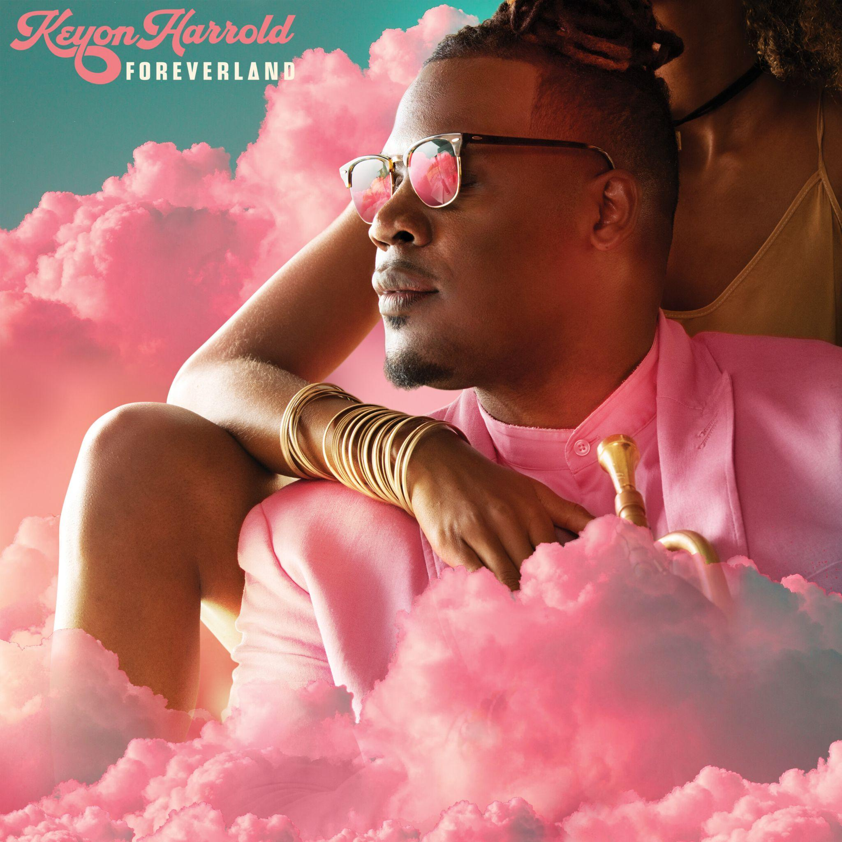

*“Genre-defying post-bop”* - **The Guardian**

*“Rumbles like thunder” -* **Downbeat**

*“A closely produced set that supports and surrounds his elegant, soulful fluency with vocals, edgy beats and rap”* - **Financial Times**

*“Foreverland is not merely good music. It is great music”* **- NYC Jazz Record**

**January 16, 2024** - - Today, trumpeter/composer Keyon Harrold has released “Beautiful Day,” the final single from his forthcoming third studio album, *Foreverland,* out this Friday on Concord Jazz. Harrold’s longtime collaborator and friend PJ Morton lends a wistful vocal to a song that is infused with positivity, reveling in the gifts of everyday existence and is “about taking ownership and accountability for our lives,” says Keyon. In addition to early album raves, a tour that launches this Friday in Los Angeles, and upcoming key media appearances, Keyon was also just a clue on Jeopardy (*Jazz trumpeter Keyon Harrold can be heard on "Stay," by this late rapper* / answer: Mac Miller).

**Listen to “Beautiful Day” featuring PJ Morton here**: <https://found.ee/KeyonHarrold_Foreverland>

“It's such a beautiful thing to create music that comes from the heart and soul. ‘Beautiful Day’ is a song that PJ Morton and I wrote together in New Orleans, after a heart-to-heart conversation about life. We've been making music together for years, and every collaboration is just as special as the last. PJ is truly one of my favorite songwriters and artists, and it was an absolute honor to create ‘Beautiful Day’ for my *Foreverland* Album.” – Keyon Harrold

*Foreverland* features 10 timely and timeless original compositions that explore themes of empowerment, positivity, love, loss, and vulnerability. A sought-after trumpeter by A-listers like Jay-Z, Beyonce, Rihanna, Eminem, Maxwell, Mac Miller, and Snoop Dogg to name a few Keyon has been widely celebrated for his ability to bridge jazz, R&B, hip-hop, and pop, earning him titles like “a certified legend in the game” by Okay Player and “the future of the trumpet” by Office Magazine. The vinyl version of *Foreverland* will be released April 5.

To celebrate *Foreverland’s* release, Harrold will host a run of shows at the [Blue Note in New York City](https://www.bluenotejazz.com/nyc/shows/?eid=13723588) from January 22-24. The shows will celebrate *Foreverland* with special guests and unfiltered, uncut performances of all of the songs on the new record, many of which Harrold will play live for the first time. He’ll also perform at [The Sun Rose in Los Angeles](https://dice.fm/event/yw6mv-keyon-harrold-performing-foreverland-19th-jan-the-sun-rose-los-angeles-tickets) on Jan 19 and 20 and has a full slate of dates scheduled, see below for full itinerary.

Harrold has previously released three singles from the record: “[**Don’t Lie**](https://www.youtube.com/watch?v=p-Z9LG8EYPM)” featuring Malaya, “**[Foreverland](https://found.ee/KeyonHarrold_Foreverland)**” ﻿Featuring Laura Mvula and Chris Dave, and “[**Find Your Peace**](https://streaklinks.com/Buxc8kw-fsYg4CzCcgJL_CQv/https%3A%2F%2Fyoutu.be%2Fko8hFjLk1Xk%3Fsi%3DomVbEwzp8Ulh-AQC?email=chansen%40shorefire.com),” featuring Robert Glasper and Common. “Find Your Peace,” one of the album’s standout tracks, is a poignant reflection on the racial assault he and his son experienced in a NYC hotel lobby in 2020. The song reflects his journey toward self-improvement, tackling timely themes like race relations and his pride as a Black father from Ferguson. It speaks to timely issues, like race relations and his pride in being a Black father.

*Foreverland* is proudly emotional and dramatic, a triumphant journey that takes the listener through the good, the bad, the ugly and the beautiful experiences that lead to wisdom. Says Harrold: “What I can offer as a musician who plays an instrument with no words is an honest conveyance of emotion. Some of these notes, I play them because there’s not a better word.”

*Foreverland* is a family affair — nearly every musician is a longtime friend, and Harrold accounts the record’s warmness to this dynamic. “It’s like the ingredients of a great meal: you don’t need just any pepper, you need a certain kind. Every musician on this record is a rare and essential element.” In addition to the aforementioned PJ Morton, the incredible full lineup includes Common, Robert Glasper, Jean Baylor, Mayala, Laura Mvula, Chris Dave and legendary musician Greg Phillinganes, known for his keyboard work on Thriller and many other classic recordings. The album was recorded with a dream team of Harrold’s longtime friends and collaborators, including Marcus Gilmore on drums, Nir Felder, Randy Runyon and Justus West on guitar, Burniss “Boom” Travis and Brandon Owens on bass, BIGYUKI, Shedrick Mitchell and Jahari Stampley on piano/keyboards, and Jahi Sundance on turntables. In addition to singing on “Find Your Peace,” Harrold also sings or speaks on four other tracks.

Harrold was born and raised in Ferguson, MO to a musical family - the son of pastors and one of 16 children, and moved to New York to study at The Mannes Conservatory of Music at The New School. While there he landed his first major gig with Common, an experience which he says broadened his musical horizons beyond jazz to include funk, Afrobeat, R&B, and hip hop. He released his solo album, *Introducing Keyon Harrold*, in 2009, and then won wide acclaim for his trumpet performances in Don Cheadle’s Miles Davis biopic *Miles Ahead*, which featured him on the GRAMMY-winning soundtrack for the film. 2017’s *The Mugician* featured Pharoahe Monch, Gary Clark, Jr., Big K.R.I.T., Guy Torry, Georgia Anne Muldrow and Robert Glasper. It was praised by the NY Times as "a stirring piece that consolidates elegy and exhortation" and AllMusic celebrated the album’s “alchemical swagger.” Hailed as “the future of the trumpet” by Wynton Marsalis, Harrold has toured the globe, playing the world’s top venues and festival stages, and will be touring extensively over the next year. He was recently on tour with Raphael Saadiq’s Tony! Toni! Tone!, worked on the music for the HBO show *Winning Time*, and is featured on the new Butcher Brown album alongside Pink Siifu.

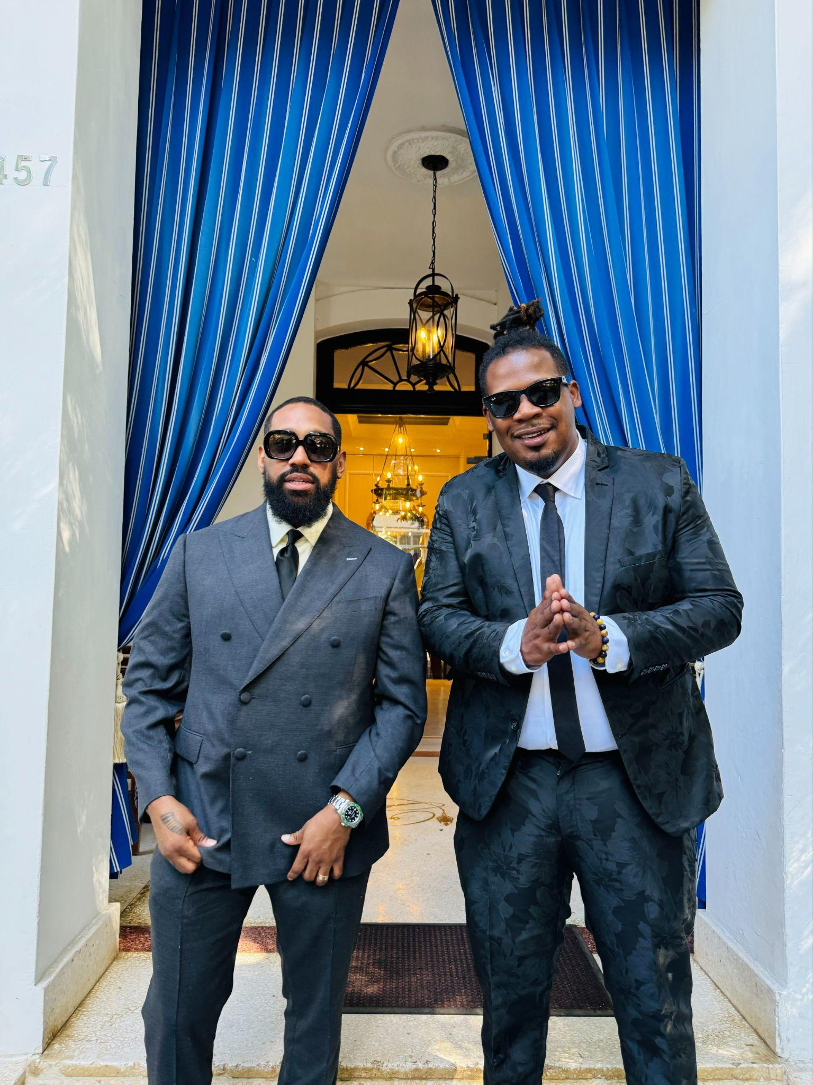

**[Photo Credit: DL Warfield]**

**Track Listing**

1. Find Your Peace featuring Common, Robert Glasper, Jean Baylor
2. Beautiful Day featuring PJ Morton
3. The Intellectual
4. Foreverland featuring Laura Mvula
5. Well Walk Now (Perseverance)
6. Don’t Lie featuring Malaya
7. Paranoid
8. Gotta Go (Outer Space)
9. Pictures
10. Peace Beyond

**Tour Dates:**

1/19: The Sun Rose – Los Angeles, CA

1/20: The Sun Rose – Los Angeles, CA

1/22: Blue Note New York – New York, NY

1/23: Blue Note New York – New York, NY

1/24: Blue Note New York – New York, NY

1/26: Jazz St. Louis – St. Louis, MO

1/27: Jazz St. Louis – St. Louis, MO

2/16-2/24: Capital Jazz Cruise – Ft Lauderdale, FL

2/25: Portland Jazz Festival – Portland, OR

3/2: Ronnie Scott’s– London, UK

3/5: Blue Note Milano – Milan, Italy

3/6: New Morning – Paris, France

3/9: Transition Festival – Utrecht, Netherlands

3/10: Bird – Rotterdam, Holland

3/11: Jazzclub Q4 – Rheinfelden, Switzerland

3/12: Jassmine – Warsaw, Poland

3/13: Cabaret des Péchés - Brno, Czechia

3/14: Jazz Dock – Prague, Czechia

3/16: Fasching – Stockholm, Sweden

3/29: Blue Llama – Ann Arbor, MI

3/30: Blue Llama – Ann Arbor, MI

7/1 - 7/3: Montreal Jazz Festival – Montreal, Canada

**https://shorefire.com/roster/keyon-harrold**

**https://www.keyonharrold.com/**