Hiromi Announces New Album Sonicwonderland out October 6 (Telarc)

Electrifying New Band Sonicwonder Features Hadrien Feraud (Bass), Gene Coye (Drums) and Adam O'Farrill (Trumpet)

Listen to Title Track “Sonicwonderland”: https://found.ee/Hiromi_Sonicwonderland

Watch the Music Video: https://found.ee/Hiromi_SonicMusicVideo
Album Trailer: https://found.ee/SonicwonderlandAlbumTrailer

Confirms October North American Tour

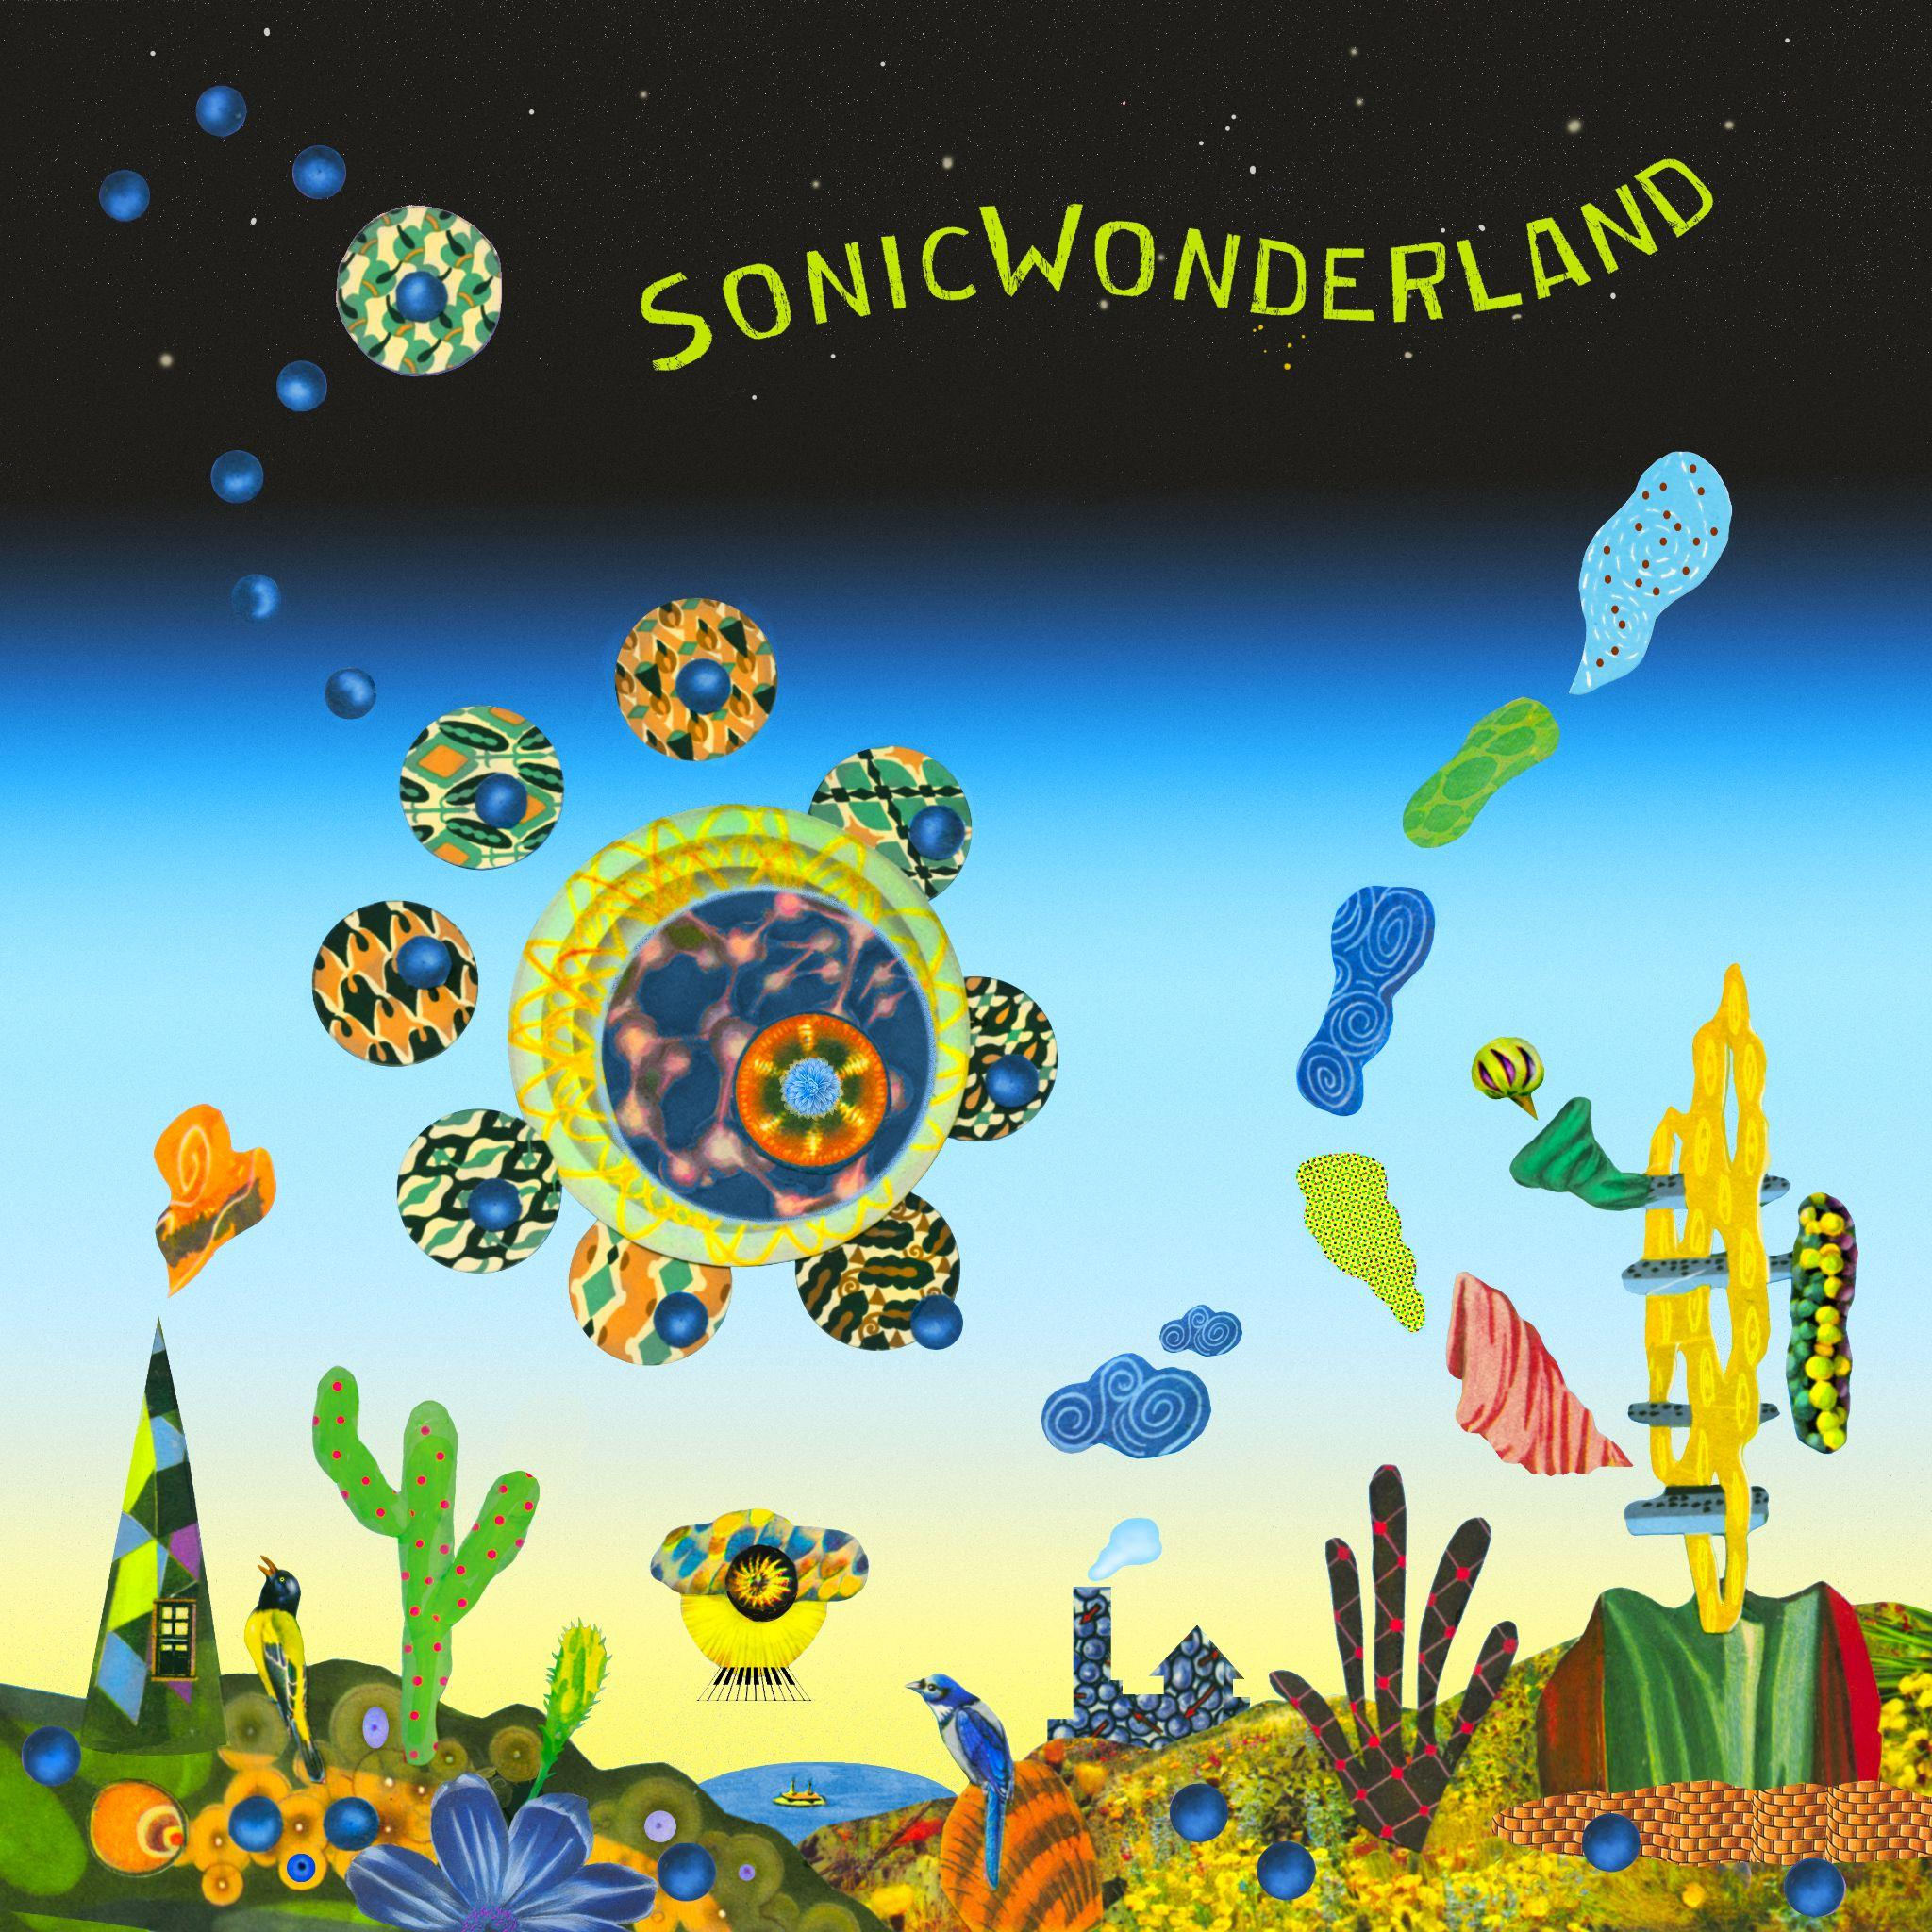

August 18, 2023 - - Hiromi has announced Sonicwonderland, the internationally celebrated and GRAMMY-winning pianist and composer’s new album to be released on October 6 (Telarc). Sonicwonderland represents a new musical adventure for the constantly evolving pianist and composer, who is a star in her native Japan, and burst onto the music scene 20 years ago with her debut album. Recorded with a new quartet, called Hiromi’s Sonicwonder, the album features 9 new works bursting with synthesizer and deep-in-the pocket grooves. Hiromi dazzles at the keyboard, striking a balance of playing that is powerful, aggressive and delicate. She has also announced a select run of shows performing this new album in North America in October.

Hiromi’s Sonicwonder is a quartet featuring blossoming young talents Hadrien Feraud (bass), Gene Coye (drums), and Adam O'Farrill (trumpet) and began performing live together earlier this spring. Sonicwonderland was recorded May 25-28 at Skywalker Sound Stage in Nicasio, California, where Hiromi also recorded her 2019 solo piano album Spectrum. In addition to new works written for this project, the album includes songs that were released on her "One Minute Portrait" YouTube initiative during the pandemic and rearranged for this band. UK singer/songwriter/keyboardist Oli Rockberger also contributes vocals to "Reminiscence" (lyrics co-written by Hiromi and Rockberger).

Today Hiromi has shared the album’s title track, listen to “Sonicwonderland” here:
https://found.ee/Hiromi_Sonicwonderland

Watch the music video, inspired by old school video games, here: https://found.ee/Hiromi_SonicMusicVideo

And learn more about the project in this album trailer: https://found.ee/SonicwonderlandAlbumTrailer

“Sonicwonderland” is a preview of the album’s many delights: it kicks off with a thumping sequenced synthesizer groove that’s more dance club than jazz club. It’s fast-paced, fun, and unfurls into an 8-minute adventure of open space and improvisation. While other songs feature quick tempos, funk grooves and synth work (“Trial and Error,” “Go Go”), Hiromi works gracefully on acoustic piano extensively throughout, her elegant playing and composition work shines on pieces such as “Polaris” and “Utopia.” The closing track, “Bonus Stage,” is a lively, modern take on traditional jazz, with a short intro that could be mistaken for a video game soundtrack.

"The word 'wonder' has a lot of meaning. It fits the musical view that I have for this project…it is definitely a new adventure for me," says Hiromi.

Sonicwonderland is Hiromi’s 12th studio album, a prolific artist who has explored a number of musical spheres over the course of her career. Earlier this year she recorded the soundtrack to Blue Giant, a motion picture film based on the manga series of the same name. 2021's Silver Lining Suite features her with a string quartet and 2019's Spectrum a solo piano recording. Her work has been celebrated by the New York Times, NPR and NPR Music, the Washington Post and beyond, and she was a featured performer at the Tokyo Olympics opening ceremony in 2021. She has worked with Stanley Clark, Chick Corea, Ahmad Jamal (who produced her first album and was her mentor), and many other jazz luminaries throughout her career, is a perennial favorite on DownBeat’s Annual Critics Poll, and has performed at the world’s finest jazz festivals.

The Sonicwonderland cover was created by Lou Beach, famous for his Weather Report album covers, not to mention Blink 182's Dude Ranch and albums by Flying Burrito Brothers, Madonna and Weird Al.

Pre-order here: https://found.ee/Hiromi_Sonicwonderland

[Press photo: Mitsuru Nishimura]

TRACK LIST:
- Wanted
- Sonicwonderland
- Polaris
- Go Go
- Up
- Reminiscence (feat. Oli Rockberger)
- Trial and error
- Utopia
- Bonus stage

TOUR DATES:
October 7 - Chan Center for the Performing Arts (Hiromi’s Sonicwonder) Vancouver, Canada

October 8 - Town Hall (Hiromi’s Sonicwonder) Seattle, WA

October 10 - Kuumbwa Jazz Center (Hiromi’s Sonicwonder) Santa Cruz, CA

October 11 - Bing Concert Hall (Hiromi’s Sonicwonder) Stanford, CA

October 13 - Sony Hall (Hiromi’s Sonicwonder) New York, NY

October 14 - Sony Hall (Hiromi’s Sonicwonder) New York, NY

October 18 - Flato Markham Theater (Hiromi’s Sonicwonder) Toronto, Canada

October 19 - Strathmore (Hiromi’s Sonicwonder) Bethesda, MD

October 20 - Stewart Theater, NC State University (Hiromi’s Sonicwonder) Raleigh, NC

###

