

BUTCHER BROWN SHARES NEW SINGLE
"THIS SIDE OF SUNSHINE" FROM NEW ALBUM SOLAR MUSIC OUT OCTOBER 6 VIA
CONCORD JAZZ

2023 SOLAR MUSIC WORLD TOUR BEGINS
AUGUST 4

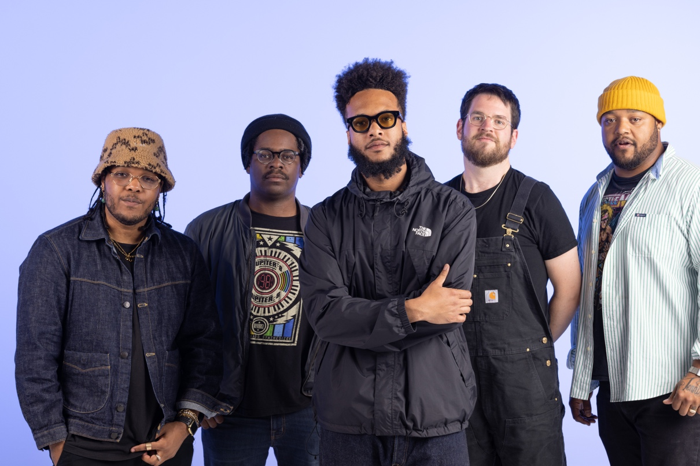

Butcher Brown photo by Jacky Flav (Download hi-res assets HERE)

"This Side Of Sunshine" (Single Edit)
WATCH: https://found.ee/BB_ThisSideofSunshineYT
LISTEN: https://found.ee/BB_SolarMusic
Solar Music
PRE-ORDER: https://found.ee/BB_SolarMusic
(July 18, 2023) - Acclaimed jazz and hip-hop fusionists Butcher Brown announce its latest single "This Side Of Sunshine," an imaginative reinvention of Roy Ayers' masterful but lesser-known cut. The single is the band’s first offering from its forthcoming album Solar Music, which is set to release digitally, on CD and double-sided LP October 6 via Concord Jazz. In support of the new music, Butcher Brown will embark on an extensive global tour with dates across the U.S. and Europe this fall.

In keeping with the slow pace of the new song, Butcher Brown’s rendition highlights the role that funk and soul play in the band's musical foundation. With half of the song dominated by the wistful sounds of the drums, guitar and bass, the band demonstrates a thorough understanding of soul without tampering with the original version's ingenuity. The single is also accompanied by an animated visual by Chris Acosta. Check it out HERE.

Speaking on the decision to rework "This Side Of Sunshine," Butcher Brown drummer Corey Fonville says, "It’s important to give masters their flowers. Roy Ayers created a new wave that impacted so many of the younger artists, and with his originality he made timeless classics. This song is everything we love about his music and casually is a sleeper you don't hear people discuss."

Solar Music follows the group’s critically acclaimed 2022 album Butcher Brown Presents Triple Trey, which NPR said “sizzles from the first note” and Pitchfork described as “finding a natural home within the comfortable confines of hip-hop and big-band jazz.” In kind, the new record demonstrates the essence of Butcher Brown down to its core – incorporating a rich lineage of musical influences from its band members’ upbringing in Richmond, Virginia to fuse soul, funk, rock, and hip-hop into a universal sound.

In support of the new music, Butcher Brown’s 2023 global tour will bring the group’s explosive live show to cities across the U.S. and Europe. The tour – which heads to 13 states and 7 countries – kicks off Aug. 4 at Newport Jazz Festival in Rhode Island. Other standout stateside performances include Telluride Jazz Festival August 11-12, an appearance at NPR’s World Cafe Live Oct. 21 and a hometown show Nov. 24 at the Broadberry in Richmond, Virginia.

To learn more about Butcher Brown, read the full bio below or watch their 2021 NPR Tiny Desk performance. Listen to "This Side Of Sunshine" and pre-order Solar Music above, and stay tuned for more new music from Butcher Brown coming soon.

Butcher Brown 2023 Solar Music World Tour Dates:
Aug. 4 – Newport, RI – Newport Jazz Festival
Aug. 5-6 – Happy Valley, OR – Pickathon
Aug. 11-12 – Telluride, CO – Telluride Jazz Festival
Aug. 24 – Virginia Beach, VA – Elevation 27
Aug. 25 – Charleston, SC – Charleston Pour House
Aug. 26 – Asheville, NC – Salvage Station
Sept. 2 – Stuart, VA – Front Porch Fest
Sept. 22 – Harrisonburg, VA – James Madison University
Oct. 12 – Reno, NV – University of Nevada
Oct. 17 – Boston, MA – Brighton Music Hall
Oct. 18 – New York, NY – Le Poisson Rouge
Oct. 20 - Charlottesville, VA – The Southern Cafe and Music Hall
Oct. 21 – Philadelphia, PA – World Cafe Live (Upstairs)
Oct. 22 – Pittsburgh, PA – Club Cafe
Oct. 24 – Minneapolis, MN – Dakota
Oct. 25 – Chicago, IL – Sleeping Village
Oct. 26 – Detroit, MI – El Club
Oct. 27 – Indianapolis, IN – Jazz Kitchen
Nov. 4 – Eindhoven, NL – So What’s Next?
Nov. 6 – London, UK – The Forge
Nov. 7 – Antwerp, BE – De Roma
Nov. 8 – Berlin, DE – Zenner
Nov. 9 – Mannheim, DE – Alte Feuerwache
Nov. 10 – Técou, FR – Coco Jazz
Nov. 11 – Groningen, NL – Rockit
Nov. 12 – Rotterdam, NL – BIRD
Nov. 13 – Amsterdam, NL – Bimhuis
Nov. 14 – Charloeroi, BE – Palais des Beaux Arts
Nov. 15 – Paris, FR – Trabendo
Nov. 16 - Geneva, CH – TBA
Nov. 24 – Richmond, VA – The Broadberry
Nov. 25 – Washington, DC – Atlantis
Dec. 5 – Seattle, WA – Madame Lou’s
Dec. 6 – Portland, OR – The Get Down
Dec. 7 – San Francisco, CA – The Independent
Dec. 8 – Santa Cruz, CA – Kuumbwa
Dec. 9 – Los Angeles, CA – Lodge Room
Dec. 10 – San Diego, CA – Voodoo Room
.

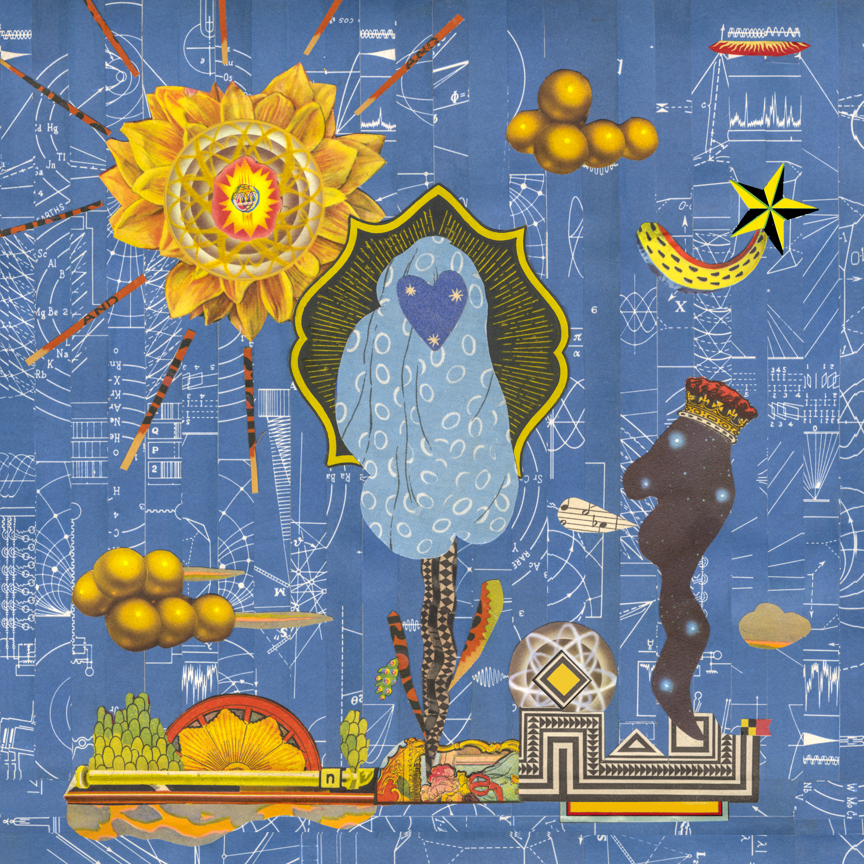

Butcher Brown
Solar Music
Concord Jazz
October 6th, 2023

1. Cozumel
2. Espionage featuring Charlie Hunter
3. I Can Say To You featuring Vanisha Gould
4. MOVE (RIDE) featuring Jay Prince
5. Turismo featuring Julia Shuren
6. Eye Never Knew featuring Pink Siifu and Keyon Harrold
7. No Way Around It
8. Half of It featuring Nappy Nina
9. DYKWYD featuring Braxton Cook
10. Happy Hourrr
11. Run It Up featuring Pink Siifu
12. Pink Fur featuring Michael Millions
13. This Side Of Sunshine
14. BubbleBath
15. Touring Pains
16. It Was Me
17. Around For A While

More about Butcher Brown:
“So, what kind of music do you make?” This question is the bane of every musician’s existence because it requires that they shrink down the wide expanse of their creativity to an easily (mis)understood genre description.

No matter how vivid or elaborate the description, “show” will always be more powerful than “tell.” The words we use to describe music don’t encapsulate what the listener’s experiences as much as give context clues.

That’s why Butcher Brown – the multifaceted band from Richmond, Virginia – call their sound and their follow up to 2020’s #KingButch and their second release on Concord Jazz, Solar Music.

“Solar music” is not simply a description; it’s an invitation to listen and an invitation to feel.

Friends and bandmates Corey Fonville (drums), Andrew Randazzo, (bass), Morgan Burrs (guitar), Marcus “Tennishu” Tenney, (trumpet, saxophone, vocals) and Devonne “DJ Harrison” Harris (multi-instrumentalist) make music that is as diverse as their own varied tastes and backgrounds. It’s a seamlessly blended amalgam of sounds including jazz, hip-hop, rock, funk, R&B, alternative, soul, country, house, bossa nova, pop, and more. “We are the melting pot. We are the mix,” says Devonne. “I feel like that's what we represent and that's what this album represents.”

But Butcher Brown’s eclecticism isn’t for the sake of musical masturbation or to impress chin-stroking critics. Theirs is music of, and for, the people. “It’s music for everybody," says Tennishu reflecting on how well-received they’ve been on stages across the globe. “You can see it on all kinds of different faces, young, old, big, small, short, tall, they all start dancing eventually. It’s literally music for the whole solar system.”

So how did this band of brothers make the sun come out on this new album? They challenged themselves to break from routine and old formulas. “[In the past] we'd make a record, like [2014’s] All Purpose Music and put constraints on what we do in the studio with the thought of the live show, thinking ‘let's make this something that we can recreate at the show,’” explains Andrew. “We did that for a few records but then #KingButch was the one where we kind of departed from that idea and took more of a Sgt. Pepper … approach of, let's just explore what we can present in the studio, even if it's not something that we can pull off live.”

Realizing that listening to their albums and their live show are two distinct experiences unlocked a new level of creativity for the band. Now Butcher Brown could allow themselves to explore new sounds and approaches to songwriting and production. This new unbridled creativity informed their approach to making Solar Music over the course of many sessions in 2021 and 2022 at go-to studios Montrose Recording, Minimum Wage Studios, and their homebase Jellowstone.

Of course the sun is at the center of the solar system, giving us warmth, lighting our days and keeping the planet revolving around it. Similarly, when it came time to create Solar Music the band saw themselves at the center of their sound drawing in other like-minded musicians with gravitational pull.

What could have been an insular musical conversation between the five became a collaboration with some of their friends and faves including Oakland-bred wordsmith Nappy Nina (“Half of It”), hip-hop iconoclast Pink Siifu (“Eye Never Know,” “Run It Up”), East London rapper Jay Prince (“Move”), real-life guitar hero Charlie Hunter (“Espionage”) and more.

On the new album, Butcher Brown flexes their musicianship not only as players but also songwriters, producers, and composers collaborating with guests. “We can do everything on our own, sure, and we have done that for forever, but it's also cool to have other people come in and get their perspectives,” explains Morgan. “Butcher Brown is evolving, maturing, and we’re growing as people,” adds Corey, reflecting on the making of Solar Music.

The results of these collabs are extraordinary. Take the album’s first single, “I Can Say To You” for instance. “You’ll find your way/ tomorrow or today/ there’s nothing else I can say to you …,” sings guest Vanisha Gould in a voice that sounds both angelic and ancestral. “She has a voice that almost sounds like a sample, almost like Billie Holiday or something, " says Corey who sought her out to feature on the song. “It’s got that warmth, like somebody’s mama singing to you.”

Warmth, light, and connection through a sound that like the sun itself is for everyone. Welcome to Solar Music.

(Download hi-res assets HERE)

Connect with Butcher Brown:
Instagram | Twitter | Facebook | TikTok

For all Butcher Brown inquiries please contact Kevin at Orienteer:
kevin@orienteer.us

--
Kevin Cordon
Orienteer
Los Angeles, CA | New York, NY

