

BUTCHER BROWN ANNOUNCES GLOBAL FALL TOUR

NEW ALBUM SOLAR MUSIC OUT OCTOBER 6TH VIA CONCORD JAZZ

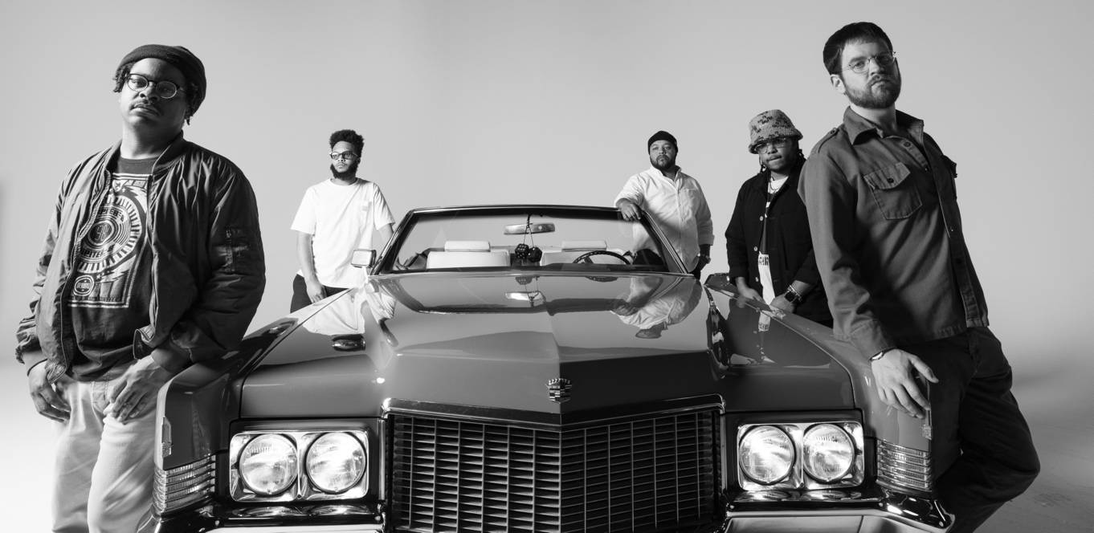
Butcher Brown by Jacky Flav

Tour
https://butcherbrown.com/#tour

Solar Music
PRE-ORDER/LISTEN: https://found.ee/BB_SolarMusic

(June 20, 2023) - Following the recent news of their forthcoming album Solar Music out October 6th via Concord Jazz, Butcher Brown announces their global release tour kicking off this Fall. Preceded by a run of festival dates this summer including Hollywood Bowl Jazz Festival, Newport Jazz Festival and Telluride Jazz Fest, the headlining tour will begin October 17th in Boston and extend through the end of November, making stops in over 20 cities including New York City, Chicago, Paris, London and Amsterdam. Tickets go on sale Friday, June 23rd at 12PM local time and are available here.

Solar Music follows their critically-acclaimed 2022 album Butcher Brown Presents Triple Trey, where they collided a hip-hop album with big band jazz and demonstrates the essence of Butcher Brown down to its core. While rooted in jazz, the band explores the through lines between genres and generations, which is clearly evident on the album's lead single, "I Can Say To You" featuring vocalist Vanisha Gould.

The album draws its name from a descriptor the band has come to use to categorize their music, the scope of which is decidedly broad and defies categorization altogether. Solar Music demonstrates the band's dynamic approach to the jazz format, and incorporating their own rich lineage of musical influences from their upbringing in Richmond, fusing elements of soul, funk, rock, and hip-hop, into music that is universal. Incorporating longtime friends and new, unexpected guests into their approach, the album features the likes of Pink Siifu, Charlie Hunter, Braxton Cook, Jay Prince, Nappy Nina, Keyon Harrold, Michael Millions and more.

Reflecting on their latest project the band shares: "Solar Music is everything under the sun. We get asked so often what type of genre we fall into, and at the end of the day, we play all of our influences. It’s not genre specific..It’s all types, & this album is a true representation of that. Solar Music is for everybody.”

Pre-order Butcher Brown's new album Solar Music above, check out all of their upcoming live dates and more info on their new album below, and stay tuned for more new music from Butcher Brown soon.

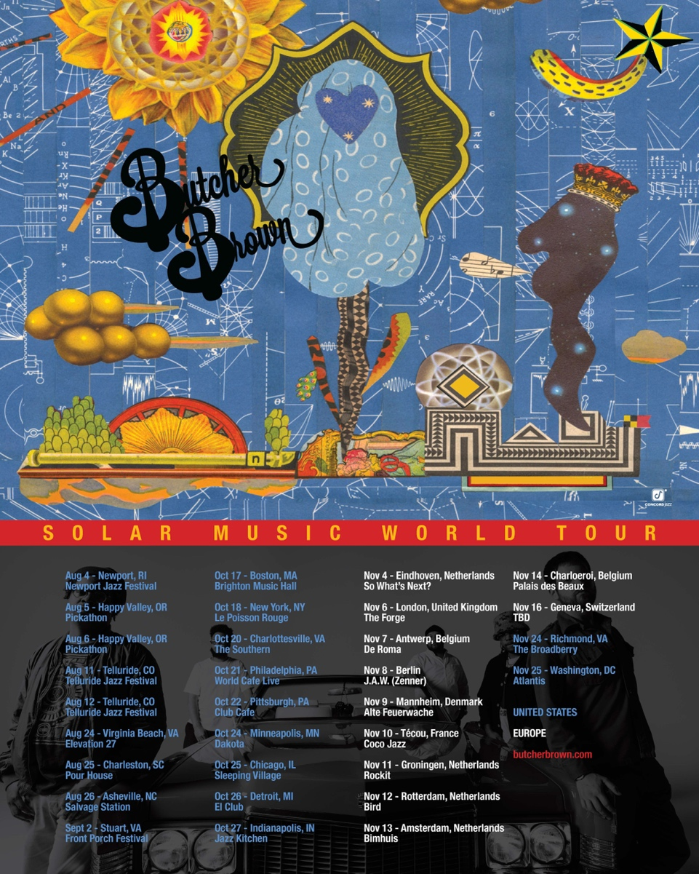
Upcoming Live Dates:

8/4 - Newport, RI @ Newport Jazz Festival
8/5-6 - Happy Valley, OR @ Pickathon
8/11-13 - Telluride, CO @ Telluride Jazz Festival
8/24 - Virginia Beach, VA @ Elevation 27
8/25 - Charleston, SC @ Pour House - Deck Stage
8/26 - Asheville, NC @ Salvage Station
8/31-9/3 - Stuart, VA @ Front Porch Fest
10/17 - Boston, MA @ Brighton Music Hall
10/18 - New York, NY @ Le Poisson Rouge
10/20 - Charlottesville, VA @ The Southern
10/21 - Philadelphia, PA @ World Cafe Live (upstairs)
10/22 - Pittsburgh, PA @ Club Cafe
10/24 - Minneapolis, MN @ Dakota
10/25 - Chicago, IL @ Sleeping Village
10/26 - Detroit, MI @ El Club
10/27 - Indianapolis, IN @ Jazz Kitchen\
11/4 - Eindhoven, NL @ So What’s Next?
11/5 - Paris, FR @ New Morning
11/6 - London, UK @ The Forge
11/7 - Antwerp, BE @ De Roma
11/9 - Mannheim, DE @ Alte Feuerwache
11/10 - Técou, FR @ Coco Jazz
11/11 - Groningen, NL @ Rockit
11/12 - Rotterdam, NL @ Rooterdam / Bird
11/13 - Amsterdam, NL @ Bimhuis
11/14 - Charloeroi, BE @ Palais des Beaux Arts
11/16 - Geneva, CH @ Soulitude
11/24 - Richmond, VA @ The Broadberry
11/25 - Washington, DC @ Atlantis

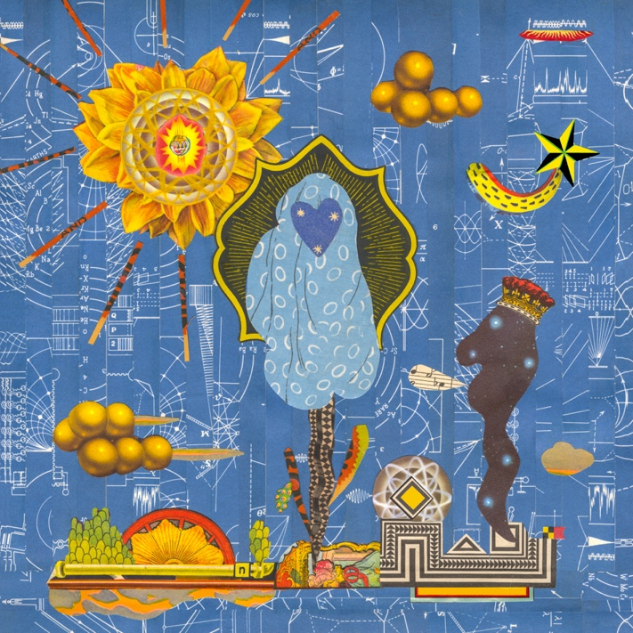

Butcher Brown
Solar Music
Concord Jazz
October 6th, 2023

1. Cozumel
2. Espionage featuring Charlie Hunter
3. I Can Say To You featuring Vanisha Gould
4. MOVE (RIDE) featuring Jay Prince
5. Turismo featuring Julia Shuren
6. Eye Never Knew featuring Pink Siifu and Keyon Harrold
7. No Way Around It
8. Half of It featuring Nappy Nina
9. DYKWYD featuring Braxton Cook
10. Happy Hourrr
11. Run It Up featuring Pink Siifu
12. Pink Fur featuring Michael Millions
13. This Side of Sunshine
14. BubbleBath
15. Touring Pains
16. It Was Me
17. Around For A While

More about Butcher Brown:
Miles Davis once quipped, “I’ll play it first and tell you what it is later.” Butcher Brown has released forward-thinking and expansive hybrids of jazz and hip-hop since 2013. Today, they have an apt descriptor for their songs: solar music. Drawing inspiration from every sound under the sun, the Richmond, VA band adds elements of funk, soul, and rock to their foundational mix. The result is a Southern-leaning, sometimes psychedelic fusion that feels fresh yet familiar. Simultaneously working within and defying genre conventions, Butcher Brown is a jazz festival mainstay that could tour with Tyler, the Creator as easily as Khruangbin.

“We get daps from the jazz cats, the rap scene, the indie scene, and everyone else,” says drummer Corey Fonville. Every Butcher Brown album, show, and improvisational leap therein stems from the synergy, vision, and inexhaustible musical curiosity of him and his bandmates: producer/multi-instrumentalist DJ Harrison; bassist/composer Andrew Randazzo; trumpeter/saxophonist/MC Marcus “Tennishu” Tenney; and guitarist Morgan Burrs.

The band’s past begins in Richmond, where several members attended VCU’s jazz program, and everyone mixed in the city’s vibrant music scene. Between classes and performances at local clubs, all congregated at Harrison’s home studio: Jellowstone. Jam sessions bled into blunt-passing smoke sessions soundtracked by beat tapes from renowned Richmond producer Ohbliv, D’Angelo’s sensual, funky and forward-thinking neo-soul, and saxophonist Joe Henderson’s Power to the People. All culminated in Butcher Brown’s 2014 debut, All Purpose Music, a 76-minute jazz-driven odyssey into every genre at the band’s disposal.

That spark fueled a beat tape (Grown Folk, 2015), southern-inflected soul and rock excursions (The Healer, 2015 and Virginia Noir, 2016), a raucous live album (Live at Vagabond, 2017), jazz-funk fusion (Camden Session, 2018), and an Afrobeat tribute (Afrokuti, 2018). After tours with Galactic, Lettuce, and jazz giant Kamasi Washington, Butcher Brown turned a corner with their Concord Jazz debut, 2020’s #KingButch. They recorded at Jellowstone and abandoned worries about creating songs that would be easily replicable live, blurring the lines between soul-jazz and boom-bap, eliminating the divide between P-funk and modern funk, and transforming rap-meets-bossa nova amalgams into kaleidoscopic psychedelia. With Tennishu rapping, the band was in new territory and closer to their roots than ever. Their catalog-spanning NPR Tiny Desk Concert, crowd-packing European tour, and inspired, Alex Isley-assisted cover of Patrice Rushen’s “Remind Me” in 2021 proved their range remained limitless, unbound by genre and time.

Describing the group's journey, bassist Andrew Randazzo says, “Over the years, everything about this band has become more refined and mature — from the playing and producing to recording — but the soul was there from the beginning... We already had the spark.”

(Download hi-res assets HERE)

Connect with Butcher Brown:
Instagram | Twitter | Facebook | TikTok

For all Butcher Brown inquiries please contact Kevin at Orienteer:
kevin@orienteer.us

--
Kevin Cordon
Orienteer
Los Angeles, CA | New York, NY

