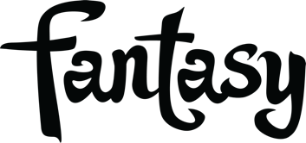

TAKING BACK SUNDAY RETURNS WITH "THE ONE"

BELOVED ROCK BAND SHARES
FIRST NEW TRACK IN FOUR YEARS LISTEN HERE

WATCH THE OFFICIAL MUSIC VIDEO HERE

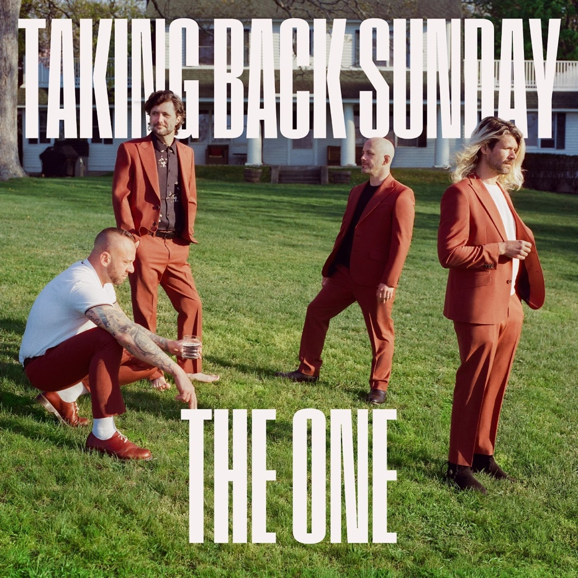
Track Cover Art - Hi-Res Download

Signs To Fantasy Records

Headlining Sad Summer Fest 2023 Beginning July 6

FOR IMMEDIATE RELEASE - JUNE 30, 2023—Today, rock powerhouse Taking Back Sunday: John Nolan (lead guitar, piano, vocals), Adam Lazzara (lead vocals), Shaun Cooper (bass), and Mark O’Connell (drums) shared a brand-new track and video entitled, “The One,” the multi-platinum selling rock band’s first new music in over four years. An inspiring declaration of love, hope, and acceptance, “The One” is a soaring reminder to seize the moment and live your dreams while you still can. Listen to “The One” HERE. In the track’s accompanying video, directed by DJay Brawner, the band primes for the next gig and new roads that lay ahead—inviting us along for the mystery ride. Watch the official video for “The One,” HERE.

Produced by Tushar Apte (Demi Lovato, Nicki Minaj), and mixed by Neal Avron (Twenty One Pilots, Bleachers), “The One” finds the influential rock band flexing its creative muscles and evolving its sound without ever losing sight of the explosive riffs, affecting vocals, and epic choruses that has resonated with their audiences for so long. The anthemic new track also marks the band’s first release for Fantasy Records, the L.A based indie label who signed the influential quartet to a world-wide recording contract earlier this year.

"'The One' is a sweet love song—full on John Cusack holding a boombox," the band says in a nod to the classic 80’s cinema moment in Say Anything. "We’ve been waiting a long time to share this song and we’re so excited that we finally can. We hope you love it as much as we do."

On the track’s deeper meaning, the band explains, "This song came from a riff that Shaun Cooper wrote the day he lost his grandmother while she was in a nursing home at the start of the Covid pandemic. Devastated with overpowering sadness, he found comfort in writing music and initially titled the riff ‘Posivibes’ in an effort to find some light through the darkness. He never shared the story of the title or how that riff came together with us until after it was complete. Shaun didn’t want his story affecting the ultimate meaning of the song, because it’s actually an uplifting one."

Taking Back Sunday is set to hit the road this summer for a nation-wide tour (they are calling Rad Summer), that includes headlining the 16-date Sad Summer Fest 2023 through July and a number of additional dates in August and September. Find tickets HERE and the full routing below.

For over two decades, Taking Back Sunday has cultivated a massive, dedicated fanbase built around music that reverberates with supreme sincerity, desire, and connection. Originally from Long Island, NY, the band brought mature songcraft and pop sensibilities to punk’s rigid conformity, helping expand the genre’s contours while carrying the band to new heights.

TAKING BACK SUNDAY ON TOUR:
SAD SUMMER FEST 2023:
7/6 — Jacksonville, FL — Daily's Place
7/7 — Clearwater, FL — Coachman Park
7/8 — Alpharetta, GA — Ameris Bank Amphitheatre
7/11 — Portsmouth, VA — Atlantic Union Bank Pavilion
7/12 — Baltimore, MD — Pier Six Pavilion
7/14 — Holmdel, NJ — PNC Bank Arts Center
7/15 — Philadelphia, PA — Skyline Stage at Mann
7/16 — Boston, MA — Leader Bank Pavilion
7/18 — Sterling Heights, MI — Michigan Lottery Amphitheatre at Freedom Hill
7/19 — Cincinnati, OH — The Andrew J Brady Music Center
7/21 — Chicago, IL — Huntington Bank Pavilion at Northerly Island
7/22 — Indianapolis, IN — TCU Amphitheater at White River State Park
7/23 — Nashville, TN — Ascend Amphitheater
7/25 — Irving, TX — The Pavilion at Toyota Music Factory
7/26 — Austin, TX — Germania Insurance Amphitheater
7/29 — Irvine, CA — FivePoint Amphitheatre

8/12 — Washington, PA - Four Chord Music Festival 2023
8/19 — Las Vegas, NV — Downtown Rocks FREE Concert Series
8/25 — St Louis, MO — Ballpark Village
8/26 — Kansas City, MO — KC Live!
9/29 — Cocoa, FL — Cocoa Riverfront Park
9/30 — Jupiter, FL — Dastoberfest

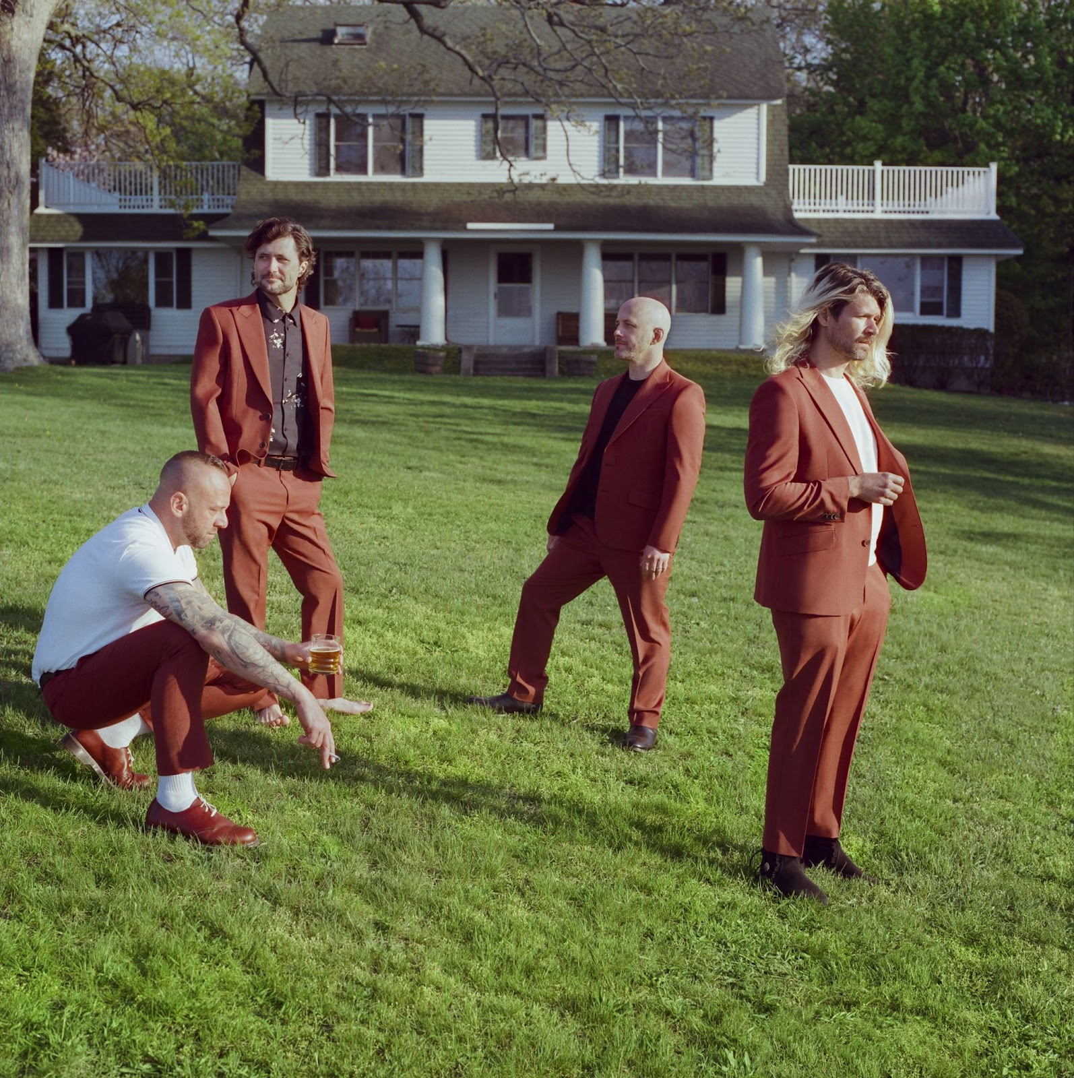
Photo credit: DJay Brawner

FOLLOW TAKING BACK SUNDAY
Website
TikTok
Instagram
YouTube
Facebook
Twitter

Fantasy Records

For more information, please contact: Atomsplitter PR - Amy Sciaretto amy@atomsplitterpr.com Tim Tatulli tim@atomspllitterpr.com
Fantasy Records - Joel Amsterdam - joel@fantasyrecordings.com

